High Precision Temperature Controller
  - Final Design Document

Group 13

Ashley Desiongco
Stacy Glass
Martin Trang
Cara Waterbury

  - Sponsored by 

Executive Summary 7
Motivation 7
Blackbody Sources 8
Temperature Controller Requirements 10
Microcontroller Research 11
Package Type 11
Memory 12
Communication 14
Input 15
Output 16
Microcontroller Candidates 16
TI MSP430F449 16
Microchip PIC24HJ128GP204 17
Microchip PIC32MX150F128B 18
Freescale MC68HC16Z1CAG16 18
Comparison 19
Microcontroller Design 20
Microcontroller Pin-Out Table 20
Software Design 22
Temperature Control Software 22
Temperature Processing 22
Other Software 25
Communicating with Peripherals 27
Determining Abnormal Operation 32
Calibration 34
Overview 34
Offsets 34
Calibration Process 35
PID 38
Overview 38
Requirements 38
Breakdown 39
Error 39
Determining the Gain 40
Proportional 43
Integral 44
Derivative 45
Variation 46
Our System 48
Temperature Sensing Subsystem 50
Overview 50
Requirements 51
Temperature Sensing Devices 51
Overview 51
Thermocouples 52
Resistive Temperature Detectors 54
Connectors 54
Amplification 55
Amplifier Design 55
Candidates 57
Multiplexing 58
Temperature Sensor Multiplexer 59
Cold Junction Multiplexer 60
Microcontroller Peripheral Decoder 61
8-bit Inverter 61
Charge Injection Problem 62
Analog to Digital Converters 63
Flash ADC 63
Successive Approximation 64
Sigma Delta ADC 64
Candidates 64
Voltage Reference 66
RTD Amplification Reference 66
ADC External Reference 67
Candidates 67
Solid State Relays 68
Heater Relays 68
Alarm Relays 69
Temperature Sensing Subsystem Design 69
Printed Circuit Board Fabrication 70
Candidates 71
Display Design 72
Overview 72
Requirements 73
Display Research 73
Graphics Controllers 73
External Graphics Controller 73
External Graphics Controller not Found in Glass 74
Integrated Graphics Controller 74
Interface 75
Parallel Interface 75
Serial Peripheral Interface (SPI) 75
Four Wire Resistive Touch Screen 75
Touch Screen Controller 76
Capacitive Touch Screen 76
LED Backlight 77
Display Candidates 77
Crystalfontz CFAF320240F-035T-TS 77
Newhaven NHD-4.3-480272MF-ATXI#-T-1 79
Newhaven NHD-3.5-320240MF-ATXL#-T-1 80
4D Systems uLCD-32PT (GFX) 81
uLCD-32PT (GFX) Specifics 84
Display Pin-Out Tables 85
Size Requirements 86
User Interface 87
Overview 87
Requirements 87
User Interface Design 87
Power 90
Power Requirements 90
Power Components 90
Future Ethernet Interfacing 92
Overview 92
Requirements 92
Design 93
Ethernet Access Candidates 94
Microchip DM320004 94
Ethernet Controllers 94
Package Types 95
Microchip ENC28J60/SS 95
Ethernet RJ45 with Transformer versus MagJack 96
Transmitting and Receiving Packets 99
TCP/IP versus UDP 99
User Interface 100
Final Design 102
Testing 103
Microcontroller Testing 103
Peripheral System Testing 104
Display System Testing 105
Thermocouple Testing 106
Multiplexing Testing 106
Power Testing 106
Complete System Testing 107
Future Advancements 107
User Interface 107
Overview 107
Requirements 108
User Interface Design 108
Solid State Relay Control 122
Administrative Content 122
Group Responsibilities 122
Budget/Cost Analysis 123
Milestones/Schedule 124
Final Design Overview 125
Schematic Overview 126
Printed Circuit Board Overview 127
Chassis Overview 127
Appendices 128
Table of Tables 128
Table of Figures 129
Works Cited 131
Permission Emails 133

Executive Summary

Infrared Systems Development Corporation (ISDC) is an engineering design firm that specializes in the design and construction of infrared test equipment. One of these test systems is a blackbody source with a high precision temperature controller. The current temperature controller being used by Infrared Systems Development is a commercial off the shelf product that specializes in controlling industrial heaters. The company that produces these controllers has made modifications to the hardware and software design to accommodate the needs of ISDC at a high cost and long turnover time. Since there are essential features that are absent and a plethora of unnecessary ones that are present, Infrared Systems Development wants to develop and design a temperature controller that will be able to have the same accuracy and speed as the current COTS product but with the ability to make modifications quickly and easily.

Motivation

Motivation for this project came from one of our group members, Martin Trang. He currently has an internship at Infrared Systems Development located in Orlando, Florida. His manager and CEO of the company, Andy Duran, expressed interest in developing a high precision temperature PID controller at their facility for his company to both utilize and sell. Once Martin heard of this interest, he quickly asked for the opportunity for our senior design group to take on the challenge. Mr. Duran graciously agreed to let us design this controller and offered to sponsor the project financially.

Infrared Systems Development Corporation has many specialties, including: preamplifiers, radiometers, blackbody sources and spectrometers to name a few. Our project will specifically cater to Infrared Systems Development’s specialty in blackbody sources. The company’s blackbody sources have very large temperature ranges, some going as high as 1200 degrees Celsius and have temperature resolutions of 0.1 degrees Celsius. These sources can take up to 80 minutes to fully respond and therefore, need some kind of controller to regulate the source and a monitoring system to alert the user of temperatures approaching the set point. This is our motivation: to design and build a controller to regulate and monitor these blackbody sources.

To supplement the research and design of our PID controller, we also need to give some information on the blackbody sources we will be interfacing with. The internal temperature sensors are embedded inside the cavity of the source and are, depending on the temperature range of the source, type S thermocouples, type T thermocouples or Platinum RTDs. There are two of these temperature sensors, each connected through a thermocouple connector and referenced to an external ice bath (0 degrees Celsius). The readings from both are outputted to 2 pins of the output connector, via thermocouple extension wire, which will be explained in its own section below.

Blackbody Sources
The two sections below, Cavity Blackbodies and Extended Area Blackbodies, describe the different type of blackbodies the temperature controller needed to interface with. The sections -will discuss the general operating parameters including the temperature range, power source, and other characteristics that may affect the design of the temperature controller.

Extended Area Blackbodies - The extended area blackbody sources have a large cavity area versus the cavity blackbodies. Their temperature ranges are lower than compared to the cavity blackbodies. The IR-140 has a 12” by 12” heating area and a temperature range of ambient to 230°C. The IR-160 has a heating area of the 12” by 12” and has a temperature range of ambient to 350°C. The IR-150 has a heating area of 12” by 12” and has a temperature range of ambient to 500°C. The IR-2100 has a heating area of 2” by 2” and a temperature range of -5°C to 145°C. The IR-2101 has a 2” by 2” heating area and has a temperature range from -30°C to 75°C. The IR-2103 has a 3” by 3” heating area and a temperature range from -5°C to 145°C. The IR-2106, as seen in Figure 1, has a 6” by 6” heating area and a temperature range from 5°C to 150°C. The IR-140, IR-150, IR-160 heater are heater coils using AC power. The IR-2100, IR-2101, and IR-2103 are thermoelectrically heated and cooled using DC power.
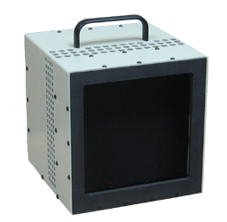
Figure 1: IR-2106 Extended Area Blackbody

Cavity Blackbodies -The cavity blackbodies have a smaller cavity area than the extended area blackbodies. There are seven different models that are being designed by Infrared Systems Development. The IR-508 has a ¼” cavity and a temperature range of 50°C to 1050°C. The IR-519 has a .4” cavity and a temperature range of 50°C to 1200°C. The IR-518 has .4” cavity and 50°C to 1050°C. The IR-704 has a ¼” cavity and a temperature range of 50°C to 1050°C. The IR-564 has a 1” cavity and a temperature 50°C to 1200°C. The IR-563, shown in Figure 2, has a 1.0” cavity and a temperature range of 50°C to 1050°C. The final blackbody is the IR-574 with a 2.25” cavity and a temperature range of 50°C to 1200°C. The IR-518, IR-519, IR-563, IR-564, and IR-574 use heater wire that are AC powered.
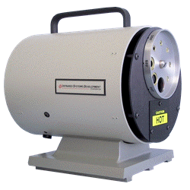
Figure 2: IR-563 Cavity Blackbody

In Table 1 below, highlights the different blackbody sources that the temperature controller would have to be able to control.

Type | Model Num. | Cavity Size/Heater Area | Minimum Temperature | Maximum Temperature | Thermocouple Type | Power Source
Extended Area | IR-140 | 12” x 12” | Ambient (25°C) | 230°C | Type T/RTD | AC
Extended Area | IR-150 | 12” x 12” | Ambient (25°C) | 500°C | Type T/RTD | AC
Extended Area | IR-160 | 12” x 12” | Ambient (25°C) | 350°C | Type T/RTD | AC
Extended Area | IR-2100 | 2” x 2” | -5°C | 145°C | Type T/RTD | DC
Extended Area | IR-2101 | 2” x 2” | -30°C | 75°C | Type T/RTD | DC
Extended Area | IR-2103 | 3” x 3” | -5°C | 145°C | Type T/RTD | DC
Extended Area | IR-2106 | 6” x 6” | 5°C | 150°C | Type T/RTD | DC
Cavity | IR-508 | .25” | 50°C | 1050°C | Type S | AC
Cavity | IR-518 | .4” | 50°C | 1050°C | Type S | AC
Cavity | IR-519 | .4” | 50°C | 1200°C | Type S | AC
Cavity | IR-704 | .25” | 50°C | 1050°C | Type S | AC
Cavity | IR-564 | 1.0” | 50°C | 1200°C | Type S | AC
Cavity | IR-563 | 1.0” | 50°C | 1050°C | Type S | AC
Cavity | IR-574 | 2.25” | 50°C | 1200°C | Type S | AC
Table 1: Table Comparing Different Blackbody Models/Types

Temperature Controller Requirements

The temperature controller that is to replace the commercial off the shelf product currently being used by Infrared Systems Development Corporation needed to satisfy a wide range of requirements. These requirements are broken down into different subsections: General.

General - The temperature controller must be able to control an electronically heated or cooled blackbody source with lower than +/- 0.5°C of error. The controller must be able to be accessed through an intuitive front panel controls as well as remotely through a computer interface. The temperature controller needed to regulate the amount of power needed to heat the blackbody source while monitoring for any disturbances that altered the actual temperature of the blackbody source that occur during the rise time and stabilization time of the blackbody. A P.I.D type control algorithm should be used to monitor the rise and control the device’s temperature. The controller must be able to be housed within an existing chassis that also housed the power supplies and high current devices. The controller must be able to run through a power on self-test to ensure that all sensors and devices are operating normally. If any abnormal conditions are present, the control should display the failure type and take appropriate action based on the error.

Alarm Outputs - Relay outputs that are set by the alarm control setup parameters must be included to allow users to connect other peripherals that reacted to fluctuations between the temperature set point and the actual temperature of the blackbody.

Computer Interface - The temperature controller must contain a serial port, IEEE-488, USB, and Ethernet interface. These interfaces need to include a simple command set that allowed the user to read the actual temperature, modify the temperature set point, report alarm conditions, as well as other maintenance tasks.

Display - One key parameter that must be shown at all times is the actual blackbody temperature. This value must be readily visible from at least ten feet away from the controller. The temperature must be show two digits of precision at all temperature values. A variable time constant needs to be implemented to smooth the value and reduce the display flicker. Beyond the actual temperature, the controller must be able to display the current set point, alarm conditions, percent power, chopper speed, and other system parameters.

Temperature Sensors - Analog temperature sensors, like thermocouples and resistance temperature detectors, is used to determine the actual blackbody temperature. The temperature controller needs to contain the appropriate circuitry to convert the voltage and/or the resistance readings from the temperature sensors into digital values that can be used in the control algorithm. Our temperature controller must be able to interface with Type “S” thermocouples and RTD devices.

User Interface - In order to provide a clean, intuitive interface, the temperature controller needs to use a minimal number of dials and keys. The user should be able to scroll/select different device options and parameters. Operating the controller needs to be intuitive and require little instruction for proper use.

Microcontroller Research

Overview - The microcontroller functioned as the brains behind the High Precision Temperature Controller. It was responsible for interpreting the temperature of the blackbody source and take appropriate action to maintain an accurate temperature output. In addition, the microcontroller must handle user driven interrupts, display updates, and other tasks.
The following subsections evaluated the various subcomponents found within the microcontroller. If applicable, a comparison between integrated components and external components was included. When interfacing with external devices like a displays and buttons, the corresponding subsections discussed how the microcontroller interfaced with the peripheral. It did not include the research and design process of the devices.
Requirements - The microcontroller needed to satisfy a variety of performance and longevity criteria. Regarding performance, the microcontroller must be able to implement a PID algorithm. It needs to be able to quickly and accurately calculate and adjust the three main parameters. In addition, the microcontroller needed to ensure zero crossing when handling AC power. Zero crossing ensured that no electrical interference occurs when power is being switched. The microcontroller needs to be able to handle a variety of computer communication interfaces, including USB, RS232, and IEEE-438, and user interactions, including displays and buttons. Also, it must be able to understand and command other peripheral devices like a chopper controller. The microcontroller must be able to perform complex In terms of longevity, the product lifecycle for the microcontroller and all its associated external components must be at least ten years following the completion of the design in December 2012. All the components must have a mean failure rate of at least ten years.

Package Type

There are three main package types that are available for all the microcontroller candidates that we are considering: SPDIP, SOIC, and QFN. All packages should be limited to 44 pins.

Skinny Dual In-line Package (SPDIP) - SPDIP is a package that have through hole leads that can be soldered to the board or inserted using a socket. The socket approach allowed for easy replacement if issues arise with the microcontroller. One of the benefits of SPDIP is the ease of prototyping because of the ease of mounting. It also allowed for easy prototyping. Thus we would favor a SPDIP package for our microcontroller. The SPDIP has a reduced footprint from the standard DIP packaging.

Small-Outline Integrated Circuit Package (SOICP) - SOICP is a surface mounted package. The footprint of these is around thirty to fifty percent smaller compared the DIP. Also, they have larger contacts than the QFNP which makes it easier to correct any errors during PCB production. However, this package is larger than QFNP and since we need to minimize the board space when possible, we would not consider SOIC for our microcontroller.

Quad-Flat No Lead Package (QFNP) - QFN is another surface mounted package. The footprint is even smaller than SOICP which is extremely advantageous for us. One of the disadvantages of having a small footprint is the difficulty of correcting any errors during PCB production. Because of the lack of clearance from the contact pads and the board, it is extremely difficult to correct any errors that exist on the board. Thus, we would not use the QFN package.

Plastic Lead Chip Carrier Package (PLCCP) - PLCC is a surface mounted package with “J”-leads. This allows the chip to be soldered directly to the board or the use of PLCC sockets. While the footprint of PLCC is larger than QFN, the ability to quickly and easily change malfunctioning microcontrollers is extremely beneficial. In addition, we can place the microcontroller in another circuit to program before placing it in the final PCB. This would allow us to save the I/O lines that we would have to use for in-circuit programming. Thus, we would prefer the PLCC package over any other for our microcontroller.

Memory

SRAM - There are three main functions in the temperature controller that are RAM intensive. First, storing the proportional band, integral band, and derivative band would take place in the RAM. These parameters needed to be updated constantly and do not need be saved if and when power is removed from the controller. Next is the implementation of data smoothing with respect to the display temperature. The particular algorithm will be discussed in the software design portion, but the RAM would temporarily hold the values for the display temperature until the averaging takes place. The final main task is the calculating of the electromagnetic energy radiated by the blackbody source using Planck’s Law. The energy curves defined by Planck’s Law do not linearly vary with temperature. This means that we would have to recalculate the curves when the temperature varies and calculate the area given a wavelength range specified by the user. There are two main approaches that are discussed in the software design portion. Since it would not be feasible for us to store a table of Planck’s Law values, we use RAM to help calculate the value according to Planck’s Law. This would allow us to have higher precision and free up EEROM space for more important parts. We tried to limit the number of reads/writes that are made to the EEPROM by utilizing the SRAM to hold common values that the user would typically manipulate. If we do not have adequate amount of SRAM on the microcontroller, we used the Microchip 23A640 with 64 Kbyte of SRAM. 23A640 would use SPI to communicate from the microcontroller and the chip. To read values from the 23A640, we pulled the chip select line low, and transmit the READ instruction (x03) followed by the 16-bit address sent to the SDI line which would be followed with the data at that address, if we reading one byte. If we want to read multiple bytes, this can be done without having multiple read cycles by clearing the data from the SDO line and waiting for another clock cycle. The address is automatically incremented and the byte from the following address is returned. For writing, we are capable of writing single bytes and multiple bytes sequentially. We start by sending the WRITE instruction (x02) followed by the 16-bit address then the eight bits of data. If we want to write multiple bytes, we followed the first eight bits of data with subsequent eight bit packets. There is no limit to the number of eight bit packets that we can write.

EEPROM - The temperature controller has several functions that heavily utilize the EEPROM. These features are expected to present after power is terminated from the temperature controller. The first major item that was stored on the EEPROM is the user interface. This includes all of the menus found within the temperature controller and the rules and conventions that translated the text into readable graphics. Since the user interface allowed the user to correctly operate the temperature controller, extensive space would be allocated to this feature. The next part captures the various parameters of the temperature control subsystem. This includes the offset points and values, PID algorithm, digital filtering parameters, and temperature lookup tables. We also needed to store the protocol required to communicate with any peripheral device developed by Infrared Systems Development. It dictated how our master temperature controller commanded the slave peripheral device and how to interpret the responses that the slave sends back to the controller. Another feature to be stored in the EEPROM is the custom scripts that the user uploaded into the temperature controller. The scripts contained commands that set a certain set point at given time for a given duration. More specifics would be discussed in the software design portion. Since these features required a significant amount of EEPROM, we would have to choose a microcontroller that has plenty of onboard EEPROM. We needed to look into interfacing with external memory if the microcontroller does not have any onboard for program and/or data. If we need to implement an external EEPROM, we used the Microchip 25AA640A. This features 64 Kbit of memory (8192 x 8 bit). In terms of reading/writing, the same convention for the 25AA640A as it was for the 23A640. Since we are using a 16-bit microcontroller and the 25AA640A returns a single byte, we needed to read from the memory twice. Since EEPROM has a limited number of read/write cycles before failure; we needed to optimize the code to avoid excessive reading/writing. This is discussed in the software design portion.

Communication

Ethernet - If our microcontroller does not provide native Ethernet support, we used the Microchip ENC28J60 Ethernet controller with SPI interface. This controller is IEEE 802.3™ compatible with support for 10/100/1000Base-T Networks. To interface this controller with our microcontroller, we used four-wire SPI to send and receive data and an interrupt pin to notify us that there a particular packet has been received. The ENC28J60 requires a 25 MHz parallel cut crystal with 15 pF capacitors tied to ground. We needed two Ethernet transformers that meet IEEE 802.3 isolation requirements. We needed to ensure that all power supply pins are connected to the same power source and all share a common ground.

IEEE-488 - IEEE-488 is an 8-bit parallel communication bus often referred to as GPIB. To implement this interface in our controller, we utilized ICS Electronics 4806 GPIB to Serial Interface board. This adds a GPIB interface to our temperature controller. It includes SCI commands necessary to customize the 4806, including defining the GPIB address. The board also features a serial-to-serial data path, so an additional DB9 connector does not have to be present to interface with this device. The serial output was RS-232 which we’ll connect to a MAX232, if we do not have native support, so our microcontroller can obtain the information.

RS-232 - For two way transmission, RS-232 Interface requires a minimum of three lines, Receive, Transmit, and Ground Pins. The RTS/CTS lines are not necessary because software flow control was used instead of hardware flow control. Software flow control, using standard XOFF and XON, reduces the complexity of the microcontroller design in favor of an easy software implementation. When connecting the RS-232 interface to the microcontroller, we connected each RX and TX lines to two 2:1 multiplexors. This saved two pins when implementing the three different communication protocols. The outputs of the multiplexors were tied to the RX/TX lines found on the microcontroller. If the controller needs to support IEEE-488, then the RS-232’s RX and TX lines were tied to the ICS GPIB to Serial board. The board has an output RX/TX line that was then be routed to the 2:1 Multiplexors, if we only have a single UART line in our microcontroller. If our microcontroller does not natively support RS-232, we needed a device that can modify the voltages so that it can be interpreted by our microcontroller since RS232 has voltage ranges of +/- 3V to +/- 15V, we needed a device that can modify the voltages so they can be interpreted by our microcontroller, which operates in the 0 – 5V range. Using a Maxim MAX232, it converted Logic 1 from [-15V, -3V] to 5V and Logic 0 from [3V, 15V] to 0V. So we tied the RX and TX from the DB9 connector to the MAX232 which connected with the 2:1 Multiplexors mentioned above.

USB - If our board does not provide native support for USB, we utilized the Microchip MCP2200. By using this chip, we avoided the difficulties associated with implementing a standard USB class like HID or Mass storage on our microcontroller or creating our own USB driver on the particular computer. MCP2200 uses standard Windows drivers for Virtual Com Port and translates USB protocol to UART protocol. An associated .inf file needed to be loaded for the computer to recognize the microcontroller. This file is provided by Microchip. The MCP2200 has both hardware control lines has active low. Since we had software handshaking, we tied both of these lines to ground, telling the MCP2200 that transmission can freely occur. Since the 16-bit microcontrollers we are considering do not have a fast enough internal clock, we used a 15 MHz external clock for the timing of the MCP2200. To power the device, the +5V from the USB connector tied to V_{DD} with capacitors to satisfy the inrush current limit and lower power suspend mode. Prior to use, the desired baud rate assigned to the MCP2200. After doing so, we used RX/TX lines from the MPC2200 connect to our microcontroller to read/write value from/to it. Since we are not going to use hardware handshaking, we needed to ensure that values are read before they are overridden and lost.

Input

A/D Convertor - Most microcontrollers have onboard ADC that has 10 to 12 bits of resolution. For our temperature controller, we needed 24 bits of resolution. There are techniques, like oversampling, available that allowed us to achieve our required 16 bits of resolution which was discussed in detail in the corresponding ADC section.. These techniques require extremely low noise environments, which we cannot guarantee. Thus, we used a 24 bit ADC. More thorough research and evaluation of potential candidates can be found in the temperature sensing sub section.. To interface a 24 bit ADC, like the AD7718, with our microcontroller, we need an external clock and serial input/output lines. The inputs required for actual conversion are discussed in the ADC section.

User Inputs - User interactions with the temperature controller was governed by a series of buttons or a touch interface. If physical buttons are used, each button was mapped to a single line on the microcontroller using a pull-down resistor to ensure that a signal is near zero volts when the button is not being pushed. A classic four button interface was used (^, V, <, >). All buttons connected with a pull down resistor to ensure that logic LOW is seen when the button is not pressed. If a touch interface is used, a touch screen controller must be included. Specific discussion on the implementation is discussed in the Display section. To interface the touch screen controller to the microcontroller, we used a four wire touch screen controller that supports SPI.

Power - The microcontroller operates around the 5V range. Circuitry needs to be designed that will allow a 110VAC/220VAC to power the microcontroller without any issue.

Output

Power - All AC powered black body sources must have zero cross sensing at the AC relay in order to lower the electrical interference generated when switching at a nonzero point. The research and design of the zero cross sensing circuit can be found in the power section. The circuit returns a value of Logic High. Since we need the relay to react quickly to the crossing point, it will be tied directly to an AND gate. These logic gates can output up to 7Vdc, which was enough to drive the solid state relays. If the voltage is not adequate, an amplifier was used to raise the DC voltage to adequate levels.

Display - A more in-depth research and design of the display can be found here. To interface the display with the microcontroller, we can use 16 bit parallel data bus or SPI. Using the a parallel bus would allow us to quickly refresh the screen at the cost of more complex circuitry and consuming more I/O ports on the microcontroller. The three/four wire SPI was slower than the parallel approach, but we would only require three to four pins, which would be used for other SPI peripherals. Since we do not need to quickly update the screen, we used four wire SPI to interface the display with the microcontroller.
Difference between four and three wire SPI = four wire allows you select between registers and data.

Timing - The overall timing of the microcontroller can be done using an internal oscillator or an external crystal. The chief benefits of using an external crystal would be higher clock speeds and accuracy. Since the performance of our temperature controller was bounded by the black body source, the addition of a faster, an external crystal with higher frequency did not help. When applicable, peripherals that require an external clock used the internal clock on the microcontroller. The MCP2200 requires a 15 MHz clock, which exceeds the limits of the internal oscillator. Instead we used an external crystal to interface with the clock.

Microcontroller Candidates

TI MSP430F449

The MSP430F449 is a 16-bit microcontroller with an 8 MHz clock frequency and 48 general input/output lines. It comes in a 100-pin LQFP. While this package is not the desired PLCC, it has exposed “gull-wing” leads that allowed us to make any necessary repairs to the solder connections. Since the MCP2200 requires a 20 MHz external clock, we needed to supply an external crystal since the 8 MHz clock from the MSP430 did not suffice. It has 60 Kbytes of onboard Flash memory and 2 Kbytes of onboard SRAM. This sufficed our program memory and data memory requirements as well as our SRAM requirements. Thus, we would not need to have any external EEPROM or SRAM. TI’s supplies an IDE, Code Composer Studio that hastened the time to complete the software portion of our temperature controller. In addition to assembly, we can use C and C++ to program the MSP430. This allowed us to quickly implement Planck’s Law and other math intensive functions. While the MSP430 does not offer native USB support, it does have two USART lines that can be used to handle USB (via the MCP2200), RS232 (via the MAX232), and IEEE 488 (). This microcontroller has a 12-bit ADC that uses successive approximation. While the conversion methodology is what we want, we need 16 bits of resolution in order to get two degrees of precision from our readings. We do not want to use oversampling to achieve this resolution, so we used an external ADC. Since we have two USART lines, we used the remaining line as SPI to communicate with the ADC as well as other peripherals. We needed to communicate with at most four different peripherals, the analog to digital convertor, display, and two slave devices. Instead of daisy chaining the SDI/SDO lines and have a common CE between all peripherals, we used four independent peripherals by having common SDI/SDO lines and using a 4:1 multiplexor to control the CE lines. One key feature present on the MSP430F449 is LCD driver capable of controlling up to 160 LCD segments. This gave us greater flexibility in choosing a display interface because the display does not need to have an integrated controller. This lowers the cost of the display and allowed us to use generic LCD displays. There are four lines available that can be used as PWM lines that are capable of driving relays to control the heater power. We needed at least one for the cavity blackbody heat sources and two for the extended area blackbodies.

Microchip PIC24HJ128GP204

The PIC24HJ128GP204 is a 16-bit microcontroller with 7.37 MHz internal clock and 35 I/O pins. It comes in a 44-pin TQFP and 44-pin QFN package. The only available Microchip microcontrollers that supported PLCC were the 8 bit varieties. The Thin Quad Flat Package has gullwing leads that allowed us to make any necessary repairs to the solder connections. Since the PIC24H does not natively support USB, we used the MCP2200 to interface with it, which has a 20 MHz oscillator requirement, which exceeds our external clock. Thus, we used a 20 MHz crystal. It has 128 Kbytes of program memory which was able to hold all of the present and future development needs of the temperature controller. It also has 8 Kbytes of SRAM. This extremely important because we need to handle complexity of implementing Planck’s Law. In addition, having a significant amount of SRAM allowed us to lower the number of read/write cycles on the EEPROM, prolonging the lifetime of our components. The PIC24HJ128GP204 does not have any data EEPROM onboard, so we used an external 64 Kbyte EEPROM that communicates via SPI. Microchip offers an IDE, MPLAB, that allowed us to quickly and easily program the microcontroller. MPLAB has a built in C compiler that is compatible with any PIC24 microcontroller. This allowed us to utilize the same code with another PIC24H microcontroller if the PIC24HJ128GP204 goes out of production.

Microchip PIC32MX150F128B

The PIC32MX150F128B is a 32-bit microcontroller with an 8 MHz internal oscillator and 21 I/O pins. It is available in a 28-pin SPDIP package. The Shrink Plastic Dual-In-Line Package has the ability to be inserted into a socket or through hole mounted which would not only make testing easier, but also integration into the final PCB design. The microcontroller has USB 2.0-compliant interface along with support for two UART lines, two SPI lines, and full-featured ANSI – Compliant C. This allowed the availability to handle RS232, a display, or other peripheral connections. It has 128Kbytes of flash memory juxtaposed with 32Kbytes SRAM memory. The available SRAM allowed us to dynamically calculate electromagnetic energy radiated by the blackbody source, instead of resorting to using lookup tables. We were able to lessen the load we put on the EEPROM by loading the values from the EEPROM and manipulating through the SRAM. It does not have any onboard data EEPROM so we used 64 Kbyte EEPROM that communicates via SPI. Some special features offered by the PIC32MX150F128B include multiple power management modes, five 16-bit timer, and three analog comparators. Just like the PIC24HJ128GP204, we used MPLAB to program the PIC32MX150F128B, which allow us to program any PIC32 microcontroller in Microchip’s similar family product line.

Freescale MC68HC16Z1CAG16

The Freescale MC68HCZ1 is a 16-bit microcontroller with 16 MHz internal clock and sixteen general input/output pins. The only package that it comes in is the 144 pin QFP. While this package is not the PLCC, it has exposed “gull-wing” leads that allowed us to make any necessary repairs to the solder connections. The internal clock was not sufficient to drive the MCP2200, which requires a 20 MHz clock. Thus we used an external crystal to provide the timing for the MCP2200. It can address up to 1 Mbyte of program memory and 1 Mbyte of data memory. The MC68HCZ1 does not have any onboard EEPROM, but has an SPI line that can interface the external memory. We used 64 Kbytes of EEPROM, with the amount of data and program memory to be allocated at a later date. It has 1 Kbyte of SRAM. This was able to implement Planck’s Law. The Freescale CodeWarrior Development Suite is not compatible with the MC68HC16Z1CAG16, so all programming must be done at the assembly level. The M68MMDS1632 Development System allowed us to quickly test and evaluate our code with real-time bus analysis and debugging. Freescale does have a rich support community that has open-sourced several programs that can help us tackle some of the more challenging programming problems including implementing Planck’s Law, which would involve a fifth order polynomial as well as integration, and display interfacing. The Freescale microcontroller has five 16-bit registers (three index registers and two accumulator registers) that allowed us to handle any math or computational tasks need. In terms of interfacing with computer peripherals, it does not have native USB support, but has two UART lines so we would not need to use a 2:1 multiplexor for serial communication between the USB, RS232, and IEEE-488. Since we needed to interface with other integrated circuits like EEPROM and other devices like a chopper controller, we needed to use Freescale’s single SPI channel. Since we only have one channel, we tied the SDO and SDI lines together and use a 4:1 MUX to control the CE pins on the SPI lines of the slave devices. It has a successive approximation analog-to-digital convertor that supports up to ten bits of resolution. While the MC68HC16Z1CAG16 has the correct type of ADC, we need sixteen bits of resolution in order for our temperature ranges to be between 30.0°C and 1400.0°C and we do not want to oversample to get sixteen bits of resolution. Thus, having a ten bit successive approximation ADC is a nonfactor for this microcontroller. Since this microcontroller does not have any built it graphics drivers, we needed to design the protocol that drove the display. We are going to interface with displays that support SPI, so no additional hardware was be required to communicate between this microcontroller and the display. If a four-wire touch screen is not used, we required a set of four direction buttons (^, V, <, >) to serve as the user controls for the microcontroller.

Comparison

Below in a Table 2 there is a summary of the features that are relevant to our temperature controller.

Candidate | MSP430F449 | PIC24HJ128GP204 | PIC32MX150F128B | MC68HC16Z1CAG16
Package | LQFP | TQFP | SPDIP | QFP
Number of Pins | 100 | 44 | 28 | 144
Number of I/O Pins | 48 | 35 | 21 | 16
SRAM (Kbye) | 2 | 8 | 32 | 1
Program Memory (Kbyte) | 60 (Shared) | 128 | 128 | None
Data Memory (Kbyte) | 60 (Shared) | None | Shared with Program Memory | None
UART Lines | 2 (Shared) | 2 | 2 | 2
SPI Lines | 2 (Shared) | 2 | 2 | 1
USB Support | None | None | None | None
RS-232 Support | None | None | None | None
Ethernet Support | None | None | None | None
Cost (1) | $10.67 | $5.43 | $3.57 | $11.37
Table 2: Comparing Features of Various Microcontrollers
The above table summarizes the main features available from our different candidates. Our main point of comparison is the amount of onboard memory, both SRAM and EEPROM, and the peripheral support on the microcontroller. We remain flexible with the package sizes, but we do prefer PLCC, SPDIP, then TQFP, then QFN. We also want to minimize the number of pins on the microcontroller. In terms of memory, the PIC24FJ256DA206 has the most, with respect to program memory and SRAM. This allows us to be extremely flexible in our software design and allowed us to implement some complex functionality in our temperature controller. One down side of the PIC24FJ256DA206 is the lack of data memory, which forced us to have external EEPROM. It also has the highest number of SPI, I²C, and UART lines. This allows us to avoid using multiplexers and let us have dedicated communication lines for some of our peripherals. Since the PIC24FJ256DA206 offers more peripheral support in terms of USB support, RS-232 support, and display support, we would avoid using the MAX232, MCP2200, and a display controller to make our different peripherals work with our microcontroller. This reduces the complexity of our circuit, size of our board, and the price of a temperature controller.

Due to ease of implementation and feature set, we decided to choose the PIC32MX150F128B as our microcontroller for our high precision temperature controller.

Microcontroller Design

The overall microcontroller design featured two PIC32MX150F128Bs connected in a Master-Slave configuration. The slave PIC32MX150F128B is dedicated to controlling the blackbody heat source. The master PIC32MX150F128B communicates with the different computer interfaces as well as the display.

Microcontroller Pin-Out Table

Below are the pins on the PIC32MX150F128B that we are going to use for our temperature controller for our slave and master. It shows the pin number, pin description as described by Microchip, and our description of the pin. It describes the functionality that we have enabled in the microcontroller. Table 3 shows the pins that we are going to use for the slave configuration. The slave is used mostly for both of the analog to digital converters and PWM. In Table 4 we show the pins that we are going to use for the master configuration. This microcontroller was be used for all other communications. The master was also in charge of interfacing with the display.

Pin # | Port Name | Function
1 | MCLR | Master clear
2 | RPA0 | Ready – 7797
3 | RPA1 [SDO2] | Master to slave
4 | RPB0 [OC3] | PWM2
5 | RPB1 [SDO1] | ADC
6 | RDY7718 | Ready – 7718
7 | NC | No Connect
8 | VSS | Ground
9 | RPA2 [SDI2] | Master to slave
10 | RPA3 [SS2] | Master to slave
11 | NC | No Connect
12 | RPA4 | Addr line 2
13 | VDD | 3.3V
14 | RPB5 [SDI1] | ADC
15 | RPB6 [T4CK] | AC input
16 | RPB7 [OC1] | PWM1
17 | RPB8 | Addr line 1
18 | NC | No Connect
19 | VSS | Ground
20 | VCAP | 1.91V
21 | PGED2 | Debug 1
22 | PGEC2 | Debug 2
23 | NC | No Connect
24 | NC | No Connect
25 | RPB14 [SCK1] | ADC
26 | RPB15 [SCK2] | M-S Clock
27 | AVSS | AREF- [AGND]
28 | AVDD | AREF+ [3.3V]
Table 3-Slave Pin Out Table

Pin # | Port Name | Function
1 | MCLR | Master clear
2 | RPA0 [U1TX] | Display transmit line
3 | RPA1 [SD02M-S] | Master-slave
4 | RPB0 [SS2] | Slave select 2
5 | RPB1 [SDO1] | Ethernet
6 | UART Select 1 | UART select line 1
7 | UART Select 2 | UART select line 2
8 | VSS | Ground
9 | RPA2 (U1RX) | Display receive line
10 | RPA3 [SPISEL1] | SPI select - ethernet
11 | RPB4 | Reset display
12 | RPA4 [SDI2] | Master-slave
13 | VDD | 3.3V
14 | RPB5 [SDI1] | Ethernet
15 | RPB6 [SPISEL3] | SPI select – ethernet
16 | RPB7 [SS1] | Slave select – ethernet
17 | RPB8 [U2RX] | COMM Receive line
18 | RPB9 [U2TX] | COMM transmit line
19 | VSS | Ground
20 | VCAP | 1.91V
21 | PGED2 | Programming pin
22 | PGEC2 | Programming pin
23 | RB12 | Driver, receive – MAX481
24 | RPB13 | SPI select line 2
25 | SCK 1 | Ethernet clock
26 | SCK2 | Master-slave clock
27 | AVSS | AREF- [AGND]
28 | AVDD | AREF+ [3.3V]
Table 4-Master Pin Out Table

Software Design

This portion discusses the methodology that we used to allow us to implement the various features of the temperature controller.

Temperature Control Software

Temperature Processing

In order for our controller to do any data monitoring, processing or controlling we have to be able to translate our voltage readings into usable, meaningful data. The microcontroller had access to digital voltages sent from all the thermocouples and reference sensors, whether this be type T or type S thermocouple or the cold junction RTD. The controller and other peripherals needed to know how to operating depending on these temperature readings. If a black body source is approaching its set point, the processor needed to send a signal to the DC relay, which in turn triggered the one of the two alarms. This process is just one example of many processes that rely on the temperature data to trigger its response. If the data is not taken in and understood properly, we could risk damaging the heater and the controller itself.

There was several functions programmed into the microcontroller specifically made to handle these voltages. Separate functions needed to be written for each type of temperature sensor because of their unique responses to temperature changes. We also dealt with double precision arithmetic; therefore, we need to allocate enough space in the PIC’s memory to accommodate this coding. Also considering memory space, we needed to store the look up tables for type T and type S thermocouples and also the look up for the cold junction RTD. Most of these values are also double precision and the tables each have 10,000 plus entries. These tables were stored in EEPROM and therefore also need a command from the controller to fetch this data from the external device.
For the purposes of this paper, we discussed different pseudo-code functions that were generic enough to accommodate both thermocouple types. We then discussed another function to realize the RTD input. The following pseudo-code aims to take a user input from the touch panel display and associate this variable with a sensor type. From this declaration, the controller knew whether we are dealing with voltages from thermocouples or resistance changes from the RTD, and can go to the appropriate look up tables.

char sensor_type = getuser_input () //Fetches user input from //touch panel
//display
if (sensor_type == T) //Type T thermocouple
Tvolt = get_T_reading ()
Ttemp = goto_Ttable ()
Sends temperature to PID loop

if (sensor_type == S) //Type S thermocouple
Svolt = get_S_reading ()
Stemp = goto_Stable ()
Sends temperature to PID loop

if (sensor_type == C) //Cold junction RTD
Cvolt = get_C_reading ()
CJvolt = translate_C2T (Cvolt) //Need to translate RTD //temp to TC voltage
Sends voltage to be subtracted from Xvolt
Ctemp = goto_Ctable ()
Sends ambient temperature to PID loop

The ‘get_X_reading’ function had the data from the output of the analog to digital converter and subtract any experimentally measured offset from this value (this was hardcoded). It also subtracted the cold junction voltage for cold junction compensation. This function also takes into consideration a delay for the charge injection, caused by the multiplexers, to dissipate before taking the reading. All values in the following functions are double precision.

double get_X_reading ()

Sends command to decoder to enable via CS appropriate ADC
Delays with no operation to allow for charge injection dissipation

VIN = goto_pin() //Input from ADC
double reading_noffset
reading_noffset = VIN – OFFSET - CJvolt //This offset will be //predetermined
//through experimental //measurement
RETURN reading_noffset //Gives PID loop a //clean voltage

The ‘translate_C2T ()’ function contained the majority of our arithmetic operations. The need for this function comes from the fact that the voltage input given from the RTD amplifier, is a function of the RTD resistance. This RTD resistance needed to be translated into a thermocouple voltage via both the RTD and thermocouple look up tables. This data needs to be a thermocouple voltage in order for it to be a useful reference to the measurements

.
double translate_CJT (Cvolt)
RTD_RES = 1000 * [(Cvolt / Vref) – 1] //Solves for RTD //resistance from known //R1 and Vref values
Ctemp = goto_Ctable ()
CJvolt = goto_Xtable (Ctemp) //Gives us cold junction //voltage depending
//on ‘X’ thermocouple //type
RETURN CJvolt

The ‘goto_Xtable’ function implemented a binary search algorithm on the appropriate look up table to find the corresponding temperature values. We’ve chosen a binary search algorithm because of its fast and reliable runtime. This function also needed to interpolate between voltage values, as there is almost a certain chance that the 5 decimal place, precise value was not correspond to a value on the table. The ‘goto_pin’ function grabs the data from the analog to digital converter and returns the digital voltage value.

Other Software

This section deals with the software not related to the temperature control portion of our temperature controller. This section deals
Locking Out Non-Administrators - Since there are several parameters that can significantly shorten the lifespan of the blackbody heat sources like the maximum power limit and the maximum temperature limit, we needed to ensure that the typical user does not have the ability to modify certain parameters. These parameters were hidden from the user and were only be accessible to the administrators at Infrared Systems Development. To hide these parameters, we used two separate menu layouts for regular users and administrators. To access the administrator page, we prompted the user to enter an ASCII formatted password. The length can be four characters or larger. Once the correct password is entered, the administrator was able to modify the sensitive parameters that are protected from the user. To implement this, we compared the entered value from the user with the current password that is being stored in the PIC32MX150F128B. If the password matches, the program updated the screen with the new menu options. Otherwise, the screen was not updated and the program returned to the user only state.

Powering the Blackbody Source - In order to precisely power the blackbody heat source without burning on the heater core, we used a solid state AC relay for the cavity blackbodies, whose maximum temperature is 1050°C and 1200°C and two solid state DC relays for the extended area blackbodies, which reach maximum temperatures of 300°C and minimum temperatures of -10°C. To control these relays, we used the PWM lines that are available on the PIC32MX150F128B. Before utilizing these pins, we need to configure them for our purposes. To do this, we need to first configure Timer1 which we used to serve as the clock for the PWM line. We wrote 8000_{Hex} to the T1CON Register. This enabled Timer1 and configured Timer1 to use the internal oscillator of 8 MHz with a prescale of 1:1. After Timer1 is configured, we wrote 1F_{Hex} to the OC1CON2.SYNCSEL bits and 0 to OC1CON2.TRIG. This set the synchronization to OC1. We wrote 4 to OC1CON1.OCTSEL to use the Timer1 clock. We also wrote 0 to OCSIDL, ENFLT2, OCFLT2, OCFLT1, and OCFLT0 and 1 to ENFLT1, ENFLT0. We then wrote the PWM period to PR1 and the duty cycle to OC1R register and OC1RS register. There are a variety of PWM period and duty cycles that we can use on the PIC24HJ128GP204, which are listed below in Table 6.

PWM Frequency | 7.6 Hz | 61 Hz | 122 Hz | 977 Hz | 3.9 kHz | 31.3 kHz | 125 kHz
Duty Cycle Resolution | 16 | 16 | 15 | 12 | 10 | 7 | 5
Duty Cycle Step Size (us) | 2.0077 | .250144 | .250144 | .249888 | .250401 | .249601 | .25
Table 5: PWM Period and Duty Cycle

By minimizing the duty cycle step size, we are able to more accurately and precisely control the amount of power that we send to the heater. This minimized the time required for the blackbody to reach stability. Using a PWM Frequency of 3.9 kHz (PWM period is 256.4 us) with seven bits of resolution, we are able to achieve a duty cycle step size of .249601 us. These statistics are relevant for the DC powered blackbodies, like the extended area blackbodies, since the AC powered blackbodies would be relegated to a PWM period of 33.33 milliseconds. Since most DC relays operate in the millisecond range, our performance was be bounded by the performance of the relay. Once the AC and DC relays are chosen, modifications were made to the PR1, OC1R, and OC1RS registers to reflect the performance of the specific relay. The following equation can be used to calculate the value to write to PR1 register.

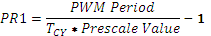 , where T_{CY} is the period of the syncing clock, which for our case is Timer1.

In order to avoid burning out heater, we needed to limit the amount of power that we sent to the heater. To do this, we needed to change the lower the duty cycle or extended the PWM period. Once we determine the minimum response time of the AC relays, we calculated the PR1 using the equation above and multiply this value by 1000. This allowed us to capture 1000 periods of the 60 Hz sine wave and classify it as a single period for our purposes. Then, we set the duty cycle from 0 to 100%, with intervals of .1%. This allowed us to use 0 to 1000 periods, with increments of 1 period. By setting the duty cycle to .1%, we are including just one period of the sine wave, limiting the power that is sent to the heater. The same approach can be applied for the DC relays and allowed us to control DC power at .1% intervals. The administrators at Infrared Systems Development were able to set the maximum percent power which was then be translated to a duty cycle value that was written to OC1R and OC1RS. The formula for calculating the value of OC1RS and OC1R is shown below, where the minimum response time refers to the minimum response time of the relay. .

Smoothing the Display - Due to the characteristics of the blackbody heat source and thermocouples, the perceived temperature tends to fluctuate when viewing it one digit of precision. To reduce this flickering, our temperature controller must be able to smooth the data by extending the time constant. To make the concept more intuitive, we implemented the time constant by determine the number of desired samples before updating the screen. By increasing the number of samples we are extend the time constant which allows to smooth the display temperature. Our program maintained three different values to implement this smoothing. The first parameter is the number of samples before updating. The second parameter is the current sum of the temperatures. The final parameter is the number of our current sample, which ranges from 1 to number of samples. Once the final parameter and first parameter equal, the program took the average temperature and update the display.

Calculating Planck’s Law - Another feature that we need to implement in our temperature controller is the calculation of the blackbody radiations using Planck’s Law. Since the user wanted to determine the radiation given a certain wavelength interval, we used Planck’s law with respect to wavelength. The equation is listed below.
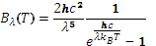 where T is the temperature of the black body, is the Boltzmann constant, h is the Planck constant, is the wave length and c is the speed of light.

To calculate the blackbody radiation, we integrated the curve that is defined with the equation above. Since C does not have an integral library, we need to use alternative methods to accurately calculate the integral. Since the B(T) is parabolic, we can accurately approximate the integral using Simpson’s 1/3 rule. Alternative methods like the trapezoidal rule would return higher errors. Since the accuracy and complexity of Simpson’s 1/3 rule increases with more intervals, we needed to determine the point where the additional accuracy is not worth the additional memory requirements. Once the user defines the upper and lower wavelength bounds, our temperature controller continued to refresh the blackbody radiation as the temperature changes.

Communicating with Peripherals

This section discusses how we are going to send data to and receive data from the PIC32MX150F128B to the various peripherals that we are communicating with.

Preventing Haphazard Writes from Peripheral to Microcontroller - To ensure that the users (non-administrators) do not haphazardly modify the contents of extremely sensitive registers, like the maximum power and maximum temperature, we need to have a byte(s) that are sent to the PIC32MX150F128B before the actual value is sent. This section deals with the computer communication peripherals that reside on our temperature controller. This byte(s) told the microcontroller that the sender is an administrator and was allowed to modify the contents of the register. If this “unlock” byte(s) is not sent, then the PIC32MX150F128B was not modified the contents of the register. To determine if the register is user write protected, we organized registers into groups of eight, numbered 1 through 8. Register 0, that precedes the group, indicated if a particular register is user write protected, with 1 indicating that the register is user write protected and 0 indicating that the register is not user write protected. For example, If Register 0 is 80_{Hex}, then Register 8 is write protected and the Registers 1 through 7 are not write protected. If the register is not user write protected, we would not need to send the “unlock” byte(s) prior to sending the register and new value. The PIC24FJ256DA20 simply performed the desired write action. Another issue that our microcontroller must handle is writing to a read only register. To tell the PIC24FJ256DA20 which registers are read only, we used the same grouping that is being used to determine if the register is user write protected. The register preceding the grouping and the user write protected register (Register 0) used to determine if the read only. A 1 indicated that the register is read only, and a 0 indicated that the register can be read to and written to.

Communicating with 25AA640A - Microchip’s 25AA640A is a 64 Kbyte (8192x8 bit) EEPROM. To read information from the 25AA640A, we needed to start by setting up the SPI1STAT register and SPI1CON1 register. To do this, we need to first write 0 to SPI1STAT.SPIEN in order to allow us to set SPI1CON1. After doing so, we wrote 07F7_{Hex} to SPI1CON1 and 0000_{Hex} to SPI1CON2. After doing so, we wrote 1 to SPISTAT.SPIEN and we are ready to read values from the 25AA640A. We started by writing 03_{Hex} to the SPI1BUF register. Writing to this register placed the value onto the transmit buffer (SDO). We then wrote the starting address that we want to read. After those values are clocked in, the 25AA640A responded with the 8 bit value that exists at the address. We then waited for an additional 8 clock cycles to get the second 8 bit word. To write information we had to use the same setup procedure as reading. After the CON1, CON2, and STAT registers are set, we then wrote 06_{Hex} to SPI1BUF, then set CE to high. This enabled the 25AA640A to be written to. Then, we set CE to low then write 02_{Hex} to SPIBUF, then the 16-bit address, and the word that we want to write to the address. Since the 25AA640A is 8 bits wide, we wrote to the address and the following address. As mentioned in the Microcontroller Design section, we formed data into groups of eight, with two bytes that indicate the read only status and user write protected status of the data. So we needed to use a unique addressing scheme that ensured that we are able to determine the location of the correct read only status and user write protected status register that is associated with the correct group. We used the following formulas to determine the block that a particular register belongs to and the location of the read only status register and the user write protect status register. Block numbers went from 1 to 455.

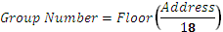

When we want to write information, we needed to first check the Read Only Status to see if we are allowed to perform the write action. After that, we looked at the User Write Protect Status register and determine if the appropriate “unlock” byte(s) is required and if it has been sent. If both tests pass, then we are able to write to the particular memory address and we proceeded with writing the value to the address. If we are reading values from the 25AA640A, we did not have to look at the Read Only Status register or the User Write Protect Status register. To utilize the 25AA640A with our 16-bit microcontroller, we hadto shift the eight bytes into its correct position. To do this, we multiplied the first eight bytes by 1 and then the second byte by 255 to shift it into the upper byte.

Communicating with Ethernet - To communicate with the ENC28J60 using SPI, we need to start by setting up some of the parameters of the interface. It only supports SPI mode 0,0 , SCK must be Idle in a low state, selectable clock polarity is not supported, data is sent to it on the SI line on the rising edge of SCK, data is sent on the falling edge of SCK and the CS must remain low during the entire operation. On the PIC32MX150F128B, we had the opposite; since SI on a slave device is SDO on the master and SO on a slave device is SDI on the master. So we want the data to be clocked out on the rising edge and data to be clocked in on the failing edge. To do this, we set SPI1STAT.SPIEN to low and then write 06BF_{Hex} and 0000_{Hex} to SPI1CON1 and SPI1CON2, respectively. After setting up the SPICON1 and SPI1CON2, we set SPI1STAT.SPIEN to high to enable the SPI line. Since the ENC28J60 stores information on the read buffer memory, we used RBM Opcode to obtain this information. To do this we wrote 3A_{Hex} to the SPI1BUF. The following bytes on SPIBUF were the data residing on the buffer. To write information to the buffer memory, we had to ensure that the SPI1CON1 and SPI1CON2 are set like we had to read the buffer memory. We then wrote 7A_{Hex} to the SPI1BUF. After writing that, the next N bytes was written to the buffer memory.

To test if the Ethernet port is operating correctly, we wrote a certain string to the buffer memory. The ENC28J60 transmitted the data to the host computer. The computer recognized that the string is a test string and echoed it back to the PIC32MX150F128B. We then checked to see if the same string is received. If the process times out or the string is not the same, we knew that the Ethernet controller is malfunctioning. We notified the user that the ENC28J60 is not working.

Communicating with RS-232/IEEE-488 - Since we converted the IEEE-488 to RS-232, our temperature controller needs to handle the RS-232 signals. As mentioned in the microcontroller design portion, we used the MAX232 to convert the RS-232 signals so we can handle them in the PIC32MX150F128B. Since we are not going to use the CTS and RTS lines, we needed to ensure that we configure the UART lines to reflect that we are only going to be using three lines. To configure the UART to our desired settings, we wrote 8890_{Hex} to the U1MODE register. This enabled the UART pins, turn off flow control, use the U1TX and U2RX I/O pins, enable the U1TX and U1RX pins, disable Loopback mode, sett Idle state to 0, set the data format to 8-bit, no parity, two stop bits, and have low speed baud rate. Since our transmission is going to be around 19200 baud, we do not need to have high speed transmission. If we want to enable high speed transmission, we would have to write 8898_{Hex} to the U1MODE register. To set the baud rate, we need write a certain value to the U1BRG register. There are different values depending on if we enable high speed or low speed transmission. We are using the PIC32MX150F128B’s internal oscillator of 8 MHz to calculate the baud rate.

 | BRGH = 0 (Low Speed) |  | BRGH = 1 (High Speed)
Baud Rate | U1BRG Value |  | U1BRG Value
110 | 4544_{Decimal} |  | 18181_{Decimal}
300 | 1666_{Decimal} |  | 6666_{Decimal}
1200 | 416_{Decimal} |  | 1666_{Decimal}
2400 | 207_{Decimal} |  | 832_{Decimal}
9600 | 51_{Decimal} |  | 207_{Decimal}
19.2K | 25_{Decimal} |  | 103_{Decimal}
38.4K | 12_{Decimal} |  | 51_{Decimal}
56K | 8_{Decimal} |  | 35_{Decimal}
115K | Not Possible |  | 16_{Decimal}
Table 6: Setting up the UART Control Lines

As shown above in Table 7, enabling the BRGH bit and permitting high speed mode allowed us to achieve a baud rate of 115K, which is not attainable through the low speed mode (setting BRGH = 0).
To test if the IEEE-488/RS-232 are operating correctly, we sent certain string to the computer that notify the computer that we are requesting it to echo the same message back. After the PIC32MX150F128B sends out the string, we looked at the response from the computer. If we timeout or we do not receive the same string that was sent, then we knew that the IEE-488/RS-232 is not operating correctly. An appropriate message was displayed if this error is found.

Communicating with the Display - To communicate with the NHD-4.3-480272MF-ATXI#-T-1, used a 24-bit parallel RGB (8:8:8) interface. As mentioned in the microcontroller section, used GB0-GB15 (RGB 5:6:5) with some modifications. We also needed to a clock input of at least 5 MHz and a hardware sync pulse that goes low then high for the duration of the data transmission. To do this, we needed to start by setting the SPI1CLK to transmit at 8 MHz. To do this we needed to start by setting SPI1STAT.SPIEN to 0. This allowed us to configure the SPI1CON1 and SPI1CON2. We sent 00001XXXXXX11111 to SPI1CON1, with Xs are used for Don’t Cares. SPI1CON2 was written with 0000_{Hex}. After doing so, we set SPI1STAT.SPIEN to high. In SPICON1, we use SDO as a general I/O port. This was plugged into the HSYNC pin on the New Haven Display. To begin writing the values in the R, G, and B bus, we need to have HSYNC go high then low. We started by setting SDO pin to low, then setting the SDO pin to high. This told the driver to read in the data on the R, G, and B data buses. To control the backlight, we used the PWM1 line. Modifying the duty cycle allowed us to control the brightness of the backlight. We allowed the user to modify the duty cycle by writing the value to the OC1RS and OC1R registers. We needed to wait a clock cycle for the changes to take effect.

Communicating with the Touch Controller - To communicate with the Texas Instruments TSC2046, we used SPI. As displayed in Table 8, in the TSC2046, data is clocked in on the rising edge and data is clocked out at the trailing edge. So we needed to set the SPICON1.CKE = 1 and SPICON1.CKP = 0. After doing that, we are ready to transmit to the TSC2046. To start, we need to send a control byte. Bits 6-4 determine what value we want to read from the display. Assuming that we are in differential reference mode, SER/DFR NOT (Bit 2) = 0, bits 6-4 equals 001 for Y position, 011 for Z₁ position, 100 for Z₂ position, and 101 for X position. We need to set Bit 3 to 0 in order to allow 12-bit resolution. Bits 1-0 was set to 11 which allowed the device, reference, and ADC to be powered on. After passing in the control byte, the TSC2046 responded with the value that we are requesting. Since we needed the X position, Y position, Z₁ position, and Z₂ position to determine the actual location of the press, we allocated four 16 bit registers to store the values until we are ready to calculate them. We needed to send four control bytes in order to get all of our desired information. Table 8 summarizes the four different commands that we sent to the TSC2046.

Control Bytes | Value Returned
10010011 | Y position, with 12 bits of resolution
10110011 | Z₁ position, with 12 bits of resolution
11000011 | Z₂ position, with 12 bits of resolution
11010011 | X position, with 12 bits of resolution
Table 7: Control Bytes to Interface with the TSC2046

Communicating with the Slave Device - Another requirement for our temperature controller is the ability to communicate with an additional peripheral device that is developed by Infrared Systems Development. Specifically, we needed to control and display information from a chopper controller. This includes the current chopper speed and the ability to modify the chopper speed from our temperature controller. The specific command structure to communicate with the peripherals will be determined at a later date.

Determining Abnormal Operation

Our temperature controller must be able to determine if there are any malfunctioning sensors and devices when we power on the device and when we are using the device. In particular, we must be wary of malfunctioning temperature sensors and malfunctioning heating/cooling unit.

Malfunctioning Temperature Sensors - When the temperature sensors on our blackbody source are malfunctioning, we would not be able to determine the actual temperature and may take actions that are extremely harmful to the blackbody. For example, the blackbody may be at 1200.0°C but we are reading a value -30.0°C. Our temperature controller sent the maximum power to correct this error, which may burn out the heater inside the blackbody. When the sensors do malfunction, the temperature controller read values at the two extremes (the minimum readable temperature (<<0.0°C) and the maximum readable temperature (>>1200.0°C). Since we know this, we can monitor the temperature readings and alert the user that the temperature sensors are malfunctioning. After displaying the error message, the temperature controller needs to disable the output power to avoid any damage to the heater. We stored the two threshold values within our data EEPROM and modified the values depending on the blackbody source that is associated with the temperature controller.

Malfunctioning Heating/Cooling Unit - When the heating unit within a blackbody source malfunctions, we were not be able to maintain the current temperature set point and the temperature either rose or fell to ambient over time, depending on the current blackbody temperature. Since the blackbody begins to deviate and the error term increases, the temperature controller responded by increasing the power that is being sent to the heater/cooler. This additional power does not result in the reduction of the error term. Instead, the error term increases over time. Since we know the characteristics of this error, we were able to detect it and take appropriate actions. To detect a malfunctioning heating/cooling unit, we observed the response of the heater when the power being sent to the heater approaches the maximum value. We used the temperature readings that are going to smooth out the display temperature to determine if the blackbody is responding appropriately to the stimulus. If after an appropriate time/sampling window and the error term between the set point temperature and blackbody temperature does not improve, then we can assume that the heating/cooling unit has malfunctioned. Our temperature controller displayed an error message conveying this information. Also, it turned off the power that is being sent to the blackbody. These time/sampling window was stored within the Data EEPROM and can be modified depending on the characteristics of the blackbody source.

Minimizing the Write/Erase Cycles on Data EEPROM - Since the data EEPROM has a minimum number of write/erase cycles before the unit fails, we had to take preventative measures to minimize unnecessary write and erases. To do this, we started by loading the values in the EEPROM into the SRAM on startup. Once the values are loaded into the SRAM, we modified the values in SRAM instead of the ones in the EEPROM. This allowed us to maintain the same capabilities when using the SRAM as when we use the EEPROM. Since we are using SPI to communicate with the 25AA640A, we are going to have lower read/write speeds then communicating with the SRAM that is onboard the PIC32MX150F128B. Since we are modifying all of the values within the SRAM, any changes are going to be lost once the microcontroller powers down. We needed to determine a methodology that allowed us to preserve these changes while minimizing the unnecessary read and write cycles. One approach was prompting the user to save the changes made to a particular value. These values were essential the operation of the temperature controller and must be preserved if the temperature is lost. The current set point and offset values are examples of these essential parameters. To implement this in the PIC32MX150F128B, we could have a byte reserved for the 8 byte data group that indicated if the value is essential and must be saved to the EEPROM. This gave us flexibility because we would be able to remove and/or add this feature to other important values. We could also hardcode this distinction in our program memory. This saved space on our data EEPROM, but we would not be able to modify these values unless we re-burn the microcontroller. In a typical day, the user may modify the set point, alarm parameters, and other essential values around two to three dozen times; the external EEPROM has a mean time before failure at around 76 years, assuming that we are able to write/erase one million times. This method did not allow us to save all of the values on the SRAM like the current PID parameters, so our performance may be reduced. Another approach to lower the number of write/erase cycles is only write values to the EEPROM before power is shut off from the microcontroller. When the user turns off the temperature controller, power was maintained to the microcontroller so it can write the values to the EEPROM. We used one of the general I/O ports that are available on the PIC32MX150F128B to determine if and when power is shut off from the temperature controller. Once this flag is set, we know that power has been shut off and we had to write the values that are residing on the SRAM onto EEPROM. This allowed to save all of the values from the SRAM onto the EEPROM since we made the save once and only once per power cycle. If we assume the user turned off the controller each day, the 25AA640A would be able to last 2740/(number of values to write) years. If we want to maintain the same lifecycle as the first method, we would be able to write twenty different values to the EEPROM which is significantly more than what is allowed by the first method. We would have to implement additional circuitry that ensured that power is being maintained to the microcontroller when power is unintentionally shut off. A third approach would be to use an additional EEPROM chip that would be responsible of storing the values that the user decides to save. This method was similar to the first one, but instead of constantly writing and erasing from the main data EEPROM, we did that to the second one. On startup, we wrote the values that are currently being stored on the secondary EEPROM on the primary one. This effectively lowered the stress we place on the main EEPROM. This method was able to increase the longevity of the main data EEPROM, at the cost of the secondary EEPROM. Once the secondary one exceeds its write/erase life cycle, we switched to use the primary EEPROM in the method descried in the first method.

Calibration

Overview

Due to the sensitivity of the temperature sensing equipment to external noise, with 6 µV to 12µV contributing to a .1°C difference between two temperatures, a set of offsets was used to mitigate the variability with our temperature sensor subsystem. These offsets must be calculated by comparing the display temperature with the actual temperature of the blackbody source. The calibration process will define the meaning of Offsets and describe the calibration process.

Offsets

Offsets are the realized difference between the displayed temperature and the actual temperature. The actual temperature was determined using an external thermocouple and other equipment. This measurement equipment was calibrated on an annual basis, using standards outlined by Infrared Systems Development.

The temperature controller must regulate the temperature of the blackbody source between 25.0°C to 1400.0°C. If each displayed temperature had an associated offset, the controller would have to store 13,750 different points. This would result in accurate readings for the entire temperature range, but would be extremely cumbersome to calculate all the offsets and would take an excessive amount of memory within our microcontroller. Thus, we must determine an offset count that allowed for high measurement accuracy while being plausible in its hardware implementation and calibration process. Since most blackbodies operate close to its upper temperature limit, the temperature readings in this range must be accurate and well within the required specifications. Thus, a majority of the offset points was concentrated towards the upper end of the temperature range. A sufficient number of points must exist in the lower range to prevent large discrepancies at lower temperatures. A curve fitting technique was used to determine the offset value for points in between the particular offset points, so an additional point must exist below the minimum allowable temperature and above the maximum allowable temperature. This allowed the curve fitting algorithm to work at all temperature ranges. The offset point should be placed 1°C away from the desired temperature. This prevented the temperature at a common set point, like 800.0°C, from constantly switching between two different curves.

The temperature controller had seventeen offset points. Depending on the type of blackbody, the positions of the offset points changed. For cavity blackbodies, which have a high upper limit, ten points was evenly distributed from 800.0°C to the upper limit of the blackbody. The remaining points was dispersed as follows. The remaining points was at 10.0°C, 51.0°C, 101.1°C, 201.0°C, 401.0°C, and 601.0°C, and the upper temperature limit plus 1°C. For extended area blackbodies, which have a low upper limit, the seventeen points was evenly distributed between the upper and lower limits, with two points falling outside the range.

Because we are not including an offset an every temperature reading, we must calculate the offset at a given temperature by interpolating between two given offset points. Since we have several offset points in between the temperature range of the blackbody source, we can simply use linearly interpolate the offset value that is found between the two closest offset values. The other offset points were not having a weighting when calculating the particular offset value. The values of the offsets fell between 100.0°C and 100.0°C. The offset points, temperatures that are linked with the offset value, can vary depending on the blackbody source. The formula that was used to calculate the offset values is given by:
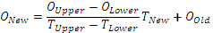

O_{New}=Offset Value at T_{New}, O_{Upper}=Upper Offset Value at T_{Upper},
O_{Lower}=Lower Offset Value at T_{Lower}, T_{New}=Current Temperature,
T_{Upper}=Temperature of Upper Offset, T_{Lower}=Temperature of Lower Offset

Calibration Process

The calibration process tuned the offsets that are found in the temperature controller in order to remove the variability in the temperature measurement equipment. To calibrate the temperature controller, we need to compare the displayed temperature with the actual temperature of the blackbody. To measure the actual temperature, an external thermocouple is read by a multimeter. This thermocouple is set in parallel with the internal thermocouple that is used by the temperature controller, and any difference in mV readings should be insignificant. In order to obtain useful data from the external thermocouple, one end must be connected with a probe that is inserted into a 0°C. The millivolt reading was now show the difference between the two temperature sources, the blackbody and the 0°C ice bath. Since we know the temperature of the ice bath is 0°C, the reading corresponded to the temperature of blackbody. The calibration of the ice bath probe is handled by Infrared Systems Development.

The process begins by setting the set point of the temperature controller to one degree lower than the corresponding offset value. For example, when calibrating the 51.0°C offset point, the set point was set to 50.0°C. The blackbody must reach stability before any changes are made to the particular offset point. Stability is defined as the blackbody's temperature changing at most by a predefined threshold during a sampling window, with the average temperature in a sampling window equal to the set point and the highest and lowest value obtained in the sampling window differing at most by a predefined range. The sampling window, magnitude of the highest and lowest temperature reading, and the number of temperature fluctuations, was defined by the technician that is calibrating the temperature. Typical values for the parameters are a sampling window of thirty seconds, temperature difference of .1°C, and one allowable temperature change. Once stability has been reached, the offset value can be altered so that the display temperature matched the external temperature reading. After modifying the offset value, the blackbody needs to regain stability. When that occurs, the display temperature and external temperature should match. If they do not, the offset value is altered again, and the steps are repeated until the two temperatures match. When changing offset points or values, the controller must check that no invalid entries are made. This includes going out of the allowable temperature ranges for either the offset points or offset values. Also, it needs to check that two offset points do not conflict. This means that two offset points cannot have the same temperature and a lower offset point cannot exceed the higher offset point. If the second case occurs, the next offset point would be raised to the lower offset point plus .1°C. This process continues until all offset values have been determined.

Calibration needs to be able to be done manually and automatically. The manual portion was handled by an employee of Infrared Systems Development. No other user may have access to the offset points and values. Thus, these features must be locked out, until the locks are cleared by an employee at Infrared Systems. To lockout the controller, we were using an alphanumeric password that is defined by Infrared Systems. Also, the offset values must be readily accessible and easily modified when the locks have been removed. The controller must be able to be calibrated by an existing calibration tool developed by Infrared Systems Development. This tool was written in LabView and utilizes the serial port to modify the offset values. In order for this to be possible, the controller must interpret serial commands that changed the set point and modify the offset values accordingly. Only employees and Infrared Systems may have access to these commands to avoid other users for tampering with the calibration parameters. By preventing any tampering, we ensured that the calibration was kept intact and no outside influences made the high precision temperature controller behave in an abnormal way.

PID

Overview

As previously stated we are working on making a High Precision Temperature Controller; this section covered the control process this device used to normalize the temperature. There are a lot of ways to go about this route, but for our specific needs we have decided to use a closed-loop controller that uses, and is named after, the Proportional, Integral, and Derivative (PID) algorithm.

Our goal is to regulate temperature so that the oscillations diminish quickly as a constant temperature is reached. A common example to explain this phenomenon is with the temperature of water. When preparing a bath you do not want the water to get too hot or too cold. Initially you turn up the heat, but come back and realize it is too hot so the nozzle is then set to cold. This process continues back and forth, hot and cold. While switching back and forth would work to reach the ideal temperature, the drastic changes cause more time to elapse before settling upon the desired warmth because it takes time for the cold to adjust to the hot already there and vice versa. The role of the PID algorithm is to eliminate some of those oscillations and achieve the necessary temperature in a more efficient manner. Instead of jumping to such extreme temperature ranges the algorithm transforms the hot and cold ranges to be smaller and smaller distances from the desired temperature, which effectively means the error is gradually eliminated.

Requirements

While this control algorithm alone is commonly used for its efficiency, adaptations of it can lead to better performance. For the specific instance of increased effectiveness, we are going to create our controller such that algorithm runs in consecutive loops. Through this it is meant that we plan on running two cycles within the closed-loop control system in hopes that each time more and more noise can be eliminated. In order for the control loop to work correctly it is important that specific parameters are set correctly, if not the system can become increasingly instable. Furthermore, since this algorithm is being implemented for a mechanical device it needs to account for certain adaptations to avoid problems, such as termination of the loop within the dead band.
To make sure this algorithm worked for our design each stage is broken down such that the step by step process can be viewed graphically. As the process progresses some of the aforementioned requirements were implemented to see their impact on the controller. It is believed that these new adaptations of the algorithm helped the controller run a bit more smoothly. Through step by step testing we can make sure the algorithm is implemented correctly, and have a graphical display of what is occurring in the device.

Breakdown

As visible in Figure 16, the input and the present temperature are put together before entering in the individual PID sections. Once the three steps of the PID are found, they are summed together and moved into the plant. The plant is comprised of the devices within the controller such as a multiplexer, amplifier, AD converters and sensors. The signals of these devices are used to create the output transfer function and the transfer function within the plant. Unfortunately without the knowledge or the ability to physically test each of these devices it is rather difficult to devise their individual transfer function which leaves us currently devoid of information to implement into the paper at this time.

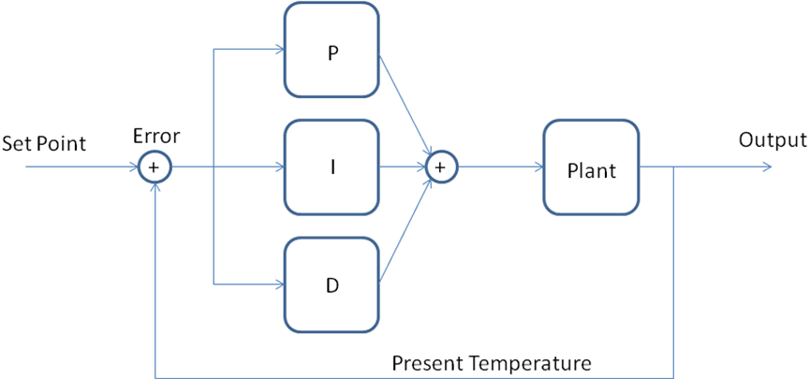
Figure 3: A basic block diagram of PID Controller

Fortunately, there is alternative solution to ameliorate this issue but to still provide some useful and applicable data for the purpose of this paper. The client has given us some data of temperature ranges and their settings along with some set points that are currently used. From here we can back track to find the gain of the current controller which may help us later on once the transfer function is known. With that being said, the old controller and the one we are making are not the same so these values most likely changed through implementation once the actual function transfer function for the plant is found. Meanwhile a generic transfer function was used to show the step by step implications of tuning and interaction by having the parts added together from P, to PI, and finally to PID. This too left us with an idea what to expect when we get our final transfer function.

Error

Before starting with the individual components, it is important to understand the center that this whole controller revolves around, the error. To no surprise very rarely do things work out exactly as planned the first time around, often it takes some work to get there. Equation 1 dictates how the error within the system is determined:

(1)

In which is the error in respect to the instantaneous time, is the Set Point which is the desired temperature for the controller. The set point is placed by the user before running the device, when testing the PID we used 100 degrees Celsius and 1000 degrees Celsius for our two example set points. The other variable is the Present Temperature the device is actually at as sensed through a type S thermocouple. With this equation, we can find the difference to determine just how far off the temperature is and so that the controller can assist in fixing it accordingly. Another form of error calculations is sometimes used in the instance of multiple loops such as those in parallel, serial or the Cascade model itself. This practice and procedure mentioned in depth later on when the different versions of PID are discussed.

Determining the Gain

Another few variables that appeared throughout the next three sections outlining the PID algorithm are the gain of each term. While each part had its own respective gain, the gain of one is dependent on the gain of another. The gains combined are described as tuning parameters. In order to perform any tests and show any examples it is first important to determine what the gain is for each individual part. This way, when the variable is mentioned it is clear where the constant we are using for it came from. First we must look at the transfer function of the PID controller in its simplest forms in terms of its parameters. Where, is the proportional gain, is the integral gain, and is the derivative gain as seen in Equation 2.

(2)

In respect to understanding their overall impact, we resorted to them in their or terms. This information provides the steps we took in determining the gains once our transfer function is found. Each of these gains has their own respective impacts upon the system’s attributes such as rise time, overshoot, settling time, and the steady state error. In Table 9 this idea is broken down further to see what exactly each happens if either of these attributes is altered and thus helps in gaining an understanding of how they are determined. As seen, the proportional gain has minimal impact on the settling time, just as the derivative gain has minimal impact on the rise time and the steady-state error.

Gain | Rise Time | Overshoot | Settling Time | S-S Error
 | Decrease | Increase | Minimal | Decrease
 | Decrease | Increase | Increase | Eliminate
 | Minimal | Decrease | Decrease | Minimal
Table 8: The gain's impact on the system

It is already known that one major goal for a PID controller is to diminish if not eliminate error, thus from looking at Table 10 it is important to see which gain variable can help in that plight. When evaluating what impact might have, once again reference Table 9 and look at that row. It is clear that the influence it has on overshoot and the settling time did not help all that much; however it does decrease the rise time which is the main aspect it was used for. The reason it is not used for the steady state error, is that while it decreases the error, can eliminate it completely. As a result, was far more useful if it is used for the steady-state error than. The last gain we are looking at is that of the derivative. Since we have already covered the rise time and the steady-state error, this leaves the overshoot and the settling time, both of which can conveniently be decreased through using

Now that is known what each variable does and their influence on the system the process of how we set them once we can derive the transfer function of the plant can begin. To initiate tuning the controller all of the gains were set to zero, since it is known that as increases the over shoot increases it was then be slowly incremented in respect to the plant’s transfer function until the output starts to overshoot. From here can be increased until the overshoot begins to diminish. Finally is then adjusted until the error is eliminated, and thus equals zero.

The above mentioned method of trial and error through manual tests is a great way to assure stability, yet there is another way that is a lot faster in computation but does not always prove to be as stable. This method for tuning begins in a similar fashion, but has a far more direct path in determining the other gains once the proportional gain is found, this method is known as the Ziegler-Nichols method. The first step, as before, is the have the proportional gain set to zero; however, this time the gain is increased until it reaches its optimum point which is a new variable that is then plugged into two equations to form and As a result of so much weight relaying on this ultimate gain, if it is off then both of the other parameters are off as well. If the parameters are set incorrectly the system remained unstable, and the outputs provided a plethora of oscillations that eventually lead to an incorrect divergence if any at all. Should this occur, it is nearly impossible to have your controller correctly set since the output produced is incorrect. Thus for our efforts we can use this method to get us approximate gains, and then plug them into the manual method to see how the work and adjust as need be before the final implementation of the device. This way we are not grasping at straws trying to adjust the parameters, but have a guideline that gives us an idea of where to start.

In the last part of Equation 2 some new variables are introduced, these are the integral time constant, and the derivative time constant. The former is derived from the proportional gain divided by the integral gain, and the latter is formed from the derivative gain divided by the proportional gain. Once we can find the proper transfer function of our plant, these values were determined for a series of sets. This way if the user has the device at a specific temperature range, the tuning parameters are automatically adjusted accordingly. For our device there were five different sets of temperature ranges, each with their own respective set coefficients. In Table 10 five examples are given based off the clients’ previous sets. While these values were not the same in our device since the overall PID hybrid used were different, these temperature ranges for the five sets, which consisted of the data in the first four rows, remained the same. Table 10 demonstrates how different, or similar, the various variables are despite the change in temperature and another aspect of our device that relays on these gains along with displayed in the last two rows how the settings resulted in the gains for the Type A equation. Through the user interface on the touch screen the client was able to choose any one of the five sets so that that the gain for that temperature range is fixed before and adjusted more specifically to that range before beginning the control loop.

Temp Range in degrees C | 0-150 | 150-390 | 390-690 | 690-890 | 890-Max
(in Degress C) | 17.8 | 17.8 | 17.8 | 17.8 | 17.8
/min | 0.3 | 0.3 | 0.3 | 0.3 | 0.3
(min) | 1 | 1 | 1 | 0.8 | 0.6
 | 59.33 | 59.33 | 59.33 | 59.33 | 59.33
 | 17.8 | 17.8 | 17.8 | 14.24 | 14.24
Table 9: Five sets of Data Sets Available through the User Interface

Even if the exact transfer function were known and a theoretical understanding of what should happen, without some sort of reference there is no true way to say if the results of tuning the device or what is happening is actually correct. Thus for the purpose of this paper and to gain an understanding of what our device was actually doing in each stage, a general transfer function was used for reference and examples. Once the overall device is built, and the transfer function is known we knew how to test each stage through MATLAB simulation and what to expect through the PID process. The equation for our general example is in Equation 3:

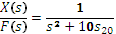 (3)

While the most common Type A form of the PID algorithm is displayed in Equation 4, there are a few other types that we considered using that was mentioned later on. Here you can see where the various gain inputs are placed in relation to the proportional, integral, and derivative functions taking place. Within the next few sections this equation was broken down and explained term by term. To implement each step, the equations and data was executed through MATLAB with the use of the transfer function in Equation 3 to provide us some visual graphics.

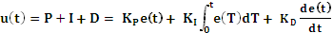 (4)

After it is broken down, a few adaptations and other things to watch out for was also discussed in depth. These too was used the same values so that any modifications to the basic equation can stand out. Hopefully this can provide a deeper understanding to the algorithm itself, along with our implementation of it along with making it clearer what to expect from our final design.

Proportional

The first part of the PID algorithm is the proportional step. As may soon become evident, each element works exactly as their names depicts, and are highly dependent on the error. The resulting output from this step is a value proportional to the error as shown in Equation 5:

(5)

Once again represents the error in respect to time; however, here the error is multiplied by the proportional gain. Since the error is constantly changing, and is the initial part of the equation that is getting finer tuned, it is safe to say that this step is really only making short term corrections. As depicted in Figure 17 and anticipated from Table 10, the proportional gain’s influence leaves the system with quite a bit of overshoot. While the signal eventually plateaus through the rest of the PID process it is believed that such oscillations can be obliterated.

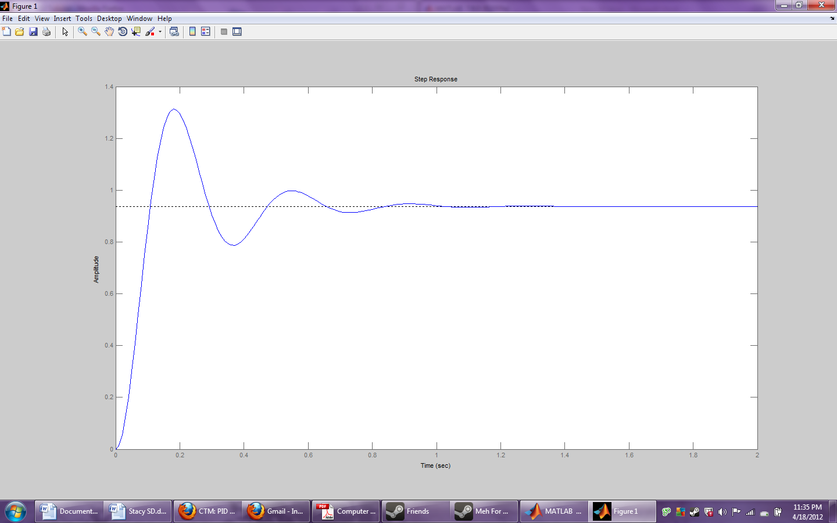
Figure 4: The Proportional response from the general transfer function

Integral

Next we have the integration component, which as the name implies consists of using integration in relation to the time parameters, the gain, and most importantly, the error as seen in Equation 6. This step is known as a manual reset for the equation, and should this manual reset be replaced with an automatic reset, the system may notice some lag. In the instance of lag another variable was added to the final transfer function to account for any dead time. Seeing as our device is sensing through a sensor before going through an amplifier, the chances of there being a time-delay between when the initial step is taken, and when the output is received is great. This is why in our final transfer function; we must include a parameter to account for dead time.

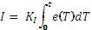 (6)

In Equation 6, remains the error in respect to time that is then integrated from when the device is started up until time t; however, here the integral of the error is multiplied by the integral gain. This step eliminates the steady-state error and thus assists in moving closer to the desired set point. As mentioned in Table 10, the integral gain causes the over shoot to increase. This is a result of the integral being taken of all the errors, not just the present error, but the past errors as well. On the bright side because it is accounting for past and present errors, it assists in adding some long-term precision.

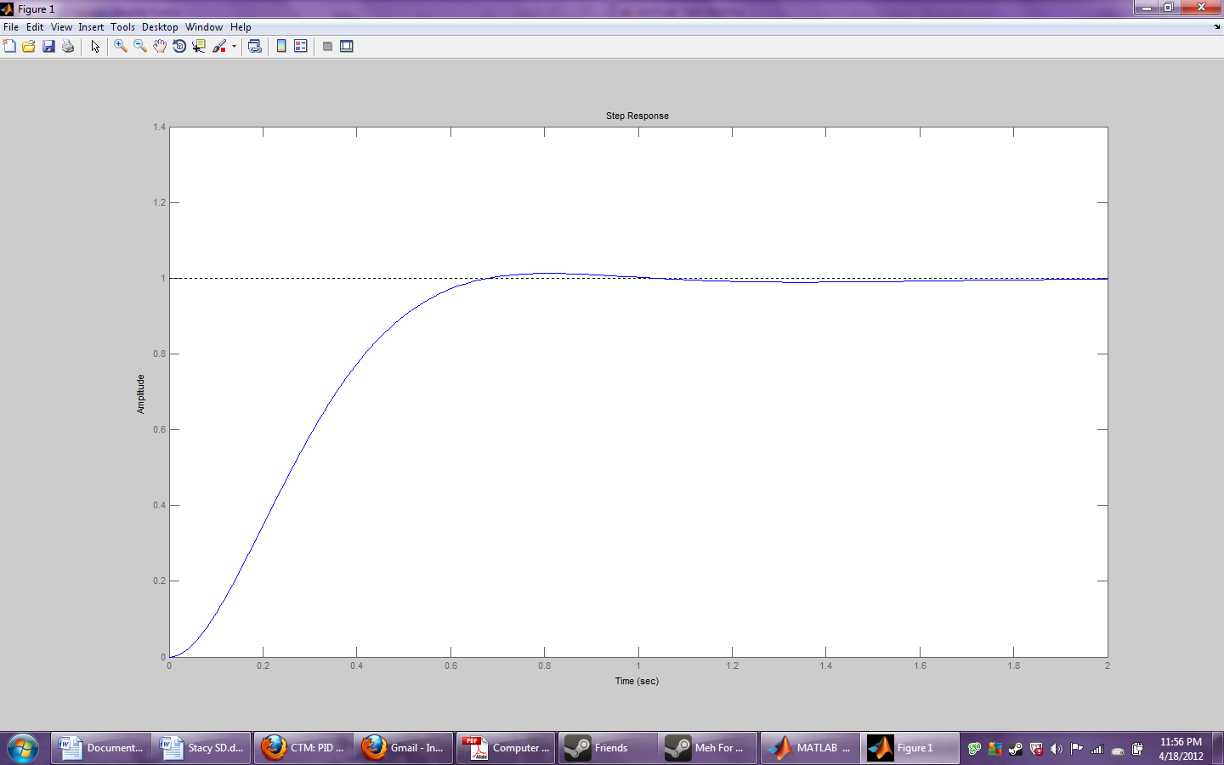
Figure 5: The new signal after influences of the Integral are implemented

As evident in Figure 18, the addition of the integration factor drastically reduced the oscillations that previously existed through properly eliminating the steady-state error. Yet under closer examination along the dotted line, it is evident that the signal is still not exact. At the end of the day our device needs to have accuracy in the hundredths, thus even the one minor oscillation is far too much and needs to be corrected. While in some cases people leave the PI alone and end it here, our device cannot wait that long for a settling time to be reached and needs to be even more exact and thus we continue to work toward the overall PID equation.

Derivative

Finally is the derivative portion of the algorithm, here is where things can get a bit messy, and by messy we mean noisy. In the process of trying to find our rate of change so that the error does not grow exponentially this step often has the issue of introducing noise.

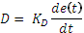 (7)

For Equation 7, the derivative of is taken in respect to time and is multiplied by the derivative gain. As many know, the derivative assists in finding the slope, or the rate of change, of a curve. This instance is no different in that in this instance the derivative is found through finding the slope of the error in respect to time. While it is not visible when looking at Equation 7, it was later more visible that unlike the integral function, that uses all of the error, the derivative function only uses the current error and the previous error. As anticipated and evident in Figure 19, through this process the derivative gain assists in predicting the next term used and decreases the settling time and overshoot of the signal.

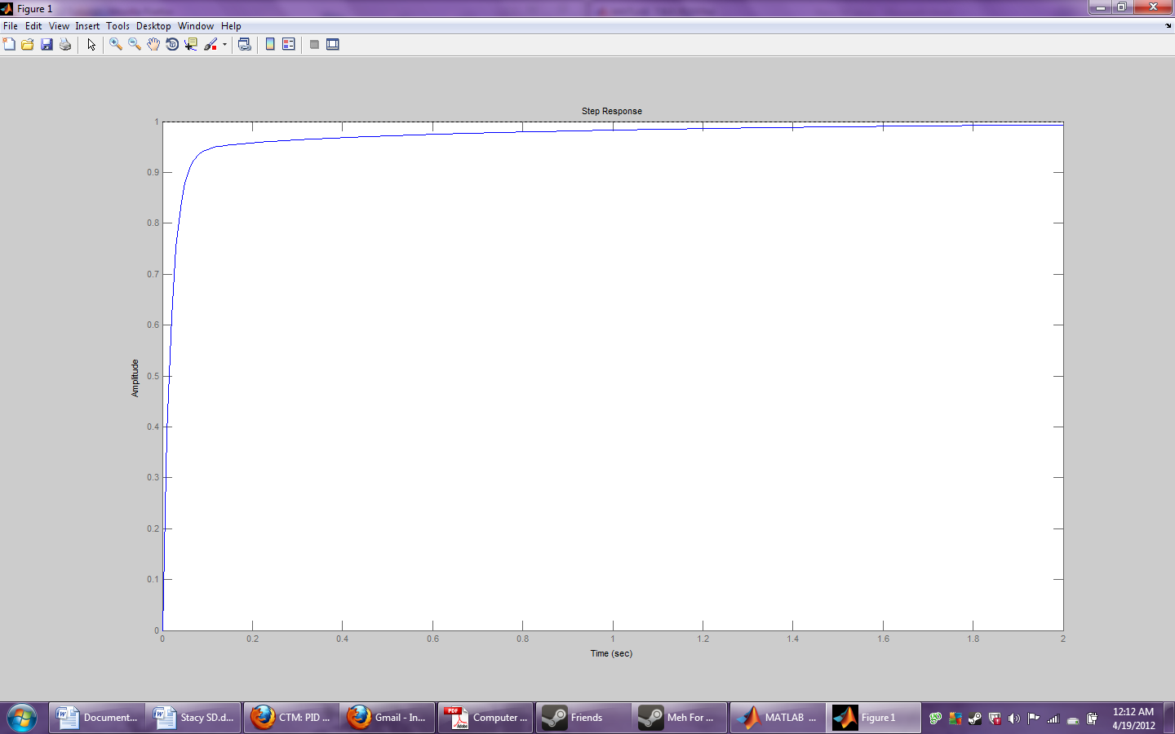
Figure 6: The final signal after going through all three PID processes

Variation

The PID formula takes on many forms, and while the general principle is the same the impact of the error to each portion of the equation often changes. Three common variations are Type A, Type B, and Type C. Meanwhile, other variations of the process include a cascade method or PID with dead band parameters. These latter methods are less differentiated by error, and more so in their form of sampling and overall process.

The first three bring discussed are Type A, Type B, and Type C. Type A, otherwise known as the Textbook PID, and the form used in the above discussion, has the error term impacting all three portions of the equation. This can cause some issues because derivative term is highly dependent on the previous set point and its impact on the error. As a result, if the set point is changed throughout the process this had a negative impact on the controllers output. In attempts to fix this, the set point is removed from the derivative term and this new form is known as Type B. This formula is much like the textbook version, except that the derivative is taken solely of the present temperature value. So instead of the derivative using the previous error and the current error, it uses the previous present temperature and the current present temperature. From here it is considered where else using the set point could cause the controller to become less efficient. Since the initial gain of the system with regards to this paper is being set through a step function the ideal temperature, the proportional gain already relies heavily on the set point. It was then decided to, and in many cases recommended to use the new variation known as Type C. Similar to Type B, the set point is taken away from the derivative term, and unlike Type B it is also taken away from the proportional term. Through this type the only term that still relays on the error is the integral.

After talking to our client it has been determined for the purposes of this project the proportional band needs to know of the error in order for it to determine a linear power. This alone eliminates Type C from contention. Secondly, when discussing the derivative portion of PID it was mention that it used as a predictive measure in that it linearly calculates for future error through the use of present and past error. This process seems a little void if it were only calculated based off of the previous present temperature and the current present temperature, for while it would predict the next present temperature it would not account for the error. If the slope of the error is too great in order to look out for over shoot, and thus making Type B not a useful variation for our purposes. This leaves us with the traditional Type A format and design of the PID equation as the basis of our controller in which any other loops or adaptations will be worked around.

When thinking of a cascade, a person might think of a cascading waterfall or something along the lines of a domino effect in which the result of one process leads to that of another. This theory remains true even in relation to PID. The cascade method uses two loops of PID in which one set point is merely the output of the previous loop. The error is still found in the same way as before, by taking the difference of the present temperature from the set point however each loop has their own independent sensor that reads them this present temperature. The outer loop often referred to as the master or the primary loop has a sensor close to the device that is being tested. In our case, this means that the sensor is located near the thermocouple that is reading the direct temperature from the blackbody source or any other device that is actually running the test. This outer loop should have a period at least four times larger than that of the secondary loop and thus should also have an extremely large C. Meanwhile the sensor in the inner loop also known as the slave or the secondary loop is placed near the controlling energy source. This is done so that outer sensor can determine an accurate temperature of the unit, while inner sensor assists in patrolling the amount of energy that is getting built up. At this stage the settings to make the device get hotter or colder are controlled. Some necessary requirements when setting this process up is that the secondary loop is infinitely faster than the primary loop, and also be able to have influence over the primary loop. These two loops work together in attempt to find a more precise process with less over shoot and the hopeful early elimination of dead time which assists in making the stabilization process much smoother. When attempting to tune this device it is important to start the process as you would a normal run, first begin with the inner loop and set those PID parameters before moving to tuning the PID parameters of the outer loop. This process is used in the high hopes that some of the problems with noise or disturbances can be eliminated or at least reduced in the beginning.

Along the lines of Cascade is feed forward and feedback. While a feedback loop would take our outputs of the system and directly input them into the loop again, the feed forward would take data from disturbances before they actually reach the system. It is almost as if it is solving the systems problems before the controller knows it has any to begin with. To include this implies another sensor and requires knowledge of the plant. Where the above sensors in the Cascade model measure the current temperature and the pent up energy, this sensor would measure the changes in the disturbances. Thus, while the Cascade model has two feedback loops measuring two different aspects of the device, feed forward measures the disturbances and the feedback through one specific feedback loop. There are two forms of feed forward, that of set point feed forward and that of disturbance feed forward, the latter is the typically seen in purposes similar to our own in which the ambient temperature is measured and adjusted accordingly. In order to use this method the system has to me causal. Through determining any disturbances before they actually make it into the system, they microprocessor can attempt to fix, adjust, or avoid them. While this is desirable for our device, the Cascade method would be more specific and efficient since those two loops can be clearly defined.

One other setting similar in theory to dead time that is important to watch out for and that is more commonly used in mechanical devices, such as ours, is the Dead Band. This is typically used in a mechanical device because it used in turning off the output. How this works, is that there exists an area that is essentially dead, in that once within this range nothing happens. In PID, this area is located closely to the set point. This way once the algorithm has gotten to a specific distance from the set point it stops producing an output otherwise once it reaches the set point there could be further complications of the system turning on/off. Should an instance such as this occur, the alarms and relays within our controller went off to alert the user of the situation so that they can choose the next path they would want to take accordingly.

Our System

When designing our system we needed to take into account the various attributes of our High Precision Temperature Controller. For starters, the temperature range of the black body heat source goes from 0°C up to 1200°C, taking at least one hour to heat up and around six hours to cool back down. The typical range needed is in the upper hundreds to thousands, and as a result takes a while to get there. Our device needs to know how much to initially kick on without an extreme overshoot so that the control process can immediately respond and start regulating the amount of power given to the black body heat source. When the temperature overshoots the controller should turn off power so that the heat source can begin to cool down. Conversely when the heat source experiences undershoot the controller should have the power back on. The main goal is to not send too much or two little power so that the black body heat source can reach the desired temperature in an efficient manner with minor oscillations.

Another factor we need to take into account is saturation of the integral component. One of the issues of integral control is that as the power cranks on the proportional, integral, and derivative control winds up except unlike the other two, which go back down rather quickly, the integral control takes a while to get back down to catch up with the other control properties. As a result his component of the temperature control process does not come into play the way it should and takes quite some time before it becomes helpful rather than hindering or rather not assisting in properly controlling the device as desired.

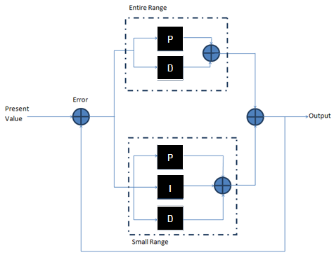
Figure 7: Diagram of Control Process

In the above Figure 20, a block diagram is given of our final design. It is broken up into two loops; the first contains the proportional and derivative control excluding the integral control to avoid the above mentioned issue. This loop encompasses the entire temperature range both above and below the set point. When the actual temperature is within 5% of the desired temperature it then entered the second loop. This control loop contains all three parameters and then eliminated the prospect of the integral control getting wound up more than it can recover from. Should the set point get changed, or the present temperature goes outside of the 5% range it once again returned to the first loop.

Temperature Sensing Subsystem

Overview

The temperature sensing system for our High Precision Temperature Controller for Infrared Systems Development must be able to accurately read temperatures from black body heat sources and send this data to a microcontroller for the information to be processed. This temperature information was then used to maintain or readjust the temperature and the loop kept accepting feedback from this temperature sensing system. The system must constantly update the information in order to monitor the temperature in real time. The data captured from the our sensing devices must be accurate within 0.5 degrees Celsius and have the lowest noise achievable for reliable analog to digital conversions.

The temperature sensing subsystem can be broken up into four main sections: temperature sensing devices, amplification, multiplexing and analog to digital conversions. For the temperature sensing devices section, we considered different types of commercially available sensors and compare their advantages and disadvantages. The devices discussed included resistance temperature devices and thermocouples. For the amplification section, we compared different candidates for the amplification process and determine what sort of gain was needed. Several methods may be used in our final design and the integration of different types of filters, amplifiers and other electronic devices were considered in this section. Several multiplexers were required for our design; two were needed for data selection from our temperature sensors to our analog to digital converters, and one was needed for our microcontroller to select which peripheral it needs to communicate with. In the analog to digital converter section, we discussed the theory of analog to digital conversions and the different methods used in modern day applications. This section may also include attributes of the microcontroller choices we are considering. After processing by the microcontroller, the output of the PID algorithm needed to go back out to the heat source. This was done via a digital-to-analog converter and then a decoder to select control of the fan or heater.

To complete our discussion on the temperature sensing subsystem, we needed to consider the possible configurations of the combined components mentioned above. Each reasonable candidate from our sensing, amplifying, multiplexing and analog to digital converters were theoretically matched up with other candidates and compared in that particular setup. Product longevity was also a factor in our design since the finished controller will eventually become a product that Infrared Systems Development will manufacture and sell. The block diagram below in Figure 22 shows the relationship between components in the temperature sensing subsystem.

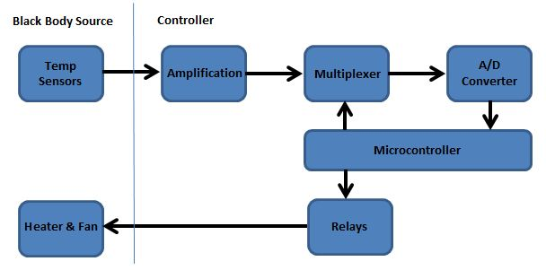
Figure 8: Temperature Sensing Block Diagram

Requirements

The temperature sensing system must be accurate within +/-0.5 degrees Celsius. The input temperature range for the device was -30 to 1400 degrees Celsius and the ambient temperature ranged from 0 to 40 degrees Celsius. Temperature sensing devices must be remotely located from the controller itself but still send real time data back to the microcontroller. The signal amplifiers must produce enough voltage to be recognized by the analog to digital converter but still be accurate to its original state. The multiplexers and decoders must have enough inputs to accommodate all sensors along with reference readings.

Temperature Sensing Devices

Overview

There are two temperature sensing devices currently embedded in Infrared Systems Development’s black body sources. Both devices are of the same time type, whether that be a type S or type T thermocouple. Type S thermocouples are used for sources with upper temperature outputs of above 500 degrees Celsius and type T are used for temperature readings under 500 degrees Celsius. We are considering adding 2 more thermocouples to the sources in different positions than the already existing thermocouples. The logic behind this idea is that if we average the measurements between all 4 thermocouples, we might account for the thermal gradients inside the heat source and gain more reliable data. We needed to gather data from ISDC’s black body sources to determine the gradient inside of their cavity and extended area sources and see if this added measurement were beneficial. Although this is a change in design to the sources themselves, we still needed to account for these improvements in our controller design.

Thermocouples

Thermocouples are the only choice we really have for temperatures readings over 850 degrees Celsius, however we had to compensate for their non-linear responses and vulnerability to electrical noise. There are many different types of thermocouples, with various temperature ranges and accuracies. Type S thermocouples are the only devices that accurately read our upper temperature limits for the extremely high temperature sources without becoming damaged. Infrared Systems Development constructs their own thermocouples in house which they use in their sources; therefore, we used proprietary thermocouple tables to determine the corresponding voltages for every tenth of a degree. Shown below is a plot of the temperature (in degrees Celsius) and output voltage (in milli Volts) for the specific type S thermocouple embedded in ISDC’s high temperature cavity sources. As you can see from the graph in Figure 23, the response of this thermocouple is non-linear but comes close to linearity in the upper temperature range of 1100 to 1400 degrees Celsius.

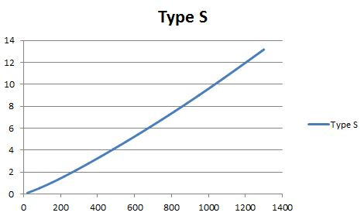
Figure 9: Temperature vs Voltage Plot of Type S Thermocouple

We must be careful to eliminate any sources or error and noise from our sensing system. There are 2 major sources of measurement error in thermocouple wire: de-calibration and unwanted virtual junctions caused by wire insulators. To prevent de-calibration of the thermocouple wire, we must be cautious to not cause a steep temperature gradient in the wire and also take care in handling our wire.

Thermocouple Extension Wire
Since the heat source and the controller were remotely located from each other, we needed to use thermocouple extension wire to connect the two. This also benefited us in the fact that our measurement wires were needed to be bundled in a wire conduit, of which small thermocouple wire cannot withstand. In order to reduce magnetically induced noise, we searched for extension wire that comes in a twisted pair configuration. We needed 2 different types of thermocouple extension wire for type S and type T thermocouples. For type S, we used extension wire made of Copper and a thermocouple alloy #11. These two wires come in a twisted pair and can be insulated with a variety of materials. For type T, we used extension wire made of Copper and Constantan. Again, these two wires come in a twisted pair and can be insulated with a variety of materials. These metals and alloys are specifically chosen to match each thermocouple type in order to prevent creating a thermal junction where they meet; therefore, we did not need to monitor and compensate for the temperature of that junction. As mentioned previously, we need to be aware of un-calibration of the wire by preventing too steep a temperature gradient; which should not be a problem in our system. Also, we need to take into consideration virtual junctions created by insulation. The gauge of these wires can range from 16 to 24 AWG.

Cold Junction Compensation
Cold junction compensation is needed whenever a thermocouple is used to measure temperature. This is because most times, the thermocouple wire is connected to leads of a voltmeter, which is usually made of a different material thus creating another thermal junction. Since we have been careful to find extension wire and connector pins that are the same material of the thermocouple wire, we have not created any thermal junctions. However, we still needed to measure the ambient temperature and subtract this temperature out of the reading from the thermocouple; this is considered cold junction compensation. To monitor the cold junction of our thermocouples, we needed a high precision RTD attached to our cold junction. The output of our RTD will be a change in resistance due to the change in temperature. This change in resistance can be correlated to a temperature value, much like the change in temperature can be related to a voltage for a thermocouple. This resistance-temperature relationship can be found from looking at an RTD lookup table. From here, we needed to look up this temperature in the appropriate thermocouple table. After this is successfully done, we need to correlate this temperature to its correct voltage output needed for the compensation of this cold junction. This can all be realized within the microcontroller, since the EEPROM stored all of our required thermocouple and RTD lookup tables. The final value of cold junction compensation voltage can be subtracted from our readings once all measurements have been sent to the microcontroller, and the true temperature can be found. The method of cold junction compensation can be summarized in the following flow chart in Figure 24.

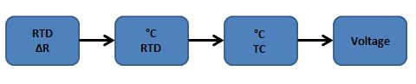
Figure 10: Cold Junction Compensation

Infrared Systems Development uses a 0 degree Celsius ice bath to calibrate their cold junctions. To maintain the reliability of our cold junction compensation, we monitored the change in resistance of our cold junction mounted RTD. Any large, sudden changes in resistance were considered an error and the data measured during that time period were discarded. This also prompted the user that there may be an issue with the device.

Resistive Temperature Detectors

Since our cold junction compensation helps determine the accuracy of our whole system, it would be wise to seek the most accurate measuring device to detect this ambient temperature. Resistive temperature detectors are considered the most accurate and stable temperature sensors because they are predictable and virtually immune to noise.² RTDs made out of Platinum are the most expensive devices, but are also the most accurate. We needed to mount this RTD to our controller, to measure the ambient temperature around the readings. Omega offers a variety of mounting options for Platinum RTDs including cement on and bolt on configurations.

Connectors

Because thermocouple wire is sensitive to what material it encounters, we need to find pins and connectors that would not create a thermal junction. We also needed to make sure that the pins for the male connectors are made for wire gauges from 16 to 24 AWG. We needed to find a connector with a minimum of 8 pins. Since the heater and fan from the source needed to be controlled depending on the output of our PID algorithm, they also needed to be connected through this piece; therefore, we needed the following pins:
- Fan power (+)
- Fan power (-)
- Fan ground
- Heater power (+)
- Heater power (-)
- Heater ground
- Thermocouple 1
- Thermocouple 2

The male connector was attached to a rubber conduit holding the bundle of wires from the source to the controller. A female connector was mounted to the chassis of the controller and therefore needed to be flanged style with mounting holes. Omega offers many types of thermocouple connectors for both type S and type T. They also offer gold plated pins for those connections not needing to correspond with the thermocouple wires, which we would use for the heater, fan and ground.

Amplification

Since the amplitude of the data we are collecting will be in the magnitude of millivolts, we needed some sort of amplification circuit for our analog to digital conversion to be reliable, and for the data to be differentiated from noise by the multiplexers. Because our data is so sensitive, we need to be extra cautious about voltage drift when selecting our amplifiers. Assuming that the temperature of our amplifier will be no greater than 40 degrees Celsius (this is a huge over-estimate) and ambient temperature will be around 25 degrees Celsius, the maximum voltage drift we are willing to afford will be 0.5 micro Volts per degree Celsius. This would produce an induced offset of 7.5 micro Volts which will be our maximum noise via voltage drift. Therefore, we will limit our voltage drift to no more than 0.5 micro Volts per degree Celsius when considering our amplifier candidates. The input offset voltage will also be considered when choosing an amplifier to minimize the amount of error in our amplifying circuit.

We must also be cautious to keep our output in the range of 0 to 5 Volts if we wish our multiplexer to operate on a single +5 Volt supply. From this, we must determine the closed loop gain desired for our amplifier. If we decide to let our maximum output be 4.5 Volts, we must divide by our maximum temperature voltage as given by our thermocouple or RTD tables.

Amplifier Design

For each type of sensor, we used the same model amplifier in order to keep the offset voltage and drift the same for each measurement. This way, after they are fed through the whole system and are ready to be used by the microcontroller, these noise values canceled each other out.

Type S Thermocouple
The maximum temperature voltage for the type S thermocouple already embedded in the high temperature heater is 13.17098 milli Volts; therefore, this would give us a closed loop gain of 4.5V divided by 13.17098 milli Volts which gives us a 341.66 maximum gain. We can now choose resistor values for Rd to equal 300 Ohms and Rf to be 10.2 kilo-Ohms, both of which are commercially available. The configuration described is visible in Figure 25.

Type T Thermocouple
The maximum temperature voltage for the type T thermocouple already embedded in the low temperature heater is 20.87 milli Volts; therefore, this would give us a closed loop gain of 4.5V divided by 20.87 milli Volts which gives us a 215.62 maximum gain. We can now choose resistor values for Rd to equal 300 Ohms and Rf to be 64.4 kilo-Ohms, both of which are commercially available.

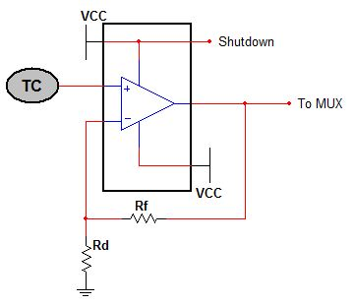
Figure 11: Thermocouple Amplifier Design
Platinum RTD

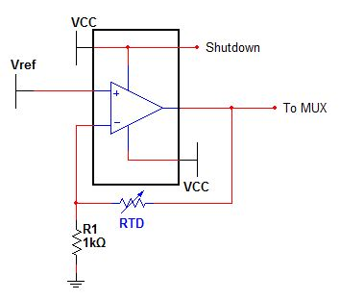
Figure 12: RTD Amplifier Design

The amplifier design in Figure 26 for the RTD is a little more complex than the ones previously mentioned. Because of the nature of an RTD, direct voltage cannot be measured and its temperature correlation is a function of its resistance. Therefore, we used the RTD as the feedback resistor in our circuit. We also needed a reference voltage source going into our non-inverting terminal, of which we also designed based on our desired output. We know the output of our RTD amplifier was

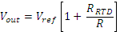

and we know our desired maximum value; which is 4.5V. We can find the maximum RTD resistance via a platinum RTD lookup table; which is 269.35 Ohms. If we choose our resistor to have a value of 10 kilo-Ohms, we can then calculate our needed Vref.

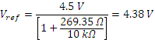

Since the exact value of 4.38 Volts is not commercially available, we looked out for a 4.5 Volt reference voltage. This still kept our output value below 5 Volts. We will discuss reference voltages in another section of this paper.

Candidates

OPA211 – Texas Instruments
This precision operational amplifier is rated for low voltage noise at 1.1 nano Volts per square root Hz at 1 kHz. Although our signal is very close to a DC signal, any noise introduced to our data could alter our data severely. The datasheet for this op amp also boasts that this device is perfect for driving high-precision 24-bit ADCs, which is what we eventually interfaced with. The voltage drift for this device is rated at 0.35 micro Volts per degrees Celsius which would correspond to an induced noise of 5.25 micro Volts. This device also offers a shutdown feature which protects the device from an overage in supply voltage. It shut off in between the rail – 3V and the rail – .35V; therefore, we needed to account for this variance in supply voltage when we consider our power design. The input voltage offset is rated at +/-30 micro Volts typically but has a maximum rating of +/-125 micro Volts. The maximum open loop voltage gain is 130 dB.

TLC2652 – Texas Instruments
This precision amplifier is chopper stabilized as well as having an extremely low offset voltage and voltage drift. The benefits of a chopper stabilized amplifier are that offset and drift compensation is done for us inside the op amp package and that noise is filtered out internally. The chopper stabilization technique is preferred for high precision DC circuits and is ideal for our temperature sensing application. However, with this chopper circuitry, two external capacitors were needed for operation. This op amp is ideal because of its super low voltage drift of 0.003 micro Volts per degrees Celsius and offset voltage of 1 micro Volt. The datasheet gives the large-signal differential voltage amplification which is more accurate than the open loop gain information because it is measured with a load. Its large-signal differential voltage amplification is 150 dB.

LTC2050 – Linear Technology
This amplifier claims to be a zero-drift op amp. The input offset voltage is +/-3 micro Volts maximum and the drift is 0.030 micro Volts per degrees Celsius, but does not use the chopper stabilization technique. This amplifier also has a shutdown feature to protect the device from an overshoot in supply voltage. This feature was useful to us because if a user accidentally changes a setting and ruins the op amp, he/she needed to send the controller to Infrared Systems Development for maintenance. The shutdown option circumvented problems like this.

AD8476 – Analog Devices
The AD8476 is considered a differential op amp, however; this device is more of a signal conditioning device than an operational amplifier. Its input can be in the millivolt range and requires a common mode voltage to center the output difference around. A precision reference voltage can be used as a common mode voltage, and the output of this device was a true differential signal.

Part | Manufacturer | Power Supply | Voltage Drift | Offset Voltage | Price
OPA211 | Texas Instruments | Single, 5 V | 0.35 uV/°C | 125 uV (max) | $5.15
TLC2652 | Texas Instruments | Dual, +/- 5 V | 0.003 uV/°C | 1 uV (max) | $5.85
LTC2050 | Linear Technology | Single, 5 V | 0.030 uV/°C | 3 uV (max) | $2.88
AD8476 | Analog Devices | Single, 5 V | 0.001 uV/°C | 50 uV (max) | $5.24
Table 10: Amplifier Candidates

Because of its true differential output and ease of use, we decided to use the AD8476 by Analog Devices for our amplification system.

Multiplexing

We used 2 multiplexers and 1 decoder in our subsystem. The multiplexers used before the inputs to our 2 analog to digital converters. One multiplexer switched in between sensing devices for the temperature sensing ADC, the other would switch between the cold junction RTD and its reference voltage for the cold junction ADC. The decoder was used to select which SPI peripherals the microcontroller needed to access. The first multiplexer needed to take in inputs of possibly 4 thermocouples. The device made the switch between the 4 thermocouples in order to average their readings in the microcontroller. The decoder was used to save pins on the microcontroller, and be able to send a high signal to any of the chip enable lines for all the peripheral devices. For sake of convenience and what is commercially available, we considered four-to-one multiplexer, a two-to-one multiplexer, and a one-to-eight decoder. The output of the multiplexer would go through some other electronic devices to be determined below and ultimately to an analog to digital converter to be digitized and sent to the microcontroller. Some specifications that need to be discussed before further selection can be made are: input offset, voltage supply and charge injection.

Input offset was an important specification when considering the DC accuracy of our multiplexers and decoders. We needed to find the amount of voltage offset and compare it to our input signal to see how much error will be induced. Input voltage offset has contributing factors of the device’s on-state resistance, drain on-state current leakage, input bias current and source resistance. Our source resistance is unknown, therefore we estimated the input offset assuming a constant source resistance. Since our input signal was no greater than 4.5 Volts, according to our amplification circuit, we did not consider any devices with an offset greater than 0.5 micro-Volts.

The voltage supply is a flexible specification for us since we did have control of the power design. For convenience and power consumption ratings however, let us seek out components that allow us to use a single power supply of 5 Volts.
The charge injection for this device played an important part in deciding what other electronic devices may be needed for this circuit. If the charge injection is very large, we may use a filtering device to filter out any spike in voltage that the switching process will incur. If the charge injection is relatively small, it might be more difficult to spot in our data; therefore, we may use a delay device to time our analog to digital converter to only turn on once this charge injection voltage spike has dissipated and only true data is flowing through. Since we are dealing with relatively small signals, noise ratings are crucial for reliable data and will play a big part in picking a component. We made an effort to choose a multiplexer and decoder with the smallest channel-to-channel crosstalk. Since our measurements will be closer to a DC signal than AC, we will not heavily consider the time delay properties of these devices.

Temperature Sensor Multiplexer

The temperature sensor multiplexer needed to be a 4:1 circuit; each input represents a thermocouple inside the source.

ADG704 – Analog Devices
This device is a 4:1 CMOS analog multiplexer that comes in a small 10 pin, micro SOIC package. It can be powered by a single supply from 1.8 to 5.5 Volts, of which we used the 5 Volt option. At a 5 Volt supply, it is rated to have a rail-to-rail operation. Its on-state resistance is typically 2.5 Ohms and its on-state current leakage is typically 0.01 nano-Amps. Its on-state resistance stays fairly constant over the entire range of analog inputs, with a variation of 0.75 Ohms typically. The typical charge injection is 3 pico-Coulombs and its channel-to-channel crosstalk is -82 dB typically.

MAX4632 – Maxim Integrated Products
This device is a 4:1 CMOS analog multiplexer that comes in a tiny 10 pin, TDFN package. It is capable of running off a single, 5 Volt supply and has a typical on-state resistance of 2.5 Ohms. This on-state resistance stays fairly constant over the entire range of analog inputs, with a variation of 0.75 Ohms typically. The on-state current leakage is typically 0.01 nano-Amps and the charge injection is 2 pico-Coulombs. Its crosstalk is -52 dB. Besides a slight advantage in charge injection and a disadvantage in crosstalk, these two candidates are virtually the same.

Part | Manufacturer | On-State Resistance | Current Leakage | Voltage Supply | Charge Injection | Crosstalk | Price
ADG704 | Analog Devices | 2.5 Ω | 0.01 nA | 5 V | 3 pC | -83 dB | $2.84
MAX4632 | Maxim Integrated Products | 2.5 Ω | 0.01 nA | 5 V | 2 pC | -52 dB | $3.03
Table 11: Temp Sensing Multiplexer Candidates

Because of its lower cost, crosstalk and desired package type, shown in Table 12 we chose the ADG704 by Analog Devices.

Cold Junction Multiplexer

The cold junction multiplexer needed to be a 2:1 circuit; one input will be the RTD amplification circuit output and the other input will be the reference voltage. The options we have narrowed it down to are discussed in Table 13.

74LVC1G53 – NXP Semiconductors
This device is a Si-gate CMOS, analog multiplexer/decoder that comes in a small 8 pin, TSSOP package. It has an on-state resistance of 6.2 Ohms, a large unwanted current leakage of 0.1 micro-Amps and a charge injection of 7.5 pico-Coulombs. The datasheet recommends the device be supplied by a 5.5 Volt supply. The channel-to-channel crosstalk rating is not specified.

AD8180 – Analog Devices
This multiplexer can be supplied by dual supply of +/- 5 Volts and comes in an 8 pin, SOIC package. Its crosstalk is rated at -80 dB and has a rating of total harmonic distortion of -78 dBc, typically. The datasheet specifies and input voltage offset of 1 milli-Volt typically but can have a maximum of 12 milli-Volts, which is huge. This device seems to be commercialized for fast switching speed and not necessarily high DC accuracy.

Part | Manufacturer | On-State  Ω | Current Leakage | Voltage Supply | Charge Injection | X-talk | Price
74LVC1G53 | NXP Semiconductors | 6.2 Ω | 0.1 μA | 5.5 V | 7.5 pC | Unknown | $0.48
AD8180 | Analog Devices | 2.2 MΩ | 1 μA | +/- 5 V | Unknown | -80 dB | $3.84
Table 12: Cold Junction Multiplexer Candidates

Because of its low current leakage, known and acceptable charge injection and ability to be powered by a single supply, we chose the 74LVC1G53 by NXP Semiconductors.

Microcontroller Peripheral Decoder

The microcontroller peripheral decoder needed to be a 1:8 circuit; the peripherals controlled will be the following: Ethernet controller, EEPROM, touch screen driver, two ADCs, and a slave device. This device was connected to the peripheral’s pins and will therefore need an 8-bit inverter in between. There will be 2 extra outputs. Our options are discussed in Table 14.

HEF4051B – NXP Semiconductors
This device contains bidirectional analog switches, allowing it to function as both a multiplexer and decoder. Its supply voltage will need to be dual but is flexible from the range of 3 to 15 Volts. Its on-state resistance is rated typically at 350 Ohms at a +/-5 Volt dual supply but is rated at maximum to be 2500 Ohms. This part has a leakage current of 0.1 micro-Amps. It has a -50 dB crosstalk between switches but does not specify its charge injection. This device comes in either a 16 pin, SSOP package or 16 pin, DIP package.

SN74CBT3251 – Texas Instruments
This FET demultiplexer device has its best ratings at a voltage supply of 4.5 Volts, therefore we will discuss specifications at this operating voltage. Its maximum on-state resistance is at 7 Ohms. The typical current leakage of this device is 1 micro-Amp. The datasheet does not specify the device’s charge injection or channel crosstalk. This device comes in a 16 pin, SSOP package.

CBT3251 – NXP Semiconductors
This FET demultiplexer has a flexible range of supply voltages, but will allow us to use 5 Volts. Typically, at a 5 Volt supply, the on-state resistance is 5 Ohms. The typical current leakage for this part is 1 micro-Amp. The datasheet does not specify the device’s charge injection or channel crosstalk. This device comes in a 16 pin, SSOP package.

Part | Manufacturer | On-State Resistance | Current Leakage | Voltage Supply | Crosstalk | Price
HEF4051B | NXP Semiconductors | 350 Ω | 0.1 μA | 5 V | -50 dB | $0.55
SN74CBT3251 | Texas Instruments | 7 Ω | 1 μA | 4.5 V | Unknown | $0.74
CBT3251 | NXP Semiconductors | 5 Ω | 1 μA | 5 V | Unknown | $0.60
Table 13: Microcontroller Peripheral Decoder Candidates

Because of its low on-state resistance and current leakage, we chose the CBT3251 by NXP Semiconductors.

8-bit Inverter

CD74ACT14 – Texas Instruments
This device is being considered by it is an existing part in a similar technology, the Watlow Process Controller, of which Infrared Systems Development currently uses. This 8-bit inverter is needed to invert the high signal sent from the microcontroller to the pins on all the SPI peripherals. This device contains 6 independent inverters, each having its own input threshold levels. They are all Schmitt triggered circuits; supplied by a 5.5 Volt maximum input, but we discussed its ratings at a 5 Volt supply. With this supply voltage and at ambient temperature, the positive threshold is 2 Volts maximum and the negative threshold is 1.3 Volts minimum. This part comes in a 14 pin, SOIC or PDIP package.

Charge Injection Problem

Since we are dealing with analog data, it is very crucial to not introduce any noise into our circuit. Charge injection is the biggest problem with multiplexers for our project. The voltage spike that is produced when the multiplexer switches inputs can be interpreted as a jump in temperature in our data if not properly taken care of. There are three potential solutions to this issue which we are going to pursue: designing a filtering circuit, developing a timing schema to turn on and off the analog to digital converter at specific times or to configure the converter’s reading capability in a manner that will ignore the charge injection. The latter will be discussed in the analog to digital converter section.

To develop a filtering circuit would be a little complex. First, we would need to use a chopper to turn our nearly DC signal into an AC signal of known frequency. Then, we would have to derive the frequency at which the maximum charge injection noise occurs. Next, we would need to search for a low pass filter that meets our filtering criteria and implement it in a way that fits both our multiplexer and analog to digital converter. To test the circuit, we could use an oscilloscope to view data from our temperature sensors in the frequency domain. Plotting with a secondary probe, we could also view the output from the multiplexer or decoder in the frequency domain and pay close attention at the times when we switch inputs on the multiplexer. This approach seems like it could fault in many aspects of design and testing and will only be considered as a last resort option.
To design a timing schema would also be slightly difficult, however; this would at least allow for a simpler approach to the circuitry. When we send a signal to the multiplexer and decoder to switch inputs, we could send a signal at the same time to the analog to digital converter to temporarily turn off. The graph below in Figure 27 shows an example of what our timing schema would look like, where the spikes in the data are the induced charge injection.

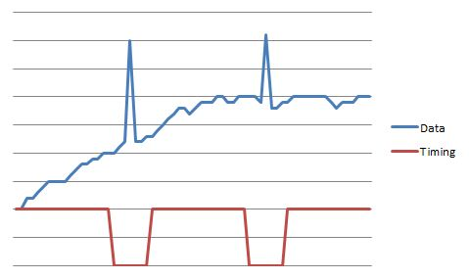
Figure 13: Possible Charge Injection Timing Schematic

To implement this, we could disable the chip enable line to the analog to digital converter. The last option would be to take multiple readings from the analog to digital converter and disregard the appropriate reading containing the charge injection. We will discuss this option when we talk about the converter itself.

Analog to Digital Converters

Our choice in analog to digital converter is crucial for the reliability of our data. Number or bits, sampling rate, DC accuracy and signal-to-noise ratio will be the main criteria for us to select an ADC. The internal voltage reference, if appropriate, will also be examined and a more precise external reference will be considered if necessary. A few different methods of conversion will be considered including flash ADC, successive approximation and sigma delta ADC. SNR and DC accuracy will be the most critical specifications in our discussion. We must also consider the data interface type and make sure that it is as universal as possible, to be flexible with our choice of microcontroller. Our interface choice will most likely be SPI because of its ease of use. The other known limitation is that the converter cannot be any less than 14 bits resolution. Since our temperature range is from -30 to 1400 degrees Celsius, that would give us 14,310 discrete measurement points to the accuracy of 0.5 degrees; thus requiring at least 14 bits or resolution. Although 14 bits is our minimum, we will be interfacing with a 16 bit microcontroller so for ease of use, a 16 bit ADC will be preferred. We will use two analog to digital converters: 1 for the cold junction voltage and reference voltage reading, and 1 for the thermocouple or source RTD inputs. The input for the present reading will be selected via a multiplexer. We will need to look for converters with bipolar inputs, since our temperature range goes into negative values.

Flash ADC

Flash analog to digital conversions are very fast, with multiple parallel comparators. To realize an N bit converter, 2^(N-1) comparators would need to be used in the converter’s architecture. The maximum number of bits most flash ADC devices are sold in is usually 8. Since our project will require higher resolution than 8 bits, we will not consider any flash converters for our controller.

Successive Approximation

Successive approximation converters will be great candidates for our project because of their high accuracy and nearly linear responses. This high accuracy comes from a sample and hold internal circuit which holds the current value of the analog signal until the conversion is complete. Also contributing to this accuracy, is the notion that each sample is compared to the output of a DAC which has been set by the previous sample’s compared value. The successive approximation register can be large, thus meeting our criteria of a minimum 14 bits of resolution. The cost of this high accuracy is conversion time, since the time is based off the number of times the sample is compared and stored in the register; which is the number of bits. When considering a successive approximation ADC, we need to take into account the pipeline delay associated with these converters and the internal DAC. The internal DAC specifications will be thoroughly researched before selecting a candidate of this type.

Sigma Delta ADC

A sigma delta analog to digital converter has 2 main parts of its design: an analog modulator and digital filter. The analog modulator uses a summing integrator, comparator, D flip-flop and a 1 bit DAC as feedback to the summing integrator. Depending on the amount of summing integrators, depends on the order of the converter; higher order systems have more precision. The sigma delta ADC uses an oversampling technique dependent on the clock rate of the internal D flip-flop. This oversampling rate is also a factor of precision. In the digital filter, there is a low pass filter that helps increase SNR. Because of the oversampling technique, all the quantization error is bound to the upper frequencies; which can be easily filtered out. The digital filter also reduces the D flip-flop’s clock rate so that the output is the sampling rate of the ADC.

Candidates

AD7715 – Analog Devices
This device is being considered because it is a part of a similar existing technology, the Watlow Process Controller, of which Infrared Systems Development currently uses. The AD7715 is a 16-bit, sigma delta ADC specifically made for low frequency measurement applications, which is perfect for our DC inputs. This converter also is compatible with low level signals at the input because it contains its own programmable gain amplifier, with programmable gains of 1, 2, 32 and 128. The sampling rate of this device depends on the gain chosen and the clock rate. This device has on chip registers, allowing for external control of key parameters such as input gain and signal polarity. The chip has 16 pins and comes in PDIP and SOIC_W (wide) packages.

The internal gain amplifier of this device may actually eliminate our need for an external amplification system completely, thus simplifying our circuitry by many parts. According to our calculations in the amplification section above, we will need to a unity gain. The output noise associated with this converter depends on the master clock rate we choose and the adjustable front end gain. Depending on these selection criteria, the noise can range from 0.9 micro-Volts to 550 micro-Volts. The datasheet does not specify a voltage drift amount from the amplifier, but it does note that it is low because of chopper stabilization, which we determined in the amplifier section above to be preferred.

AD7718 – Analog Devices
This ADC is a sigma delta, 24 bit converter with a 10 channel input multiplexer. This device needs to be referenced to a precision voltage reference and also needs an external crystal oscillator at 32 kHz. The benefit of this device is that no external multiplexing will be needed, and that Analog Devices has accounted for the total offset in the entire system; including the multiplexer. The AD7718 also had an internal programmable gain amplifier that ranges from 1 -128. The device allows to enable a chopper, which will eliminate a lot of noise in the system.

AD7797 – Analog Devices
This ADC is a sigma delta, 24 bit converter with a differential input. This device needs to be referenced to a precision voltage reference and has a fixed internal amplifier set at a gain of 128.

AD7684 – Analog Devices
This device is a successive approximation ADC with 16 bits of resolution and a high throughput rate of 100 kilo-samples per second. With a supply and reference at 5 Volts, the SNR plus distortion is a decent 91 dB. Its internal reference has a temperature coefficient of 0.3 ppm/°C. The device has no internal reference, therefore we will need to choose our own. The internal DAC is a charge redistribution converter, which is preferred. It comes in a small, 8 pin MSOP package and has an SPI interface.

ADS8326 – Texas Instruments
This ADC is the successive approximation type with 16 bits of resolution. It has a small offset error of 1 mV and a high throughput rate of 250 kilo-samples per second. It has a decent SNR of 91.5 dB and a SNR plus distortion at 91 dB. The device requires an external reference and clock, which may be preferred so we can set the accuracy of the voltage reference. This device comes in a small 8 pin, MSOP package and has an SPI interface.

Part | Manufacturer | ADC Type | # of bits | Throughput Rate | Voltage Supply | Price
AD7715 | Analog Devices | Sigma Delta | 16 | Depends | 3 V or 5 V | $12.68
AD7718 | Analog Devices | Sigma Delta | 24 | Depends | 5 V | $10.73
AD7797 | Analog Devices | Sigma Delta | 24 | Depends | 5 V | $7.83
AD7684 | Analog Devices | Successive Approximation | 16 | 100 ksps | 2.7 ~ 5.5 V | $13.83
ADS8326 | Texas Instruments | Successive Approximation | 16 | 250 ksps | 2.7 ~ 5.5 V | $8.91
Table 14: ADC Candidates

In the end, we chose to use both the AD7718 and AD7797 both by Analog Devices. We decided to use the AD7797 for the primary thermocouple reading since this converter had better specifications and the AD7718 for the secondary thermocouple reading and all RTD readings via its 10 channel input multiplexer. This also eliminated the need for external multiplexing.

Voltage Reference

We will need 3 voltage references in our temperature sensing subsystem: 1 for our RTD amplification system and 2 for our analog to digital converters. When choosing a voltage reference, we need to be cautious of 2 major specifications: the temperature coefficient and initial accuracy. The temperature coefficient can be calculated by

where e is the error percent, A is the initial accuracy at 25 degrees Celsius and ΔT is the extreme operating temperature different from 25 degrees Celsius. From this equation, we can select a device with a known initial accuracy and determine an appropriate temperature coefficient depending on our operating temperature range and error allowance.

RTD Amplification Reference

The precision of this voltage reference is not as critical as the references for the ADCs; however, we still want to minimize the error if possible. Let’s assume that our maximum operating temperature will be 40 degrees Celsius (again, an over-estimate); this is 15 degrees away from ambient temperature. The error percent we are willing to afford will be 0.2%; therefore, our allowable temperature coefficient will depend on our initial accuracy by

So we shall consider components where the specs fall within allowable ranges of this equation. We had previously decided in our amplifier design section that we wanted a V_{ref} of 4.5 Volts.

ADC External Reference

In order to maintain the accuracy of our analog to digital converters, we need an extremely high precision voltage reference. The performance of this voltage reference must surpass the ADC’s internal reference performance in order to justify consuming more power on an external reference. Like the RTD amplification reference, we will look at references that have a low error percentage and have a tolerable temperature coefficient and initial accuracy. Since we have narrowed our choices of converters to a 16 bit successive approximation converter, we can calculate the amount of voltage per resolution bit given from a chosen reference voltage. In order to allow the input of our ADC to match the maximum amplifier output we chose of 4.5 Volts, we need to seek a standard voltage reference of 5 Volts, this would give us

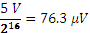

for each bit of resolution. Because the accuracy of the analog to digital conversion is one of the most crucial components of our system, we will expect an error of no more than 0.5LSB.

Candidates

REF5045 – Texas Instruments
This bandgap voltage reference fits our allowable range for temperature drift and initial accuracy: its temperature coefficient is 3 ppm/°C and its initial accuracy is 0.05%, both maximum values. These specifications give us an error percent of 0.055%, which is way below our allowance. This 8 pin package is available in a MSOP footprint. From V_{out} to ground, there must be an output capacitor ranging between 1 and 50 micro-Farands for the output to be stable. A bypass capacitor is recommended by the datasheet between V_{in} and ground. The power supply required for this reference is between 4.7 and 18 Volts. We will be able to determine whether or not our controller can supply the maximum voltage in the power design section of the paper.

MAX6161 – Maxim Integrated Products
This device comes in an SO 8 pin package, although there are only 3 usable pins: V_{in}, V_{out} and ground. The maximum temperature coefficient is 5 ppm/°C and the initial accuracy is 2 milli-Volts maximum, which equals 0.044%. This gives us an error percentage of 0.049%, even better than the previous candidate. This datasheet also recommends a bypass capacitor on the input but does not require an output capacitance for stability. The absence of this output capacitor could help us save board space. This device can operate on a supply voltage range of 4.7 to 12.6 Volts, also giving it another advantage over the previous candidate.

ADR431 – Analog Devices
This device comes in an 8 pin SOIC, although there are only 3 usable pins: V_{in}, V_{out} and ground. This device outputs at 2.5 Volts and requires an input supply voltage of 5 Volts. This part is considered a precision reference voltage and has a very low error percentage of 0.04% maximum.

Part | Manufacturer | Supply Voltage | Error Percent | Price
REF5045 | Texas Instruments | 4.7 ~ 18 V | 0.055% | $4.46
MAX6161 | Maxim Integrated Products | 4.7 ~ 12.6 V | 0.049% | $3.24
ADR431 | Analog Devices | 5 V | 0.04% | $6.60
Table 15: Voltage Reference Candidates

Because of its precision and low error percentage, we choose to use the ADR431 by Analog Devices in our design.

Solid State Relays

For our project, we have decided to use solid state relays versus generic mechanical relays because of many advantages. These advantages include but are not limited to: little switching noise, no bouncing, increased lifetime and a much smaller package. There will be 3 relays used in our design; 2 to control power to the heater and 1 to control inputs to the alarms. The heater will need an AC relay for the cavity sources and a DC relay for the extended area sources; each where we can adjust the power level and signal duration. The alarm relay will need a DC relay with an output of about 5 Volts, 1 Amp and an input of 3 Volts or less. The inputs of the relays came from the microcontroller.

Heater Relays

DC – Extended Area Sources
The heaters for Infrared Systems Development’s extended area sources are DC powered. This relay will need to control the power level and signal duration going into the heater. For the coupling of our signals, we will use an optical coupling system. We will use an LED to stimulate a photo-sensitive diode as our coupling device and can choose from a MOSFET, thyristor or controller rectifier to switch the load. When we deal with DC signals, we will also use MOSFETs and a TRIAC to conduct the load current to the load.

AC – Cavity Sources
The heaters for Infrared Systems Development’s cavity sources are AC powered. One of the requirements we need to meet for our device is that we need to have zero cross sensing at the AC relay, which will ensure that we turn off the power to the heater when the voltage crosses from positive to negative. This will ensure that we eliminate or lower the electromagnetic interference that would be generated when switching at a nonzero point. There are two different ways we could go about doing this. We can either design a logic circuit to implement the zero cross sensing or we can find a chip that will interface with the microcontroller. The issue with designing a logic circuit is that it will take up more space and cost more because we would have to buy more components. Some AC relays come with a zero crossing detector integrated into it, which would be a good option because it will cut cost and use less space.

Alarm Relays

We also need DC relays for the alarm outputs. If the relay is closed it will allow the user to add external circuitry that will be triggered once the alarm goes high. If the relay is open it will deactivate the circuit. We will need to have two sets of normally-open and normally-closed relay contacts, so we will use double pole single throw (DPST) relays. A DPST relay is a relay that has two pairs of terminals actuated by a single coil. We will need two of these relays, one DPST (2 Form A) and one DPST (2 Form B). 2 Form A refers to two normally-open contacts which connect the circuit when the relay is activated, and 2 Form B refers to two normally-closed contacts which disconnect the circuit when the relay is activated. By using one of each of these relays we will meet our requirements of having two sets of normally-open and normally-closed contacts. Since we are using a 5 volt input voltage we will use a relay with a 5VDC coil voltage. To minimize cost and the amount of parts, we want a relay that has a diode in it, the diode is used to keep the voltage on the coil leads from going negative. Since the microcontroller can’t produce enough current to drive the relay we need to use a FET to drive our relays, there are other ways to drive the relays but this is a good option because it doesn’t take up as much space as a transistor would. Since our display will include the alarm status lights we will not need to integrate a separate LED into this design. The alarm status lights will be controlled by our microcontroller. TE Connectivity makes many different DPST relays in both Form A and Form B. Until we know for sure exactly how much current we need we will consider relays with a current rating of 2A, which should be enough for our alarm outputs.

Temperature Sensing Subsystem Design

Shown in the image below, is our temperature sensing subsystem design. As you can see from the schematic, the inputs to our system will come from Infrared Systems Development’s source (with the exception of the cold junction signal). The output of our system will also end at the source to control the heater and the fan. The analyzing of this data will all be done within the microcontroller, which will also command most of the electronic devices in this subsystem.

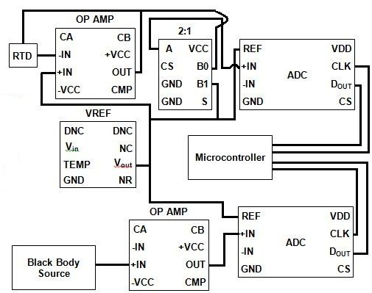
Figure 14

This schematic is assuming all grounds and voltage supplies are connected. The CS lines will all be controlled by the microcontroller which depends on a 1:8 decoder and 8-bit inverter to select the devices. Any address lines will also be controlled by the processor and the NC and DNC pins will not be connected.

Printed Circuit Board Fabrication

The final design for our temperature controller is shown in the final design section below. As anyone can see by our block diagram, our design contains many ICs and in all variety of package types. We will need a versatile, but relatively compact board to maintain a small chassis size for our controller. Since no one in our group has lengthy experience in designing PCB layouts, the ease of CADing software use and understanding will play a big role in the decision of our PCB manufacturer. Our PCB will have a maximum of 2 layers for the testing phases of our design. When the controller is ready to be produced and sold, the option for more than 2 layers could be considered. We want our PCB manufactured at the highest and latest fabrication standard of IPC 6012 Class III. Our ideal board size would be about 4 by 4 inches, with a thickness of around 0.062 inches. We would like our finished copper weight to be the standard 1 ounce since we are not distributing large amounts of current through our board. If we have room in the budget, a white silkscreen and green solder mask on our board would add a professional touch and create more isolation between traces. Our board also has to be easily mounted to the controller chassis. The following components in Table 17 will take space on our PCB:

Device | Pins | Package Type
Amplifier(s) | 8 | SO
4:1 MUX | 10 | SOIC
2:1 MUX | 8 | TSSOP
1:8 Decoder | 16 | SSOP
8-bit inverter | 14 | SOIC
ADC(s) | 8 | MSOP
Reference(s) | 8 | MSOP
Ethernet Controller | 28 | SOIC
IEEE – 488 | 16 | SOIC
EEPROM | 8 | SOIC
Touch Controller | 16 | TSSOP
Table 16: PCB Components

Candidates

ExpressPCB
ExpressPCB offers free PCB layout software downloadable from their website. We’ve already downloaded their PCB layout software and have experimented with their user interface. The click and drag approach implemented by their program is very intuitive and quick to use. Their software package also comes with a schematic designing program which you can link to their PCB layout program; linking the two programs will highlight the pins that need to be connected in the PCB layout according to the schematic. The software even comes with an instant quote that will give us the exact manufacturing price and estimated time of shipping. Orders under 500 boards (which will include our 2 board order) will be shipped the following business day; therefore, we should not have to wait long after we order our board to get the prototype. This company is preferred over the other candidates because of the easy integration between schematics, PCB layouts and quotes. The cost and time analysis for this manufacturer is shown in the table below.

EAGLE PCB
EAGLE PCB does not offer free software, but is highly recommended for the paid professional version of their PCB layout software. Our sponsor, Infrared Systems Development, has a license for this software, should we choose to use it for our design. If we choose to purchase the software, a “light” version is available for an economical $69.00. EAGLE PCB does not fabricate their own PCBs, they only provide the CAD tools needed for layout design and recommend partner vendors for actual fabrication. Sunstone Circuits are one of EAGLE PCB’s fabrication partners and will accept any generic Gerber file for processing.

Sunstone Circuits
Sunstone Circuits offers free PCB layout software downloadable from their website, called PCB123. Their user interface is similar to that of Express PCB, where they have a user friendly GUI. They also offer a schematic designing program which can be linked to the PCB layout; whenever an update is made to the schematic, the PCB layout automatically adjusts and vice versa. The company boasts a large parts library of over 500,000 new parts and also has a unique feature that allows users to search Digikey in real time. The software outputs both Gerber and Excellon files which will allow us to design the layout in the software, if desired, but send the board to get fabricated elsewhere. This would be beneficial to us since the cost of 2 small boards with this manufacturer will cost of $100. The cost and time analysis for this manufacturer is shown in the table below.

PCB Fabrication
PCB Fabrication is an online service that allows you to upload your Gerber files and then customize your PCB’s specifications to order for fabrication. This company has allowed for the most flexibility and options when it comes to choosing a board. To request a quote, the form lets you choose: board material, fabrication standard, the routing width, finished copper weight, hole size, silkscreen, solder mask, and board surface finish, just to name a few of the many options PCB Fabrication allows users to choose. I cannot view standard prices without submitting an actual request for a quote.

Manufacturer | Software Price | Board Price | Shipping Cost | Turnaround
ExpressPCB | Free | ~$85.40 | $9.85 | 2 days
EAGLE PCB | $69.00 | NA | NA | NA
Sunstone Circuits | Free | ~121.00 | Free | 2 weeks
PCB Fabrication | NA | Unknown | Unknown | Unknown
Table 17: PCB Fabricator Candidates

Because our sponsor had extra licenses for EAGLE PCB, we used this software to draw our PCB layout.

Display Design

Overview

The display of the temperature controller will be the face of the whole device. Ideally the display should look sleek and high-tech but still be user friendly. The display will need to show the actual temperature of the device at all times. It will also need to provide a series of menus and user settings that are critical to the specific user. Our display will be a touch screen display. In addition, the display must interface with the microcontroller and handle other tasks.

Requirements

The display must have the ability to show the actual temperature of the device. This must be displayed in large, readable numbers that can be viewed from at least ten feet away. The display must show the user the temperature with two digits of precision along with the scale of degrees (.XX °C). The display must also be able to show negative temperatures and have a selectable time constant to smooth the value and reduce flicker. In addition to the actual temperature of the device, it must also show a series of menus and values that are specific to the user. These menus and options will be discussed in more detail in the User Interface section. We are going to use a touch screen for our display. The display we choose needs to be compatible with the microcontroller that we choose. Ideally the display and its associated components must be in production for at least ten years after the completion date of the device. We have size limitations when it comes to our display. Ideally the display we choose should fit in the existing chassis but if modifications are needed then we can work with it. The space we have for the display is 3.9” x 3.9”, the height of the display must not exceed this but the length can be longer if needed. The size will be discussed more in the design section once we know which display we are using.

Display Research

The following subsections will discuss and evaluate various features of the touch screen display such as graphics controllers, interfacing, touch screen options, LED backlight driver, candidates, touch screen controller and size requirements.

Graphics Controllers

When designing a touch screen display we need to decide on which graphics controller we are going to use. There are four main ways to integrate a graphics controller into the design. Out of those four ways only three of them are available to us because of our microcontroller candidates. We are considering the option of external graphics controller not found in glass, external graphics controller and integrated graphics controller.

External Graphics Controller

An external graphics controller is a configuration of two devices. It consists of the microcontroller and the display module that has an onboard graphics controller in itself. This means the frame buffer, display controller and display are all on one device. This option is cost effective and convenient but there are disadvantages to having it all one on device. If the display module is no longer in production then another solution would have to be developed, making this option not a long lasting solution. From our research not many displays come with an onboard graphics controller. This option would be risky for us because we want something that is going to have a long production lifetime and if the display we choose goes out of production we would have to reconfigure our whole design by either getting a new microcontroller or integrating a separate graphics controller. The photo below in Figure 28 shows an example of an external graphics controller.

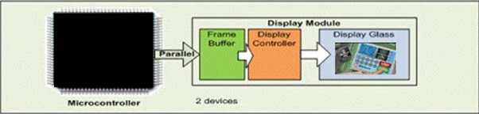
Figure 15 - Example of an External Graphics Controller (Image from Microchip)

External Graphics Controller not Found in Glass

This type of external graphics controller is a configuration of three devices. It consists of the microcontroller, the graphic controller chip and the display module. The display module itself doesn’t contain any onboard graphics controller which means an extra controller needs to be purchased and connected. This option will add an extra cost to our design but the advantage of that is if our display breaks or goes out of production we would only need to purchase a new display. While this option takes up more space and cost more it could be beneficial in the long wrong if we need to make modifications to our design. The photo below in Figure 29 shows an example of an external graphics controller not found in glass.

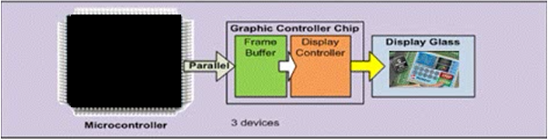
Figure 16 - Example of an External Graphics Controller not Found in Glass (Image from Microchip)

Integrated Graphics Controller

With an integrated graphics controller the microcontroller has a built in graphics module to help drive graphical features. This option is limited to specific microcontrollers but if the microcontroller we pick has this feature then it would be a good choice because it will cut cost and space. The other advantage of this is that a lot of displays don’t come with onboard graphics controllers so when choosing a display we have a larger selection to choose from. The photo in Figure 30 shows an example of an integrated graphics controller.

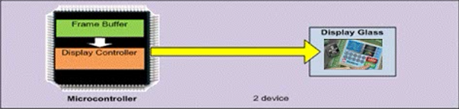
Figure 17: Example of an Integrated Graphics Controller (Image from Microchip)

Interface

Parallel Interface

To interface the display with the microcontroller we have two options. The first option is to use parallel data bus interface. Depending on the display we pick we could use anywhere from 8-bit parallel to 24-bit RGB parallel. If we choose to use the parallel bus it would allow us to quickly refresh the screen, which we don’t necessarily need. This option is a more costly and complicated set up because of its complex circuitry and the use of more I/O ports on the microcontroller. The availability of this option with displays is everywhere so depending on what we can find this might be our only option.

Serial Peripheral Interface (SPI)

Our second option is to use SPI to interface the display with the microcontroller. We could use either a three or four wire SPI. This option is slower than the parallel interface but in return it would require only three to four pins, which is beneficial to us. We would want to use a four wire SPI instead of the three wire because the four wire allows you to select between registers and data. Unlike the parallel interface, this option is less available in touch screen displays.

Four Wire Resistive Touch Screen

A four wire resistive touch screen consists of two transparent resistive layers lying parallel to each other separated by a thin space. When the user touches the display the two layers get pressed together and that spot behaves as a pair of voltage dividers. The transparent screen also has four wires coming out of it for its interfacing. These four wires are also used to calculate the coordinates on the touch screen where the user touched. The four wires are labeled X-, Y-, X+ and Y+ and are used to directly connect the touch screen signals. X+ and Y+ are both analog and digital signals while X- and Y- are digital output signals. There is an applied voltage to each side of layer 1 of while layer 2 senses the proportion of voltage at the point the user pushed. This will give the horizontal coordinate. Then there is a applied voltage to the top and bottom of layer 2 and layer 1 will sense the proportion of voltage at that point. This will give the vertical coordinate. The X+ and Y- signals are multiplexed with the touch screen controller. Once we decide on a display we will choose which touch screen controller we will use. This information is then sent to the microcontroller. A four wire resistive touch screen is cost effective and widely available. It can be touched with a finger, stylus or glove and isn’t affected by dirt, dust or water.

Touch Screen Controller

If we decide to use a 4-wire resistive touch screen that does not come with a touch screen controller we will need one to determine the position of where the user touched. This controller will allow us to get the information using serial interface instead of parallel. We have many options when choosing a touch screen controller but we are only going to consider two types based on size, number of pins and the troubleshooting capabilities that each one offers. The two controllers we are comparing are the TI TSC2046 (16TSSOP) and the TI TSC2008 (12DSBGA). The two main differences of these candidates are the pin count and the package type. The TI TSC2008 is a very low-power touch screen controller which can work with a supply voltage as low as 1.2V. This controller is available in different packages but we are looking at the 12DSBGA package. The TSC2008 has 12 pins but since it has the ball grid array (BGA) it can get very complicated when it comes to making repairs and modifications. The good thing about this controller is that it is smaller in size. The TI TSC2046 is a touch controller that supports a low-voltage I/O interface from 1.5V to 5.25V. This controller is available in different packages but we are looking at the 16TSSOP package. This controller has 16 pins and compared to the BGA package it would be a lot easier to make repairs and modifications. The downside to this controller is that it is bigger than the TSC2008. If we find we need a touch screen controller we would go with the TI TSC2046 (16TSSOP) for our touch screen controller because of the ability to easily make changes even though it has more pins and is bigger. We will use SPI to interface this to the microcontroller.

Capacitive Touch Screen

A capacitive touch screen consists of a layer of glass coated with a transparent conductor. A capacitive touch screen works by sensing a change in the amount of charge on the capacitive layer. When the user touches the display some of the charge is transferred to the user and the charge on the layer decreases. One type of capacitive touch screen detecting is surface capacitance. With surface capacitance only one side of the glass is coated and a small voltage is applied to the layer which results in a uniform electrostatic field. When the user touches the surface it distorts the electrostatic field by drawing current form each side proportionally. The displays controller can determine the location from the change in the capacitance. Capacitive touch screens are more expensive and aren’t widely available. The downside of the capacitive touch screens is that it can only be touched with a finger or special type of stylus. Capacitive touch screens support multi-touch but we do not need that feature in our device.

LED Backlight

The LED backlight of the display needs to be driven in some way in order for it to light up. There are three different ways to do this. Since LEDs are current devices a current source could be used to drive the LEDs. This approach is very complex. Another way is to add a current limiting resistor in line from the voltage source. This approach is simple and would work but it takes a lot of voltage to do this. In the displays that we have seen the backlight needs around 20V to power the LEDs. The last option is to use a LED driver. This option allows you to drive the LEDs with a smaller input voltage. Sometimes there is an extra cost to this but it small. This is the best option for our design since our max voltage is around 5V. There are some displays that will come with an integrated driver already on it but most of them do not. Using a LED driver will also allow us to control dimming of the backlight as well. To do this we would use a filtered PWM signal. The PWM signal is filtered by an RC network and fed to the driver. If we choose to do this the microcontroller must support PWM. There are many different LED drivers and each of them have different configurations depending on the number of LEDs in the backlight, the voltage and current. Most of them use configurations consisting of resistors, inductors and capacitors that get connected to the driver. Once we make the final decision on the display then we will decide on what driver to use depending on if the display has one integrated or not.

Display Candidates

Crystalfontz CFAF320240F-035T-TS

The CFAF320240F-035T-TS is a 320xRGBx240, full-color QVGA graphic TFT display module shown in Figures 31 and 32. It has a 3.5 inch diagonal screen with a white LED backlight. The display is white edge-lit with two parallel rows of LEDs, three LEDs in each row, six LEDs total. The white LED backlight has the anode and cathode pins brought out on the flexible printed circuit (FPC) connector. The CFAF320240F-035T-TS does not come with an integrated LED driver so if we choose this display then we would have to buy a driver that can support all the displays features. The features to consider for the driver would be the input voltage, the number LED strings, the number of LEDs in each string, and the LED voltage. Depending on our microcontroller we could dim the backlight of this display using a filtered PWM signal. The CFAF320240F-035T-TS has 50 pins for interfacing brought out on the FPC and can be connected with standard .5mm ZIF sockets. Crystalfontz recommends the HFJ150CT-ND or the HFK150CT-ND. This display has a 4-wire resistive touch panel with an integrated Solomon SSD2119 display controller. Since this display has the integrated display controller we could use a microcontroller without a graphics controller on it. The issue with this is that if the display module goes out of production then we would have to either get a new microcontroller or get a separate graphics controller which will waste time and money. We would also need to get a 1mm pitch touch panel connector for the 4-wires of the display. Crystalfontz recommends either the 609-1883-1-ND or the 609-1886-1-ND. One advantage of the CFAF320240F-035T-TS is that it has SPI interface as well as 18/16/9/8-bit parallel interface. It also has a wide temperature range of -20°C to +70°C, which is needed since we are dealing with such intense temperatures. It has a 12:00 o’clock viewing angle which is a top viewing angle like what you would see if looking down at the speedometer of a car. The CFAF320240F-035T-TS has logic supply voltage of +2.5V to +4.0V and a supply voltage for I/O signals of +1.4V to +3.6V. This display has a module reliability of 50,000 hours > 50% of initial brightness when operated and stored specification limitations.
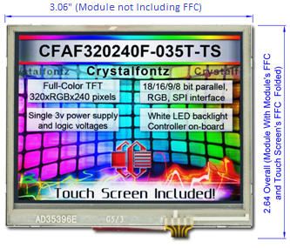
Figure 18: Crystalfontz CFAF320240F-035T-TS - Modified to Appear as the Eye Perceives the Display (showing no FPC connectors)

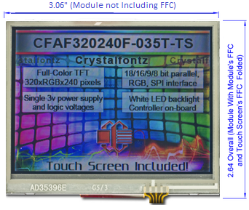
Figure 19: Crystalfontz CFAF320240F-035T-TS - Unmodified, Appears as the Camera Perceives the Display (showing no FPC connectors)

Newhaven NHD-4.3-480272MF-ATXI#-T-1

The NHD-4.3-480272MF-ATXI#-T-1 is a 480xRGBx272, full color TFT display module shown in Figure 33. It has a 4.3 inch diagonal screen with a white LED backlight. This display has two parallel rows of LEDs, six LEDs in each row, twelve LEDs total. The NHD-4.3-480272MF-ATXI#-T-1 has an Orise OTA5180A LED driver integrated into the display. This can be an advantage from a cost and space standpoint but also a disadvantage if the driver doesn’t have all of the features we need. Since it has more LEDs it is going to take more power and the OTA5180A has the feature of using the filtered PWM signal. This display has a 4-wire resistive touch panel but does not have an integrated graphics controller. This gives us the option to either get a separate graphics controller or get a microcontroller with an integrated graphics controller on it. This is a benefit because we have more options when it comes to designing it the way we want. If we choose to get a separate graphics controller this will be an added cost but it won’t be a big one. We would also need to get a 1mm pitch touch panel connector for the 4-wires of the display. The NHD-4.3-480272MF-ATXI#-T-1 only has one option when it comes to interfacing. This display has 24-bit RGB interface. The microcontroller we choose needs to have the capability of driving 24-bit displays. Most of the microcontrollers we are considering only have 16 pins but there is a way to make it drive a 24-bit display. More on this can be found in the microcontroller section under microcontroller design. The NHD-4.3-480272MF-ATXI#-T-1 has 40 pins for interfacing brought out on the flat flexible cable (FFC) and can be connected with standard .5mm sockets. Newhaven Displays recommend the Molex 54132-4097. Since the display has the LED driver on it we will not need to purchase a separate backlight connection. This display has a 6:00 o’clock viewing angle which is a bottom viewing angle like what you would see when looking at a cell phone. It has a power supply voltage and logic supply voltage of 3.0V to 3.6V. The total LED voltage is about 22V and total LED current is about 32mA. The operating temperature range of this display is -20°C to +70°C.

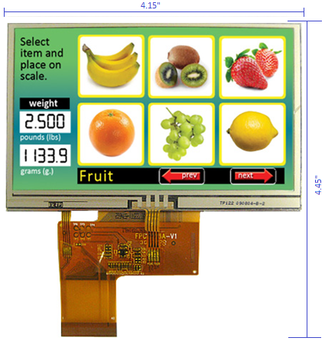
Figure 20: Newhaven NHD-4.3-480272MF-ATXI#-T-1 Display (showing FFC connectors)

Newhaven NHD-3.5-320240MF-ATXL#-T-1

The NHD-3.5-320240MF-ATXL#-T-1 is a 320xRGBx240 pixel, full color TFT display module. It has a 3.5 inch diagonal screen with a white LED backlight shown in Figure 34. The NHD-3.5-320240MF-ATXL#-T-1 has a Novatek NT39016D LED driver integrated into the display. Again this can be an advantage due to cost and space but also a disadvantage if it doesn’t have all of the features we need. The NT39016D will allow us to use a filtered PWM signal when interfacing this with the microcontroller. This display is also a 4-wire resistive touch panel. The NHD-3.5-320240MF-ATXL#-T-1 does not have an integrated graphics controller so we would need to compensate for that. We can either buy a separate graphics controller or use a microcontroller that has an integrated graphics controller. We would also need to get a 1mm pitch touch panel connector for the 4-wires of the display. Newhaven recommends the Molex 52207-0485. This display uses 24-bit RGB interface which can be interfaced to most microcontrollers using 16 pins. The NHD-4.3-480272MF-ATXI#-T-1 has 54 pins for interfacing brought out on the flat flexible cable (FFC) and can be connected with standard .5mm sockets. Newhaven Displays recommend the Molex 51296-5494. Since the display has the LED driver on it we will not need to purchase a separate backlight connection. The NHD-3.5-320240MF-ATXL#-T-1 has a 12:00 o’clock viewing angle, which is a top viewing angle like what you would see if looking down at the speedometer of a car. It has a power supply voltage and a logic supply voltage of 300V to 3.6V. The total LED backlight voltage is about 19.2V and the total LED backlight current is about 20mA. This display has an operating temperature range of -10° to +60°C.
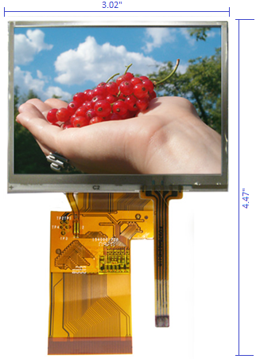
Figure 21: Newhaven NHD-3.5-320240MF-ATXL#-T-1 Display (showing FFC connectors)

4D Systems uLCD-32PT (GFX)

The uLCD-32PT (GFX) is a low-cost 320xRGBx240 pixel, full color TFT display module. It has a 3.2 inch diagonal screen with a white LED backlight. The uLCD-32PT (GFX) has an integrated 4-wire resistive touch panel. This display has an easy 5 pin interface to any host device which significantly less pins than the other options we are considering. The 5 pins are VCC, TX, RX, GND and RESET. These pins are interfaced serially to the microcontroller and are also used for programming the display. This display also has 2-30 pin headers for I/O expansion which is valuable if we want to expand in the future. The uLDC-32PT (GFX) is powered by the 4D-Labs PICASO-GFX2 processor. The PICASO-GFX2 acts as the graphics controller and controls most of the functionality of the display. This is a benefit because we would not have to buy a graphics controller or a LED driver. The uLCD-32PT (GFX) comes with 14KB of flash memory for user code storage and 14KB of SRAM for user variables. The uLCD3-32PT (GFX) also has 13 general purpose I/O pins, on-board micro-SD memory card adapter for multimedia storage and data logging purposes and an on-board audio amplifier with a tiny 8-ohm speaker for sound generation and WAV file playback. One extremely valuable feature of this display is that it has built in graphics and system library functions. This will help us when it comes to programming and adding buttons to the display. The built in graphics will be very useful because we would be able to put any image or video on this display if we wanted to. It also has a font tool which is extremely useful because we can design our own text and have this displayed on the screen. This display needs 5V to power the whole system which is more than the other displays but this won’t be an issue because some of our other components need 5V also. The display has a viewing area of 47.87 x 63.84mm and the whole module itself has dimensions of 56.0 x 77.7 x 11.4mm. One concern we might have with this display is that it is manufactured in Australia and there might be issues getting it fast if something happens. We are going to continue to look for US vendors which would be the best option for us.

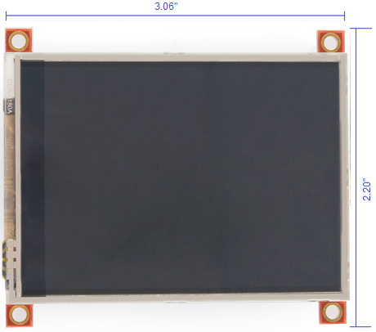
Figure 22: 4D Systems uLCD-32PT (GFX)

Comparison

Candidate | CFAF320240F-035T-TS | NHD-4.3-480272MF-ATXI#-T-1 | NHD-3.5-320240MF-ATXL#-T-1 | uLCD-32PT (GFX)
Dislpay Type | TFT | TFT | TFT | TFT
Type of Touch | 4-Wire Resistive | 4-Wire Resistive | 4-Wire Resistive | 4-Wire Resistive
Num. of Pixels (Width) | 320 | 480 | 320 | 320
Num. of Pixels (Height) | 240 | 272 | 240 | 240
Diagonal Dimension | 3.5 in | 4.3 in | 3.5 in | 3.2 in
Overall Module Dimensions | 3.47”x2.64” | 4.15”x2.65” | 3.02”x2.51” | 3.06”x2.20”
Graphics Controller | Yes Solomon SSD2119 | No | No | Yes  PICASO-GFX
Integrated LED Driver | No | Yes Orise OTA5180A | Yes Novatek NT39016D | Yes  PICASO-GFX
Interface | SPI or 18/16/9-bit parallel | 24-bit RGB | 24-bit RGB | 5 pin serial
Viewing Angle | 12:00  o’clock | 6:00  o’clock | 12:00  o’clock | 12:00  o’clock
Typical Logic Supply Voltage | +3.0V | +3.3V | +3.3V | +5.0
Min. Operating Temp. | -20°C | -20°C | -10°C | -20°C
Max. Operating Temp. | +70°C | +70°C | +60°C | +70°C
Min. Storage Temp. | -30°C | -30°C | -20°C | -30°C
Max. Storage Temp. | +80°C | +80°C | +70°C | +80°C
Cost @ Qty 1 | $53.72 | $38.00 | $31.50 | $79.00
Table 18: Comparison of Different Display Features

The above values in Table 19 summarize the main features available with our four candidates. The most important features we need to consider is if it has an onboard graphics controller, the size of the overall display, its interfacing options and if it has an integrated LED driver. One downfall of the Crystalfontz CFAF320240F-035T-TS is that it does not have an integrated LED driver unlike all of the other options. On the upside it does have a graphics controller on-board and it has both SPI and parallel interfacing. Even though our microcontroller has an integrated graphics controller it does not necessarily mean that we have to use it. After some consideration we ruled the Crystalfontz CFAF320240F-035T-TS out because it does not have the integrated LED driver and that is just another added cost and something else that we have to learn how to use. The Newhaven NHD-4.3-480272MF-ATXI#-T-1 and the Newhaven NHD-3.5-320240MF-ATXL#-T-1 are very similar with the features they come with. They both have an integrated LED driver and both have parallel interface. The only big difference with these two is the size. Since these displays have 24-bit RGB interface and our microcontroller only has 16 pins we are going to need to make some modifications. In order for our 16-bit RGB 5:6:5 display controller to drive the 24-bit RGB 8:8:8 display we are going to have the red and blue upper three MSBs serve as the upper three MSBs and the lower three MSBs as their 8-bit equivalent. For the green bits we would use the upper two MSBs to serve as the upper two and the lower two MSBs for its 8-bit equivalent. This option is doable but it can get a little complicated. The 4D Systems uLCD-32PT (GFX) has a lot of the same features as the Newhaven displays but it has one significant difference, which is the pin count. This display on uses 5 pins compared to the others that use 40 pins. This will make a huge difference in footprint and simplicity when I comes to our design. The PICASO-GFX2 serves as the graphics controller and it also controls the LED backlight. Even though our microcontroller has an integrated graphics controller, we will not be using it because the PICASO-GFX2 is so powerful. The price of the uLCD-32PT (GFX) is more expensive than all of the other candidates but it is well worth it because we will not need to buy extra parts to supplement the display. At $79.00 it is still less than what we budgeted for so the price is not an issue in this case. For all of those reasons, we will use the uLCD-32PT (GFX) by 4D Systems as our display for our temperature controller.

uLCD-32PT (GFX) Specifics

As we described in the previous section the uLCD-32PT (GFX) is driven by the PICASO-GFX2 processor. This processor belongs to a family of processors powered by a highly optimized soft core virtual engine, EVE (Extensible Virtual Engine). EVE is a high performance virtual processor with an extensive byte-code instruction set optimized to execute compiled 4DGL programs. 4D Systems created their own language called 4DGL (4D Graphics Language) and it was specifically developed for the EVE engine core. 4DGL is an easy to learn, high level language that is used to deliver many embedded graphics applications. 4DGL allows us to write applications and run it directly on the PICASO-GFX2 processor. It also allows us to take complete control of all available resources on the PICASO-GFX2 such as the serial ports, the graphics LCD display, micro-SD memory card, I/O pins and audio functionality. All of the functionality including the high level commands are built into the PICASO-GFX2. The chip is configured using a PmmC (Personality-module-micro-code) file. A PmmC file contains all of the low level micro-code information which define the characteristics and functionality of the device. Programming the device with a PmmC file provides us with an extremely flexible method of customization and the ability to upgrade the device in the future which is very important. Programming the uLCD-32PT (GFX) is as simple as connecting the 5 pins to one of three parts. We were able to choose from using the 4D Programming Cable, the uUSB-MB5 or the uUSB-CE5. We decided to go with the programming cable to program our display. The programming cable hooks directly into a PC which makes it extremely easy to program. 4D Systems provides a wide variety of software tools for the PICASO-GFX2 display modules. They have a PmmC Loader, Graphics Composer, Font Tool and 4D Workshop3 IDE. The PmmC loader is used to program the PmmC file into the PICASO-GFX2 chip. The Graphics Composer is used to compose the images, animations, and movie clips which can then be downloaded onto the micro-SD card. The Font Tool is used to convert standard Windows fonts into the bitmap font used by the PICASO-GFX2. This tool can also be used to modify and Windows font. The 4D Workshop3 IDE combines the editor, compiler, linker and downloader to develop complete 4DGL application code. This workshop is very valuable to us especially since none of us are familiar with the 4DGL code. The workshop also provides another feature called 4D-ViSi. 4D-Visi is a software tool that is used to see instant results of a desired graphical layout for the display. It has a variety of premade buttons, gauges, digits, etc. that can be simply dragged and dropped onto the simulated display. This makes positioning and sizing infinitely easier since we can see what we are doing without having to upload the code to the display every time. When using 4D-ViSi the workshop generates a base code for whatever we put on the simulated display. This saves us a lot of time in coding.

Display Pin-Out Tables

Below are the pins on the uLCD-32PT (GFX). Table 20 shows the pin number, the pin label from 4D Systems and the description of the pin. There are 5 pins on this display which control the power of the backlight and the display itself. The pins are voltage, transmit, receive, ground and reset. We will use all these pins when programming the display and we will use these pins to provide power when we have it hooked up in the final design. The uLCD-32PT (GFX) also has 2-30 pin headers for I/O expansion. The pin out for one of the two expansion ports is found below in Table 21. We are planning on accounting for these pins when we are doing our PCB layout for the purpose of future expansion. We will decide later on if we will be using these pins for sure or not.

Pin # | 4D Systems Label | Description
1 | Vin | 5V Voltage Supply
2 | TX | Serial Transmit Pin
3 | RX | Serial Receive Pin
4 | GND | Supply Ground
5 | RES | Master Reset Signal
Table 19: Pin table for the 5-pin Interface

Pin # | 4D Systems Label | Description
1 | IO2 | GPIO 2 Pin
2 | IO1 | GPIO 1 Pin
3 | IO3 | GPIO 3 Pin
4 | NC | No Connect
5 | IO4/BUS_RD | GPIO 4 Pin or Bus Read
6 | NC | No Connect
7 | NC | No Connect
8 | NC | No Connect
9 | NC | No Connect
10 | NC | No Connect
11 | NC | No Connect
12 | NC | No Connect
13 | NC | No Connect
14 | RESET | Master Rest
15 | GND | Supply Ground
16 | NC | No Connect
17 | BUS5 | IO Bus (BUS0..7) bit 5
18 | 3.3V | Regulated 3.3V output
19 | BUS4 | IO Bus (BUS0..7) bit 4
20 | NC | No Connect
21 | BUS3 | IO Bus (BUS0..7) bit 3
22 | NC | No Connect
23 | BUS2 | IO Bus (BUS0..7) bit 2
24 | NC | No Connect
25 | BUS1 | IO Bus (BUS0..7) bit 1
26 | NC | No Connect
27 | BUS0 | IO Bus (BUS0..7) bit 0
28 | NC | No Connect
29 | NC | No Connect
30 | NC | No Connect
Table 20: Pin out table for expansion port

Size Requirements

The existing chassis has a 3.9” x 3.9” space for a display. We are able to modify the length of this space but we cannot have our display exceed the allowed 3.9” in height. Since the uLCD-32PT (GFX) has dimensions of 3.06” x 2.02” we will need to shorten the length of the allowed space so that the display can fit. Having a rectangular shaped display will make the device look more sleek and modern. Below in Figure 36 is a drawing of the chassis and the existing space for the display. We will have to add fillers into the chassis to account for the smaller display. This will not be an issue since the chassis is easy enough to modify. The chassis also has a power switch and all of the communication ports and alarm hook ups.

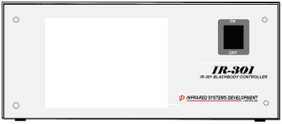
Figure 23: Existing drawing of the chassis that will need to be modified

User Interface

Overview

The user interface is a very important part of this device because many different users are going to be using this so it needs to be intuitive and require little instruction for proper use. The user interface will be designed to look sleek and high-tech but be user friendly. Because of time constraints and we will only be implementing the set point feature of the display. The other features will be talked about more in detail in the Future Implementation section of the paper.

Requirements

The main requirements for the display are that it needs to be very user friendly while still looking very advanced. The screen needs to be able to be seen from a distance and the current temperature needs to be displayed at all times. For this project we will implement a series of a few screens. We will be demonstrating how the set point feature of the display works.

User Interface Design

The design for the user interface is very simple. When the device is powered on the user will see a screen that shows the current temperature, the current set point and a button to change the set point. Figure 37 below shows this screen. The temperature needs to be big enough to see from across the room. We went with red numbers because it will be bright enough on the black background to see from a distance.

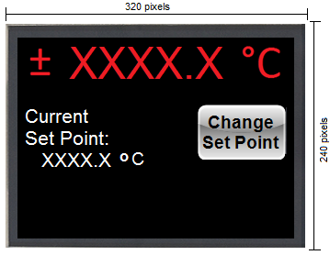
Figure 24: Main User Screen

If the user presses the Change Set Point button they will be brought to the screen in Figure 38. This screen allows the user to change the set point using up and down arrows. Figure 39 shows a sample of adding a set point.

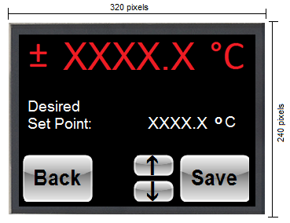
Figure 25: Sample Desired Set Point Screen

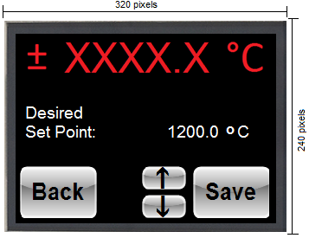
Figure 26: Example Desired Set Point Screen

If the user presses the Back button they will be brought back to the original screen and the set point will not be changed. If the user presses the Save button then this set point will be saved and the user will be brought to the current set point screen as shown in Figure 40.

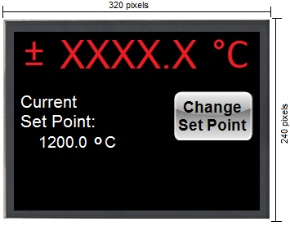
Figure 27: Example Current Set Point Screen

Power

Power Requirements

The input of our device will be 110VAC/220VAC, which will power the heater directly. From the input we will generate the DC voltages we need to power the rest of the components. We also need to have zero cross sensing at the AC relay which will lower the electrical interference generated when switching at a nonzero point. We will use different components to reduce the noise and control the power, which will all be discussed in more detail in the following subsections.

The values in Table 22 below summarizes all of our components that need to be powered by our DC voltage along with the total power in watts. We will have four different rails to power these components, one +5 volt rail and one 3.3 volt rail. As you can see we have a total of 2641.393 mW of power.

Component | Voltage  (V) | Current (mA) | Power  (mW)
ADC | 5V | 0.65 | 3.25
ADC | 5V | 0.325 | 1.625
ADC | 3.3V | 0.65 | 2.145
ADC | 3.3V | 0.325 | 1.0725
OpAmp (2) | 5V | 0.33 | 3.3
Ref | 5V | .8 | 4
Quad Buffer | 5V | 30 | 150
RS485 | 5V | 0.9 | 4.5
RS232 | 5V | 15 | 75
USB | 5V | 95 | 475
Display | 5V | 150 | 750
Ethernet Controller | 3.3V | 180 | 594
Microcontroller | 3.3V | 50 | 330
4:1 MUX | 3.3V | 75 | 247.5
TOTAL POWER: |  |  | 2641.393 mW
Table 21: Power for Components

Power Components

The input of our device will be 90VAC/240VAC, which will power the heater directly. Our input will convert the AC input voltage to a DC voltage of 5 volts, which we will use to power the rest of the components. TDK-Lambda Americas Inc makes the LS25-5 power supply that will do this for us. The LS25-5 produces 5 volts DC at 30 amps. It has a maximum output power of 150W which is more than enough for our power needs. The LS25-5 also has an internal fan which is good since the heater has a maximum power of 550W. The power supply itself is a little bigger than what we want but since the power requirements meet our needs we can compromise. We want to have a switch on the device to power the device on and off. We also want to have a fuse for safety purposes. TE Connectivity makes many different kinds of switches with these integrated fuses. Since these switches come in different shapes and sizes, we will wait to decide on the exact one until we start building our device. We can also decide to put an emergency shutdown button on the device, but we will wait for that also until we determine if we definitely need it.

When it comes to the power design we have a few different options. We can use multiple regulators and multiple analog and digital lines to get our desired 5 volt and 3.3 volt lines or we can just use one regulator for the 3.3 volt and use the 5 volt from the power supply to power the 5 volt components directly. Both of these options have positives and negatives. The negatives for the first option are that we would have to buy multiple regulators so that is an added cost and it results in a bigger footprint. The negatives for the second option are that if we feed the components power straight from the power supply we might get some added noise. After taking these things into consideration we decided to go with using just one regulator for the 3.3 volt line.

On the 5 volt line we will need to power our analog to digital converters, the op-amp, the references, the buffers, RS232, RS485, USB and the display. We will have to use a combination or capacitors and resistors to do some filtering to minimize the noise. On the 3.3 volt line we will need to power the ethernet, microcontroller, the analog to digital converters and the MUX’s. For our +3.3 volt rail we will use a regulator that produces less current since we only need about 244mA of current for these components, which will reduce cost and noise. Linear Technologies makes the LT1129-3.3 low dropout regulator which has a 3.3 volt fixed output voltage. The LT1129-3.3 has an input voltage range of 4.3 volts to 20 volts and is capable of supplying 700mA of output current which will be sufficient for our components.

Figure 41 below is a power diagram of all the power supplies and the regulator that we are going to use to power our components. All of our parts are able to run off of 5 volts or 3.3 volts. As you can see we are using one different regulator that produces +3.3 volts.

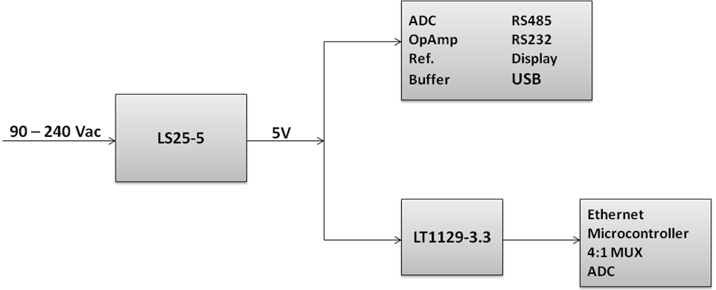
Figure 28: Power Diagram

Future Ethernet Interfacing

Overview

When looking at the previous product used, it was important to find ways to make our design stand out and more desirable to the customer. One idea was to make it more user-friendly and accessible in the respect of the work place. Previously to see the temperature of the device, or devices in the instance that there is more than one, the user would have to constantly get up and check the readings straight from the device itself. However, these devices are running for extended periods of time, and to continuously stop what they are doing to check the temperature is disruptive and could truly hinder the amount of work a person gets done, especially if the devices are nowhere near their desk. In effort to ameliorate this issue, our device will not only have a user interface through the touch screen, but also through the network.

The initial idea was just to have the device hooked up to the network through an Ethernet connection and have a table available that displayed the current settings of each device. This way the user could check the information they need straight from their desk without having to interrupt what other project they may be working on. This idea was then taken a step further, instead of just receiving data from the device, making it available to send a command to the device while it is running that will change the current set point the device is at. This effectively allows a user to begin a run and monitor its temperature throughout without having to leave whatever else they might be working on, meanwhile should they be unhappy with the process and where the temperature is going they also have the ability to adjust the desired temperature.

Requirements

In order to this we need to have components that are compatible with the rest of the controller, an Ethernet connection to a computer on the network, and a program on the computer that receives data and sends back commands. These components must also need to be able to fit into our chassis in a compact and uncomplicated fashion. Even though our project is for only one controller, there is a possibility that a company may have more than one running at a time. This means that not only does this program need to send and receive data from one controller, but to multiple devices as well across a network. This can be done through either TCP or UDP. The data needs to be displayed in a simple, easy to read, format on a program that can run on various computers. It needs to display data for each individual device and include information such as its current temperature, its set point, and a timer showing how long each respective controller has been running. While the data is available the user needs to use this same program to send direct commands to the device such that the user can change the set point of a device as it is going.

Design

The design process for executing the network design is rather thorough. First we will discuss what chip and boards looked at in trying to find a way to connect to form an Ethernet connection to the device. If it is a board, it has everything on it ready to go, however with a chip there more parts still left to choose in order to complete a connection from one location to another. These parts then have things to consider such as packaging, and mounting. While it is fairly obvious on how a chip would be mounted, the other external components such as the Ethernet port are not as simple. The data needs to be sent across the network in a timely fashion. The Ethernet connection must not only connect to the board, but must also be compatible with the microprocessor. In terms of software, it is essential to know how data is making its way from the microprocessor and how the packets will be sent. Then it is essential to ascertain that the computer can receive said packets. Since we are going both ways in this design, it is also important to know how commands are sent back through the Ethernet connection to the microprocessor to change the set points in the middle of a run.

Once all of the networking capabilities are determined, the next step is to work on the user interface. First there is creating a program that can used on multiple versions of windows, and available on a desktop. Then the program must receive the data from the device and be able to input into a table. This live feed also needs to have a timer going so that the user is not constantly refreshing the program. This is where the user then needs to have a way to send a command to change the set point for any particular device at the users will.

Ethernet Access Candidates

Microchip DM320004

When first looking at Ethernet options it was questioned how difficult we wanted to make our lives. The DM320004 would have been by far the easiest option, mainly because it is a PIC32 Ethernet Starter Kit. As one can assume from its name “starter kit”, it came with everything we could need to start off with and more. The board included components such as: Ethernet, USB host, USB micro-B connectors along with a slew of software assistance such as debuggers and compilers. This product was ruled out because of the price and the amount of unnecessary baggage it came with. For one, it had its own microcontroller which is fairly redundant considering another microcontroller is already being used for the temperature controller itself. Not to mention its two USB compatibilities which are also unnecessary. It was also unsure whether or not the board would fit the space confines that we have with all of the extra components so from here it was deemed necessary to look for individual chips and go from there.

Ethernet Controllers

With the board ruled out an alternative approach was taken where instead of looking for an all in one we only purchase the specific parts we need to execute the desired task. Since we need this chip to interface with our micro controller it seemed like a good place to start looking for Ethernet chips would be the same place we got the microcontroller. When looking at Ethernet chips there are two distinctive categories, Analog and Interface Ethernet chips or Microcontroller Ethernet chips. Once again, since we have already chosen a microcontroller an Ethernet chip with the later would provide unnecessary memory and would be over kill for our design. Thus the focus was then put on the three Analog and Interface options that Microchip offers as compared in Table 23.

Part Number | Interface | Available RAM | Number of Pins | Price
ENC28J60 | SPI | 8 Kbytes | 28 | $2.03
ENC424J600 | SPI and Parallel | 24 Kbytes | 44 | $2.60
ENC624J600 | SPI and Flexible Parallel | 24 Kbytes | 64 | $2.81
Table 22: Microchip’s three Analog & Interface Ethernet options

All three of these stand alone chips are IEEE 802.3™ compliant with an integrated MAC, 10/100 Base- T PHY and have a SPI interface. The first chip is much smaller in comparison to the other two chips which is probably a result of its lack of parallel interface. While the last two have the same amount of available on-chip RAM buffer available, the ENC624J600 has twenty more pins than the ENC424J600 and is thus about twenty cents more expensive. Considering the amount of available RAM on our microcontroller, and the limited amount of space on our printed circuit board both of these options are far more than what we need. The only interface we need is SPI thus it is only rational to choose the ENC28J60 for our design purposes.

Package Types

In terms of packaging, the ENC28J60 Stand-Alone Ethernet Controller provided a few options as seen in Table 24. The considerations when discussing the packaging for this controller are similar to that of the microcontroller; however, for our design purpose, a different packaging type will be used. The main difference between the different types of packaging relies in the overall shape of the chip and the type or orientation of the leads. From the layout of our design, and the basic interface as seen in Figure 6, we can automatically rule out the QFN, Quad Flat No Lead Package. For one it is essential to have leads so that it can be soldered into our board with the rest of the hardware, and as also mention the quad layout would not be ideal and could cause complications in the pin out process due to the pines being on all four sides opposed to only two. Thus in discounting this option our focus will now resort on dual pins opposed to quads.

Package Type | # of Sides with Pins | Leads | Max Length | Max Width | Price
SPDIP | 2 | Through Hole | 35.56 mm | 7.49 mm | $3.03
SOIC | 2 | “J” | 17.90 mm | 7.50 mm | $2.83
SSOP | 2 | “J” | 10.50 mm | 5.60 mm | $2.79
QFN | 4 | None | 6.00 mm | 6.00 mm | $2.99
Table 23: Packaging types for the Ethernet chip

The next few packaging types that will be discussed are all the same general size and layout. The next one we will look at is the SPDIP (Skinny Plastic Dual In-Line) package which is the largest, most expensive and uses through hole leads that can be inserted into the board. Due to our desire to conserve space on our printed circuit board, and compared to the dimensions of the remaining options, this can be immediately removed from contention. The SOIC (Plastic Small Outline) is much smaller than the previous option, but when compared to SSOP (Shrink Small Outline) it is still a bit larger and a bit more expensive. The “J” leads of both the SOIC and the SSOP will allow the chip to be soldered directly to the board far more easily than the through hole pins which is another reason these two are more desirable. In the end the ideal package for our design will be the SSOP mainly because it is the smallest, has the ideal leads, and is also the most affordable. As a result the final part number for our chosen Ethernet chip will be Microchip’s ENC28J60/SS.

Microchip ENC28J60/SS

Now that the specific part number has been determined, we can further analyze this part in effort to figure out what other components are needed to make the Ethernet connection from the microcontroller to the user’s personal computer. We also need to gain a deeper understating of how data will be transferred once this connection is made. The figures used within this section were extracted from the parts’ Microchip data sheet. From here we can tell that the next we need to look at is the Ethernet Transformer and from there the RJ45 jack, another alternative is to use a jack that has the magnetic already built in.

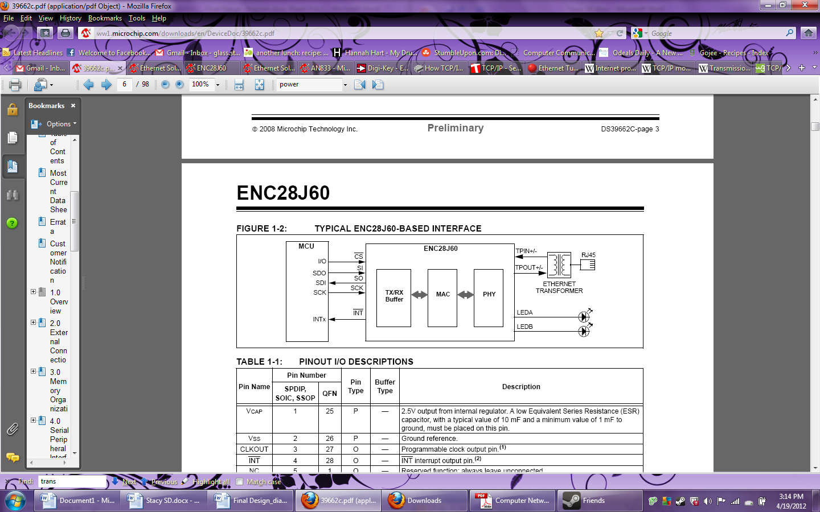
Figure 29: Typical ENC28J60-Based Interface

From Figure 42, we can see the flow of data from the microcontroller to the Ethernet controller and from the Ethernet control out to the RJ455 jack that will be connected with an Ethernet cable to the user’s computer. Before we can start understanding how data is sent out of the device, we need to pick the parts from the Ethernet controller to the through the RJ45 Jack.

Ethernet RJ45 with Transformer versus MagJack

As shown in Figure 42, the Ethernet Transformer is connected to a RJ45 jack, from here the hunt for a part can be narrowed down to some extent. Initially it was found that the main choice in trying to pick the exact part was the mounting. Since we already have a chassis that we want to use it is essential to make whatever RJ45 that we use adaptable to this chassis along with easily accessible to the user. Without knowing the difference between the various types of mounting the first guess was to assume that a surface mount would be it and that there would be no further discussion, but upon further examination, it was discovered that a surface mount can be attached through just a simple cut out, which while easy enough would not provide any actual support to holding this component in place. So from there the various types of mounting were then looked into further.

Mounting Type |  | Company | Part Number | Length | Width | Height | Price
Panel Mount | Bulkhead | TE Connectivity | A-RJ45KU-R | 30.5 mm | 25 mm | 25 mm | $15.90
Panel Mount | Flange | TE Connectivity | 1546908-1 | 44.45 mm | 44.45 mm | 23.9 mm | $19.33
Panel Mount | Flange, Through Hole | Amphenol Commercial Products | MRJ-5481-01 | 22 mm | 29 mm | 14 mm | $13.02
Surface Mount |  | TE Connectivity | 1-338088-3 | 12.7 mm | 14 mm | 14 mm | $1.87
Through Hole | Edge Mount | Sullins Connector Solutions | SMJ401-S88W-DS-01YG | 16.66 mm | 18.40 mm | 11.55 mm | $2.45
Table 24: RJ45 Mounting Options

When being the search for the proper part, it was important to find something that can easily be accessed through the chassis but is also small. In Table 25, five different mounting types were compared along with a specific part to represent each of them. Some important factors in picking the best part for our design are cost, size, its ability to adapt to the chassis, and its ease in implementation. While both the Surface Mount and the Through Edge are the smallest and cheapest options, upon further research it was proven that neither part would suit our needs. The surface mount would have to go directly into our printed circuit board, which not have the external access we need and with its connection to the transducers will take up more space than what is available. Meanwhile, the Through Hole Edge Mount proved to have similar if not even more issues. This too would have to be placed onto the printed circuit board itself, but in doing so it would literally have to be mounted through the holes which are not entirely compatible with our current design.

This then leaves us with the three types of Panel Mounts, the bulkhead, flange, and the flange through hole designs. A panel mount would work better than the previous options because they can be mounted on the side of the chassis by cutting a hole to put them through and then screwing them to side panel. This leaves them at a sturdy and easily accessible ninety degree angle so that no stress is put on the Ethernet cord itself nor is it taking up space on the printed circuit board. The Bulkhead Panel Mount was structurally sound but as visible by the dimensions, this connector is a bit more heavy duty than what we needed. This design would be useful in an environment where the receptacle would be in between heavy industrial machinery opposed to being part of a device that is smaller than a shoe box that is just getting plugged into a computer in an office. The flange panel mount is not as industrial, but is still the largest and most expensive of the given options. It consists of the jack being shielded before being placed in the receptacle assembly and finally locked in place with a flange mount. This too, while secure is far more than what we need for our design. Finally this brings us to the flange through hole panel mount, where like the other panel mounts can be attached directly to the chassis however it is much smaller and is the most affordable compared to the other two panel mount options. in order to mount this part to the chassis, a 16 mm by 14 mm rectangular hole would have to be cut along with two 3.45mm in diameter circular screw holes. From there the part can be slipped in and secured by tightly locking it in place with a nut.

Now with this being said if this Ethernet jack is used we then have to find an external transformer and get those put together onto a circuit board which will take up even more space in comparison to the other components that will also be there. A possibility to do this is by using two of the Pulse Electronics Corporation’s H1164NL Module Transformer Ethernet LAN and placing them in a circuit layout such as seen in Figure 43. This transformer is used for 10/100 Base-Tx port applications and is compliant with IEEE 802.3. If this route is taken then our printed circuit board will end up being extraordinarily cramped with all of these components.

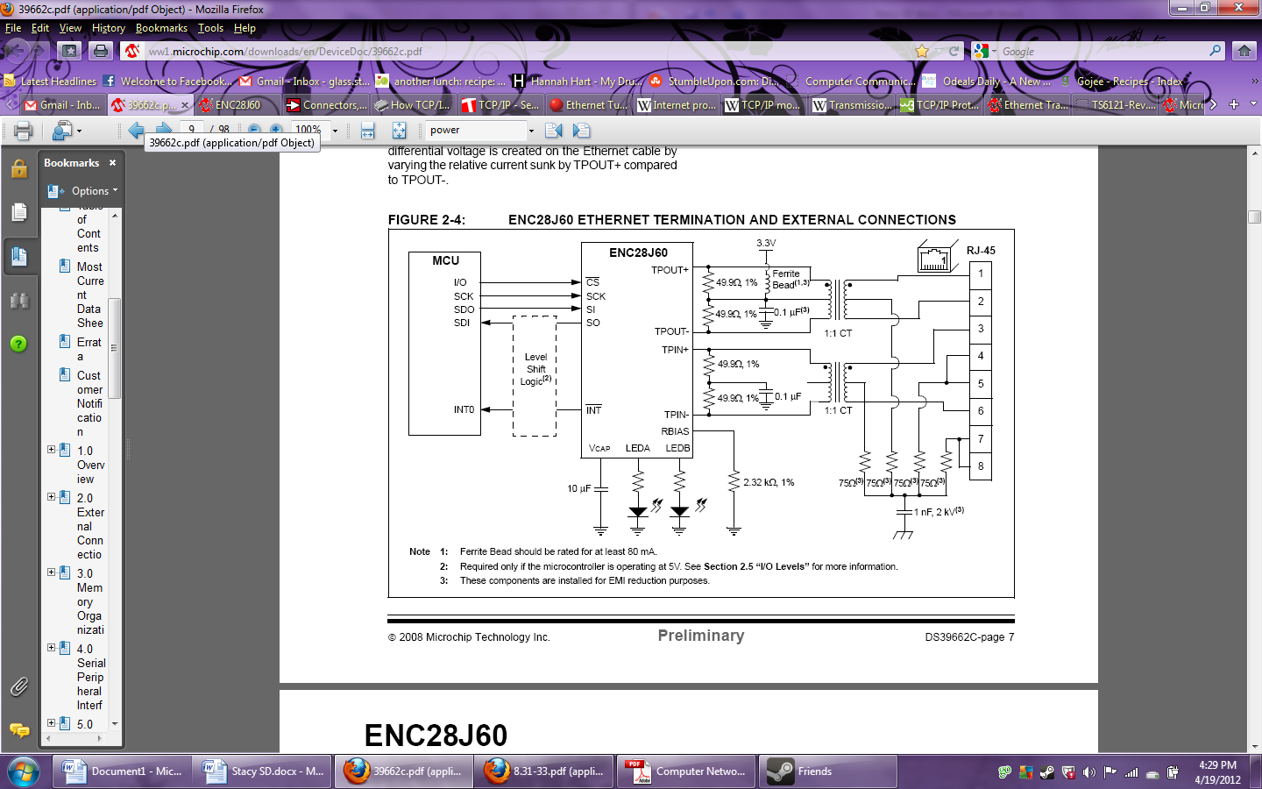
Figure 30: Ethernet Termination and External Connections

There is however an alternative solution that combines both the RJ45 and the Ethernet transformer and it is purely magic. Bel Fuse Inc created a connector series known as “MagJack” the reason for this is that while it is a RJ45 connector with a 10/100 Base-TX speed, it also has the magnetics already included in it. Therefore it is both the jack and the transformers that are needed combined into one package. Its mounting type is a panel mount, through hole, right angle and costs $5.66. While this is not the ideal mounting type, this individual part would make the overall Ethernet design far less expensive and far less complex. The only parts that would be left to purchase are the four 49.9Ω resistors, the two 0.1μF capacitors and the one Ferrite Bead. Typically these components are rather inexpensive making this option far more affordable than buying a RJ45 jack and Ethernet transformers independently. To ensure a strong connection with the Ethernet cable we can make a small hole in the chassis that the cable will be fixed within.

Transmitting and Receiving Packets

As common practice for networks, the internal MAC (Media Access Control) addresses will generate the fields that will be transmitted. The microcontroller will contain all of the data from the PID implementations, along with their current settings. It is this data that will be sent through the buffer memory of the ENC28J60 for transmission to the user’s computer. Each packet will need a control byte to accompany it as it is sent. The layout of transmission is in the form of a stack. First is the control, which is followed by the data, which is then trailed by a status vector that will point to the next designated location. When data is being sent back to the controller, the microcontroller will use the RBM SPI and start reading in the information. In the instance that RAM is needed, the Ethernet controller will manually calculate the proper amount of space needed and buffer itself accordingly. The two LED bulbs shown in Figure 42, LEDA and LEDB, are there for the purpose of informing the user when there is network activity.

TCP/IP versus UDP

Now that the hardware is all figured out, and we have a firm connection from the High Precision Temperature Controller to the computer and we understand how the Ethernet controller is sending and receiving data, we can look further into the network protocol that the Infrared System Development Corporation’s computers will use. At this stage in the network system data is transferred across the Transport Layer. This layer follows, and thus relies on the Internet Protocol from the previous Network Layer. The two main types transport layers we will compare are TCP/IP and UDP, both of which are supported through the Serial Peripheral Interface of the Ethernet controller. Some of the their strong differences are compared in Table 26. Transmission Control Protocol and User Datagram Protocol are used for transmitting data from the High Precision Temperature Controller to the company’s network.

Connection Type | Reliability | Dependency on Connection | Delivery of Packets | Example Uses
TCP/IP | Reliable | Dependent | Ordered | HTTP, FTP
UDP | Unreliable | Independent | Unordered | Streaming, Skype
Table 25: Comparison of TCP/IP and UDP

TCP/IP is so named strictly because the TCP breaks the data down into individual Internet Protocol packets before they are sent, and assembles them when they are received. TCP/IP waits for a connection to be made before sending data. Once this connection is made, the data it is sent in an orderly fashion which is done through both congestion control and flow control which is what assists in making this option 100% reliable. If a packet is unable to send, the server will request the lost information to be sent again. Typically data is sent in a specific order, however, if an incidence occurs where the packets are sent in an incorrect order the TCP will buffer the data until they can be arranged in the proper sequence. One of the reasons this protocol is such a strong contender is because of its ability to send data bi directionally. This is important because on top of reading data into a table the program on the user interface will also have the ability to change the set point of a device. In order to do this we need to have the ability to send a command back to the High Precision Temperature Controller to initiate the change.

Meanwhile UDP is named such because the information is sent in the form of a datagram. Unlike the alternative option, UDP does not need a connection to set up and does not care if the network can handle the packets or not. Rather it begins sending data in an unordered process and ignores any segments that may get lost. The reason the packets are not sent in any specific order is because each packet is independent of one another and the data can only be sent in one direction. One of the positives of this process and what makes it a contended despite its unreliability, is that this process is good for servers answering to a multitude of users. It supports packet broadcasting and multicasting where information is sent to all on the network and not just sending information to one host which will then go to another host in a chain of internetworking. Instead it can just to all of the subscribers on the local network. Despite this massive pro, then information we are sending cannot afford to get lost and for the purposes of the user interface on the computer, all of the data needs to appear without needing to wait to buffer. Also, since the data we want to read into the user interface may be coming from several devices the lack of congestion control in the UDP is concerning. Not to mention that part of our design for this network is to be able to send information back through to the devices, since UDP’s connection is only one way and attempts and handshaking would be rather complicated. If we were streaming constant live feed or videos, then this approach would be much more desirable, but since this is not the case we will be using the TCP network.

User Interface

This is not the user interface of the device itself, but rather the user interface through the computer. As we have previously mentioned one of main reasons we are connecting our device to the network is so that a user has access to the current devices’ settings from the convenience of their desk. Once the information is sent from the Ethernet controller, through the TCP network the data is then accessible from a program on the user’s device. We want the program to be easily accessible and thus will have available shortcuts that can be placed on the desktop if desired. Another important factor is the visual appearance and how user friendly the program is. Thus, instead of writing a long code a gooey was and will be used to format the overall layout of the program. For the design see in Figure 44 we used a GUI editor available through Java’s NetBeans.

Once this program is opened a display such as that see in Figure 44 will appear. As you can see, the information is visible through a concise and easy to follow table that shows the device, the set point desired, the temperature that it is actually at and the a timer for how long the device has been running. Most, if not all of this information can be found in the PID process within the microcontroller. The reason there is room for multiple devices, is that while right now we are only creating one controller this company usually has more than one Blackbody source being tested at time, which would imply that more than one High Precision Temperature controller will be used. As a result we have added space for multiple devices to accommodate this possibility.

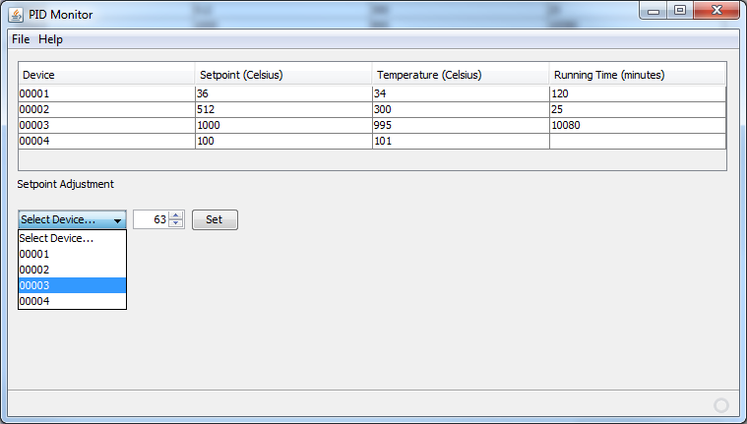
Figure 31: Sample Program Display

When the idea was proposed to have this information available on the network the idea was discussed and the further built on. Instead of just having a one way connection we could fully utilize the TCP and send data or commands back to High Precision Temperature Controller. This concept is utilized in the small menu beneath the table. From here the user can choose which device they want to change. Once that is decided the user can use the small field to the right and input the set point they want to see the device at. Once this is set the information will go back through the network and the set point will be augmented accordingly. Thus the computer interfacing is complete from the connection of the microcontroller to the ENC28J60 to the Ethernet transforms and the RJ45 Ethernet jack, across to the TCP network to the computer. This process is then repeated in reverse order in sending data back. Overall with the use of the Computer Interface our High Precision Temperature Controller will become even more user friendly.

Final Design

Shown in Figure 45 below is the block diagram of our final design. As shown from the diagram, there are 3 main devices we will need to communicate with inside Infrared Systems Development’s black body sources: the thermocouples, heater and fan. The fan is communicating directly with the microcontroller with no intermediate devices. Control of the fan will be limited to on and off commands. The heater inside the source is controlled by either an AC or DC relay depending on the heater type, and will turn on and off at different power levels according to the output of our PID algorithm. The thermocouples inside the source are the only devices communicating out of the source. Their end goal is to transmit their readings to the processor; however, this signal is very small and will need to go through an amplification process first. The processor will choose which thermocouple to read at that instant and its input will be passed through by a multiplexer. Once selected, this amplified signal will become digitized through our analog to digital converter and finally end up at the processor. The processor will then communicate with the EEPROM to access data from the thermocouple look up tables and implement the algorithms mentioned in the temperature processing section.
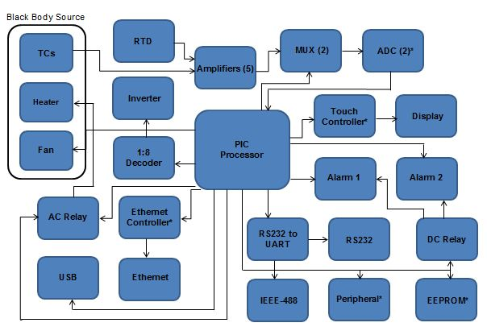
Figure 32: Final Design

Our touch panel display will need to communicate with the touch controller which is getting its instructions from the microcontroller. The display will also need to send information back to the processor depending on certain user inputs. Alarm settings are one of these user inputs, which will be displayed on the touch screen and will go off when the temperature of the source is approaching its set point. These alarms are controlled by a DC relay which will turn on and off appropriately to trigger the alarms.

Data can be taken from the microcontroller or uploaded to via many communication lines included in our design. The user can even monitor the temperature and status of the heating source from an application on a computer desktop via communication with the Ethernet. The Ethernet controller controls this port and allows data to be sent to the user remotely. USB, RS232 and IEEE-488 are also available communication ports included in our design. An example application of data transfer via the USB would be an update to a sensor look up table, but these devices can be utilized in many different ways.

Overall, each of our subsystems collaborates at a central control unit to constantly monitor the temperature of the source and the user inputs. The intuitive user interface also makes it easy for the user to communicate to the controller what kind of data is wanted. Collectively, each device plays its part to ensure maximum accuracy and quick response times as efficiently and economically as possible.

Testing

Microcontroller Testing
To test the Microchip PIC32MX150F128B, Microchip offers the MPLAB REAL ICE In-Circuit Emulator. This device is capable of debugging through MPLAB’s IDE. It offers single-step debugging with variable inspection and modification. In terms of hardware debugging, it features eight logic input/output probes. Also, it has SPI trace capabilities that will allow us to look at the data that is being sent through these lines. This is extremely important because all peripherals on the microcontroller will communicate via SPI. To interface the In-Circuit Emulator with our temperature controller, we will use a CAT-5 connection (Pins 1 – 5) on our temperature controller with connections to V_{DD}, V_{PP}/MCLR, PGC, PGD, and V_{SS} pins on the PIC32MX150F128B. The testing procedure will ensure that our temperature controller is responding correctly to an appropriate heat stimulus. We will use a mV power supply to serve as our virtual heat source. We will use an SPI trace to read what values are being sent from our ADC to our microcontroller. Based on this value, we will look at the relay control output to detect the percentage of power used to power the heater by looking at the duty cycle of our output. We will compare the response to the response of our simulated PID temperature controller. This will determine if our microcontroller is correctly responding to the temperature stimulus. We will also check the functionality of the two onboard alarms. We will use the I/O probes to determine the predicted alarm response with the actual alarm response. We will have display test to ensure that all portions of the display are addressable and working. We will also use an SPI probe to determine if the correct data is being written to the display controller. We will have a display test to ensure that all pixels on the display are functioning correctly. We will do this by sending out the correct GD0-GD15 values to make all blue, red, and green. We will ensure that the our touch screen is functioning correctly by using the SPI probe to determine what X+, X-, Y+, and Y- values are being returned when the screen is being pressed. Another feature available to us is the JTAG Boundary Scan using the JTAG pins (TMS, TDO, TCK, and TDI). This test will use Shift registers to go through all of the different I/O pins and the external JTAG controller will provide a set of instructions to the pin and read its appropriate response. This will allow us to test the functionality of all 64 pins quickly and easily. The JTAG controller we will be using will be the JTAG USB-1449.1/IE. This has software, ScanExpress Runner that will allow us to quickly and easily write instructions and evaluate the responses. Pictured below in Figure 46 is the MPLAB REAL ICE emulator and how we will connect it with our PIC32.

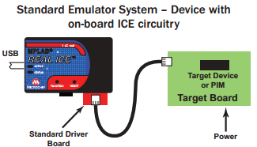

Figure 33: Microchip REAL ICE

By using the Microchip REAL ICE debugger, we were able to ensure that our PID algorithm was responding in the correct manner. By running the code in the Debug mode within MPLABX, we were able to see the different values of the proportional, integral, and derivative control and see its effect on the duty cycle of the PWM line. By viewing these values, we were able to see issues that may not have been apparent if we were not able to do in-circuit debugging via the Microchip REAL ICE.

Peripheral System Testing

To ensure that we are able to utilize all of the peripherals associated PIC32MX150F128B, we will need to determine a testing protocol that will be able to quickly and easily confirm that the all devices are working properly. With the computer peripherals, we will use a special command that will instruct the computer to respond with the same message that it just received. If the device is working correctly, the microcontroller will get the same bytes back. We will compare the bytes received with the expected bytes and if they are equal, we know that the particular computer interface is operating correctly. If we get a different response, we know that the peripheral is not working correctly and we will display the error to the user and perform an appropriate action. To test 25AA640A, we will have a byte that will be written to an unoccupied memory address. After the write operation, we will read the value contained at the memory address. If the value we read matches the value we wrote, then we know that we are able to communicate with the external EEPROM. Otherwise, we know that there is an error communicating with this device and we will display this error and take appropriate actions. To test the uLCD-32PT (GFX), we will run a color test that will vary the screen from red to green to blue, the tester will confirm if the display performed as expected. If it did not, then we will notify the user and take appropriate actions. To test to see if we can communicate with the TSC2046 touch controller, we will wait for a touch input at the touch screen during a predefined window. If there is not a touch detected, we will timeout and report that there is an error with communicating with the TSC2046.

Specifically with the MAX232, which handled RS232 to UART conversions, we were able to view the control signals using an oscilloscope to see if the MAX232 was inverting and reducing the voltage levels of RS232 to usable TTL levels. By confirming this, we knew that the hardware portion of our computer interface was working. The troubleshooting that occurred had to do with the configuration of the baud rate of the UART lines. Since the PIC32MX150F128B utilizes a clock divider to obtain the desired baud rate, we were limited in the possible baud rates that were available because of the integer divider values which resulted in large errors when comparing theoretical baud rates with actual baud rates. We were able to use a 30 MHz peripheral clock and use a divider value that allowed us to use a baud rate of 19200 with .16% error. By inserting error checks in the computer interface and in the PIC32MX150F128B, we were able to ensure that when an errors occurred, it would cause catastrophic issues with our temperature controller.

Display System Testing

To test the touch screen display we will write some test code to have the microcontroller turn the screen different colors. This test will make sure that all of the pixels are working properly and that it can produce the different colors. We will also have it display writing in different areas of the display. Once we know that no pixels are out then we can go on to test the touch sensing. We can write more test code to but buttons on the screen. If we have time it would be a good idea to make a series of different shapes and sizes of the buttons. This will help us detemine how small we can make the buttons while still being easily and accurately touched by the user. One way to test the simplicity of the user interface would be to have someone outside of the group go through the user interface seciton of this paper and try to navigate their way through the menus. This will help us troubleshoot any confusion before we actually write all the code for it. Once we have the code written and everything hooked up we can fix any other bugs that we find when we come to it.

Thermocouple Testing

Infrared Systems Development’s black body sources have a thermocouple connector embedded into them. We can use these straight connections to verify the exact voltage output coming from the thermocouples and therefore determine the correct temperature. From this direct reading, we can determine the accuracy of our subsystem.

Multiplexing Testing

To test the multiplexer’s reliability to transmit our measurements, we will design a series of test circuits to measure data accuracy, switching time and fluctuations in operating temperature conditions. For testing purposes, we will order some through hole parts as well as the surface mount parts we will need for our printed circuit board. To measure data accuracy, we will use monitor the known input signal and keep a constant watch on the output to check for any offset or noise. We will do this for each input and vary the temperature from 25 to 40 degrees Celsius each time. Here, in this testing environment, we will also observe the effects of charge injection on our data.

Power Testing

Once we get all of our components and our PCB board we can start to test to make sure all of our components work. We can test our power supply easily just by plugging it in and making sure we are getting our desired output. Next we will start by conducting a smoke test by wiring up our board to an input power and to ground. If nothing catches fire, blows up or starts to smoke then we can continue onto testing our other components. Once we conduct this test we will test each component that needs power one by one. We want to make sure that everything is soldered right and that there are no shorts or any other issues with the circuitry. This process can be tedious but it is necessary to do so that we know our components will work properly. Once we test each individual components we can test the system as a whole. Hopefully everything will work but if not then we will have to conduct a series of other tests to find out what is causing the issue. If something with our PCB board is soldered wrong this will be an issue if we have to send it back to get fixed because it will waste time and money. We also need to be very careful when testing our components because we won’t have many spare parts lying around. Once we test to make sure that everything is being powered correctly we can go onto other testing and troubleshooting to get our device working the way we want it to.

Complete System Testing

The temperature controller needs to accurately regulate the temperature of a blackbody source with +/- .1°C of error. After the blackbody source and controller undergo calibration, testing will occur to confirm that the controller has been calibrated correctly.

To test the controller and blackbody source, there are two main procedures to follow: Data and Stability. Both processes will check to see if the controller and source were correctly calibrated. No modifications can be made to the offset points or values during testing.

During Data, the controller will bring the blackbody source to the temperature indicated by the offset points minus 1.0°C. For example at an offset of 101.0°C, the temperature controller will bring the heat source to 100.0°C. Once the source reaches stability, a comparison will be made between the display temperature and the external temperature as read from the external thermocouple that is set up in parallel with the internal thermocouple used to calculate the display temperature. If there discrepancy between the two temperatures is greater than .1°C, the modifications can be made to that offset value. Since we are using linear interpolation that only utilizes the two closest points with equal weighting, modifying one of the offset values, should not affect the temperature at any other offset point. However if any modification is made to any offset value during the testing phase, the blackbody source and controller must be retested at all other offsets to ensure that the modifications did not have a negative effect on the accuracy of other points.

During Stability, the blackbody source will be brought to the maximum temperature rating of the source. Once stability has been reached at that temperature, data recording will begin. Once every hour, for five hours, a recording will be made copying the display temperature and the external thermocouple temperature reading. Like Data, these readings should be within +/-.1°C. Unlike Data, changes cannot be made to the offset values during Stability. If any changes are required, the controller and source must be recalibrated.

Future Advancements

User Interface

Overview
The user interface is a very important part of this device because many different users are going to be using this so it needs to be intuitive and require little instruction for proper use. The user interface will be designed to look sleek and high-tech but be user friendly. In the future we would like to incorporate a series of menus with on screen buttons and also increase the screen size to 4.3” diagonal. There will be a menu for the everyday user and a menu for the administrator.

Requirements

One of the most important requirements of this user interface is that it needs to be use friendly. It needs to be very simple but still look advanced. For the user menu it needs to have an alarm menu, set point menu, backlight dimming menu, the ability to show the actual temperature, the energy radiated by the blackbody when the device is on, and the black body radiance. For the administrator menu it needs to have a menu to set the number of samples, a menu for the offset points, a thermocouple menu, a menu to change the PID coefficients and a menu for the max power to send to the device. These menus will be discussed in more detail in the following sections. The device should also perform power on self testing to be sure all sensors and devices are operating normally. In the event of a failure, the system should report the failure type. The system will also have automatic save and restore to default settings after any value is changed.

User Interface Design

When the user turns on the display the first thing that will appear is the Infrared Systems Development logo. As soon as the display warms up a screen with the device temperature, the alarm output status lights, the power output to heater status lights, the user menu and the administrator menu will come up. The yellow dots are the power output to heater status lights and the red dots are the alarm output status lights. These will be lit when there is power going to the heater or the alarm conditions have been met. More on setting these values will be discussed in the following menu sections.
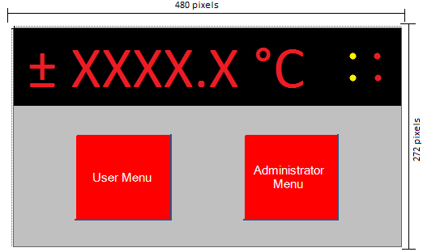
Figure 34: User Menu and Administrator Menu Screen

If the user presses the User Menu button in Figure 47 then a new screen will appear with different options. The temperature and status lights will be on the screen at all times. When the User Menu button is pressed it will display a screen showing the settings of the alarm status, the current set point, the BBRD, the input 1 and input 2 and the power 1A. If either ALARM 1 or ALARM 2 says HIGH then that means that the relay is closed allowing the user to add external circuitry that will be triggered once the alarm goes high. If either of them says LOW then that means that the switch is open which will deactivate the circuit. The alarms are typically tripped when the actual temperature is above or below the set point by a certain amount. The SETPOINT is the temperature that the user wants the device to get to. The BBRD stands for black body radiance. This value is calculated by the Stefan-Boltzmann law. This law states that the total energy radiated per unit surface area of a black body per unit time (or the emissive power) is directly proportional to the fourth power of the black body’s thermodynamic temperature. The equation will be calculated based on the current temperature of the device. The equation for this is , where is the Stefan-Boltzmann constant and has a value of 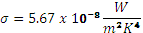. The INPUT 1 and INPUT 2 show the temperatures that are being read by the thermocouples. The CHOPPER SPEED is the frequency that the blade is spinning at, which is measured in the device. The ENERGY BY BB is the energy radiated by blackbody, which is calculated by Planck’s Law. We will be using Planck’s Law in terms of wavelength. The equation for this is 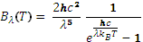 where T is the temperature of the black body, is the Boltzmann constant, h is the Planck constant, is the wave length and c is the speed of light. The user will have to define the upper and lower wavelengths so the energy radiated by the blackbody can be calculated. The POWER 1A is the percent of power to the heater and this is also set by the administrator. The user has the options to change certain values. To do this the user will press the Operations button at the bottom right corner of the screen in Figure 48. If they press the Back button they will be brought back to the menu in Figure 47.
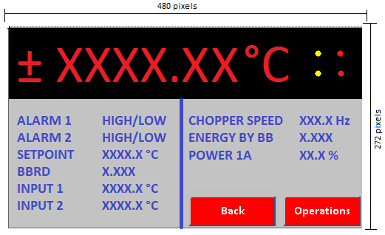
Figure 35: Current Values of Device

After the user presses the Operations button it will bring them to a menu where they can change the alarm set points, the ramp to set point value, the current set point value, the wavelength range for the blackbody energy and the backlight brightness. The alarm set points allow you to change the high and low deviations for alarm 1 and alarm 2. The alarm low deviation defines the deviation value on the low side of the set point at which the alarm will be triggered. The alarm high deviation defines the deviation value on the high side of set point at which the alarm will be triggered. The ramp to set point allows you to choose how many °C/min or °C/hour you want the temperature to increase until it reaches its set point. This setting can be turned off, on at start up or you can choose to start up and change. The current set point value is the temperature you want the device to reach and the user can also change the brightness of the backlight. The brightness setting is controlled by the PWM signal through the driver. The user will also have to enter the lower and upper wavelength so that the energy radiated by blackbody can be calculated. If the user presses the Back button they will be brought back to the menu in Figure 48.
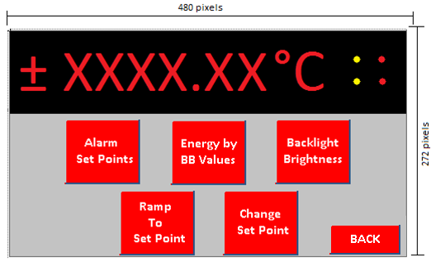
Figure 36: User Operations

If the user presses the Alarm Set Points button then they will be brought to another screen with Alarm 1 and Alarm 2 buttons as seen in Figure 50. If the user presses the Back button they will be brought back to the screen in Figure 49.

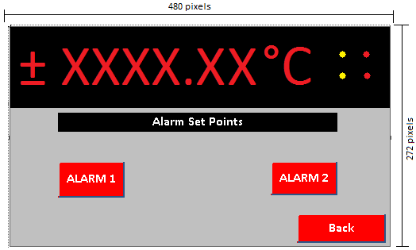
Figure 37: Alarm 1 and Alarm 2

When the user presses either the ALARM 1 or ALARM 2 button they will be prompted to a screen where the user will enter the low and high deviations for each alarm as seen in Figure 51 and Figure 52. This will usually be in the form of ± X.X ̊C but the user will have the ability to enter a number as high as ± XXXX.X ̊C. The negative (-) is for the low deviation and the positive (+) is for the high deviation. Once the user is done entering this information they will press the DONE button which takes them back to the screen in Figure 50.

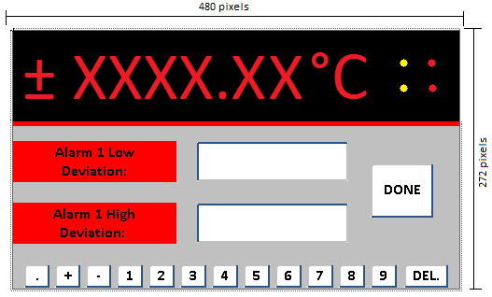
Figure 38: Alarm 1 Deviations

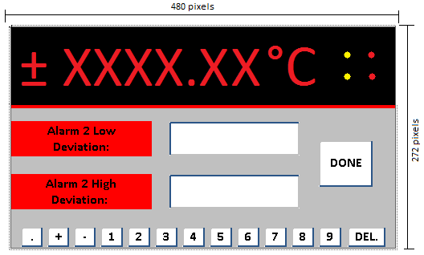
Figure 39: Alarm 2 Deviations

Next the user will need to enter the upper and lower wavelength values so the energy by the black body can be calculated. If the user presses the Energy by BB Values button it will take them to another screen where they will have the ability to enter each of the values as seen in Figure 53. Once the user is done they will press the DONE button and it will take them to the screen in Figure 49.
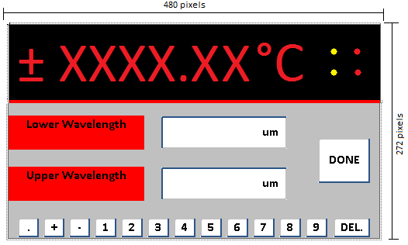
Figure 40: Wavelength Ranges

If the user wants to change the backlight of the screen to make it lighter or darker they will press the Backlight Brightness button. After pressing this button it will take them to a screen that has a scroll bar that ranges from 0 – 100% with an indicator showing what percentage the backlight is at as seen in Figure 54. There will also be arrows on each side of the bar for the user to move the indicator left or right. Once the user chooses their backlight preference they will press the DONE button and return to the screen in Figure 49.

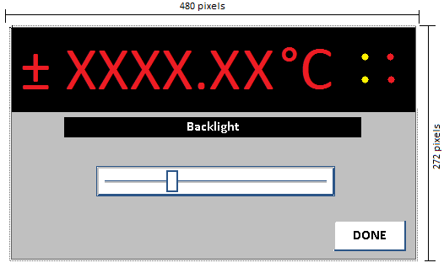
Figure 41: Backlight Setting
The Ramp to Set Point button will allow the user to choose how many °C/min or °C/hour they want the temperature to increase until it reaches its set point as seen in Figure 55. The user has two options for this setting, which are off and start up and change. If the user presses the OFF button then this setting will be turned off and it will automatically shoot up to the desired temperature and return them to the screen in Figure 49. Start up and change means that once you input the value and leave the menu it will start ramping up in the increment that the user chose. Pressing this button will take you to a screen where the user will enter the Ramp to Set Point Rate as shown in Figure 56. Once this setting is set the user will press the DONE button to go to the screen in Figure 49.
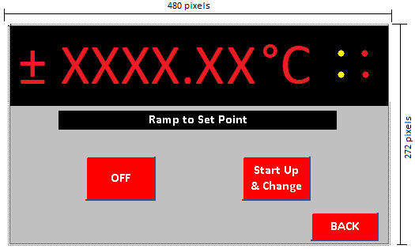
Figure 42: Ramp to Set Point Options
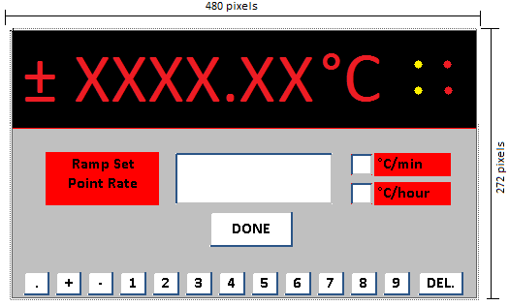
Figure 43: Ramp to Set Point Rate

The last button on this screen is the Change Set Point button. This button allows to user to change the current set point to the desired set point as seen in Figure 57. The value the user inputs will be in the form of XXXX.X °C. Once the user has entered the value they will press the DONE button to return to the screen in Figure 49.

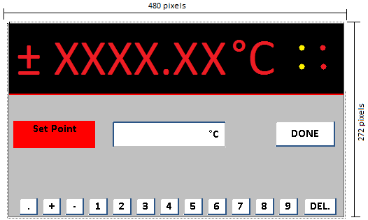
Figure 44: Set Point

After the user enters all of their values then they will press the Back button on Figure 49 to return to the screen in Figure 48. The user will most likely stay on this screen for the remainder of the time that the device is on since this screen shows all the values that they just put in.

This device also has an administrator menu which is protected by a password and will be accessed through Figure 47. The administrator will have access to all the user menus as well as few extra options that should only be accessed by the administrator. Once the Administrator Button is pressed then a new screen comes which will prompt the user to enter a passcode as seen in Figure 58. Once this passcode is entered correctly then the administrator will press DONE and a new screen with all the administrator options will appear as shown in Figure 59. If the user presses the back button it will take them to the menu in Figure 47.
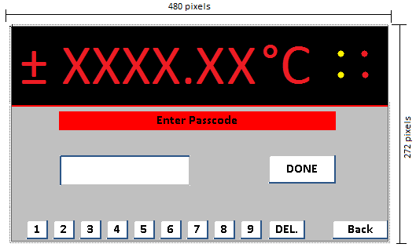
Figure 45: Administrator Passcode

The extra settings on this menu are offset points, thermocouple type, the max power to send to the heater, the number of samples the device takes and the option to change the PID coefficients. The offset points menu will allow the administrator to change any of the offset points. The thermocouple menu and max power menu will allow the administrator to pick the thermocouple type that will be used and choose the amount of power that is sent to the device, respectively. The number of samples menu is the menu where the administrator can choose the amount of samples the device takes in a certain time period before it displays the temperature. The PID menu will allow the administrator to change the crossover points and the coefficients. If the user presses the Back button then they will be brought back to the menu in Figure 47.
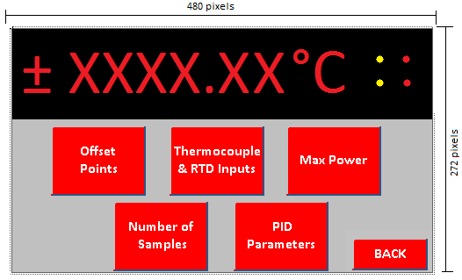
Figure 46: Administrator Settings
If the user presses the Offset Points button then they will be brought to a screen where they can modify the offset point and offset value as seen in Figure 60. A scrolling list menu will come up with Offset 1 through Offset 17 and the user will pick which offset they want to modify. Once the user picks an Offset then they need to press the continue button to move onto the screen in Figure 61. If the user presses the Back button they will be returned to the screen in Figure 59.
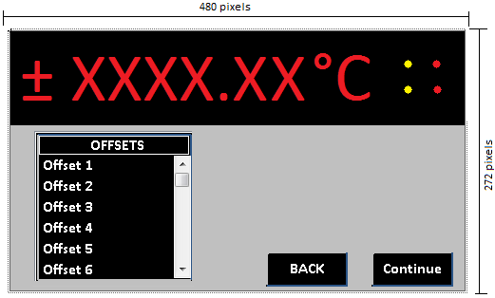
Figure 47: Offset Menu

Once the user picks the offset they want to modify they will get brought to a screen with the Offset Point and Offset Value boxes as shown in Figure 61. The user will input the value in °C for both values. Once the user is done they will press the DONE button which will take them back to the screen in Figure 59.

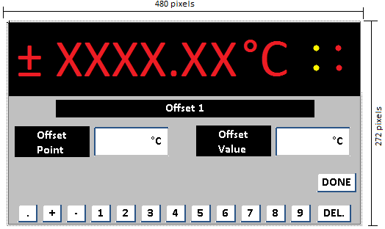
Figure 48: Offset Point and Offset Value
If the user presses the Thermocouple & RTD Inputs button then they will be brought to a screen with Input 1 and Input 2 as shown in Figure 62. Both input buttons take you to different screens but they all display the same options. The user will have to set each of these to either a thermocouple, a RTD or turn it off. If the user wants to go back to the screen in Figure 59 then they will press the BACK button.
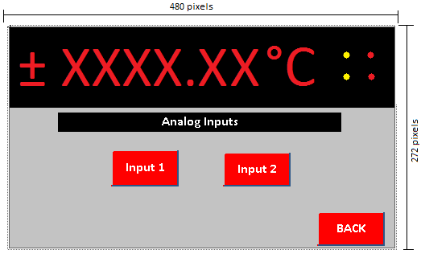
Figure 49: Analog Input 1 and Analog Input 2

Once the user chooses the input they will need to choose the thermocouple type and RTD for inputs. They can choose from type S and T for the thermocouples. If the user chooses RTD then they are finished but if they choose a thermocouple type they will be brought to another screen. The user can press the BACK button to return to the screen in Figure 63.

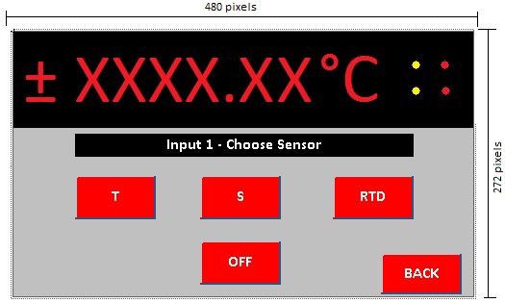
Figure 50: Sensor Type
If the administrator chooses thermocouples they will be brought to a screen to that has Cold Remote Sensing options as shown in Figure 64. The user can choose from Internal, None (Constant) or CJC on Input 2. Once the user makes their selection they will press the DONE button to return to the screen in Figure 59.
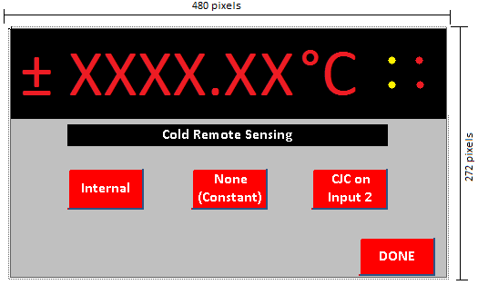
Figure 51: Cold Remote Sensing

The Max Power button allows the administrator to input the maximum percentage of power that is being sent to the device. The user will be brought to a screen where they choose either Heat (Reverse) or Cool (Direct) as shown in Figure 65. If the user presses the Back button they will return to the screen in Figure 59.

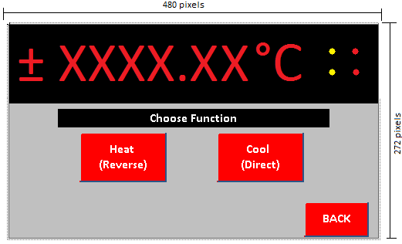
Figure 52: Heating or Cooling Function
Once the user chooses they will be brought to a screen where they enter the percentage of power they want to send to the device as shown in Figure 66. Once this value is entered the user will press the DONE button to get to the screen in Figure 59.

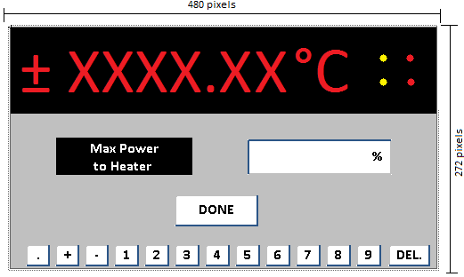
Figure 53: Max Power to Heater

The Number of Samples button will allow the administrator to input the number of samples that the device will take before the actual temperature is displayed as shown in Figure 67. The device will average the temperature for however many samples the administrator enters. Once this is entered the user will press DONE to get to the screen in Figure 59.

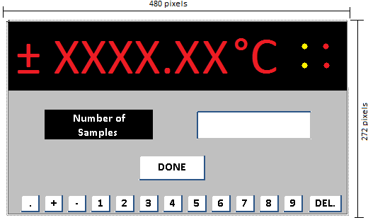
Figure 54: Number of Samples
The last menu that the administrator can control is the PID parameters. The device will use five PID sets for different temperature ranges. Once the user presses the PID Parameter button they will be brought to a screen with five different PID Sets and they will choose which set they want to change as shown in Figure 68. If the user presses the BACK button they will be brought to the screen in Figure 59.
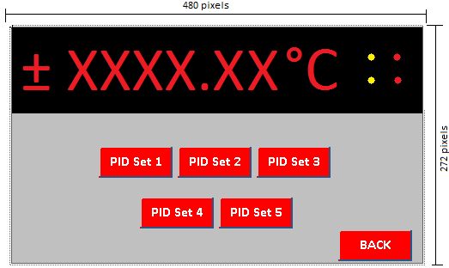
Figure 55: PID Setting Menu

Once they press the PID Set button they will be brought to a screen to enter the parameters for each part of the PID, as shown in Figure 69. The proportional parameter will be in units of °C, the integral parameter will be in units of /minute and the derivative parameter will be in units of minutes. Once the administrator enters these values for each parameter and each set they will press the DONE button and return to the menu in Figure 68.

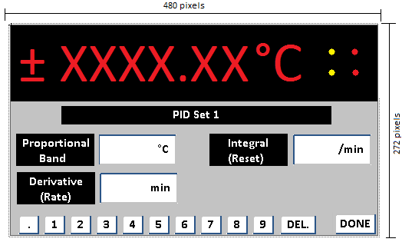
Figure 56: PID Value

Solid State Relay Control

One of the future features of the high precision temperature controller is a single output solid state relay control. By using single output control versus pulse width modulated output, it will allow us to further divide the pulses which will allow us to more accurately control the temperature of the blackbody heat source.

Administrative Content

Group Responsibilities

In the planning phase of our project, we decided to break down our design into 4 major subsystems: microcontroller and communications, display, temperature sensing and PID optimization. Since there are 4 members in are group, this break down seemed appropriate and distributed the workload fairly. We also assigned miscellaneous research and tasks that did not easily fit into a subsystem to group members according to their workload and interest. The block diagram shown below presents the break down of our design and details the group member responsible.

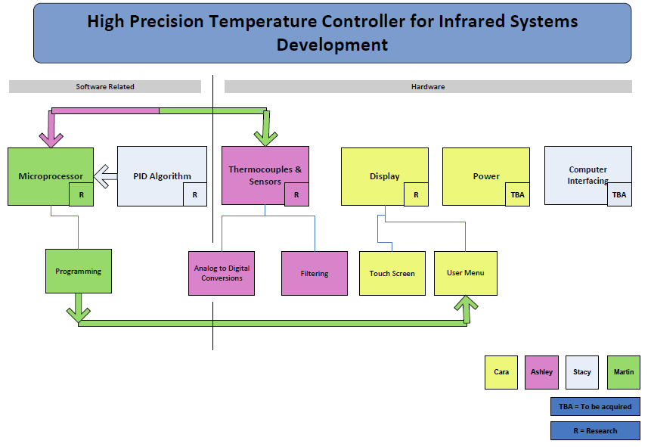
Figure 57: Subsystem Block Diagram and Assignments

As you can see from the diagram in Figure 70, the design research and tasks were distributed fairly. Martin Trang is responsible for the microcontroller, programming and any interfacing devices that communicate with the microcontroller. This is a huge task on its own and therefore, we did not assign Martin any more tasks. He was given this subsystem because of his interest in embedded systems and his vast experience and knowledge in C programming. Ashley Desiongco is responsible for the temperature sensing subsystem which includes research and design of devices embedded in Infrared Systems Development’s sources and also many electronic devices needed for data collection. This also is a huge effort by itself and therefore, we did not assign Ashley any more tasks. She was given this task because of her interest in electronics and her experience with circuit design. Cara Waterbury is responsible for the display and power subsystems. She not only had to research and choose an appropriate touch screen and controller, but she also had to design the user interface according to our sponsor’s specifications. She was given this subsystem because of her interest in touch panel technologies. The power system research and design was also done by Cara, and she had to work with Martin and Ashley’s subsystems in order to find and account for power to all the devices including her own. Stacy Glass is responsible for the PID algorithm and computer interfacing subsystems. Her research on the PID algorithm optimization is critical for the quality of our controller and therefore has been her main focus. She was given the task because of her experience working with genetic algorithms. She was also assigned the computer interfacing because it was her idea to allow users the capability to monitor the temperature remotely via a desktop application.

Budget/Cost Analysis

Before we had started thoroughly researching and designing the devices needed for our project, we drafted a rough estimate budget based upon little initial research done via the internet. We know from our sponsor’s requirements that the finished, ready for production controller should cost no more than $500.00 to manufacture. This allows Infrared Systems Development to sell the controller still at a reasonable cost to consumers, but still make a profit. This cost only includes components found within the controller itself, but for our project, we will probably spend more than this manufacturing budget for prototyping, testing and ordering spare parts in case of device failures. In the chart below is a rough budget of what we had previously estimated before we started the project, and the cost of the desired parts we have now discussed.

Device | Estimated Cost
Microcontroller | $10.00
Memory | $2.50
A/D Converters | $15.00
Misc. Peripherals | $15.00
Misc. Electronics | $30.00
Touch Screen | $150.00
TOTAL | $222.50
Table 26: Budget

As you can see, in Table 27, we over estimated for many of our components. For example, we estimated $150.00 for the touch screen previously, but since then have found a perfect candidate that meets all of our requirements for a mere $38.00. The miscellaneous electronics category encompasses all the small, but necessary, components in our design such as: amplifiers, multiplexers, decoders, inverters and voltage references. The miscellaneous peripherals category encompasses all the communication devices in our design such as: Ethernet, USB, RS232 and IEEE-488. Certain components such as the thermocouple extension wire and alloy pins and connectors were not included in our cost analysis because Infrared Systems Development manufactures custom thermocouples and extension wire. All final design components will be fully funded by ISDC and any testing equipment costs will be co-funded by all four of our group members. Texas Instruments has also given us an allowance of $200.00 worth of TI parts.

After finishing the design and implementation of the high precision temperature controller, we were able to compare our proposed budget with the actual cost of a single high precision temperature controller. As seen in Table 28, our actual budget for the High Precision Temperature Controller exceeded the estimated budget calculated in the Spring semester. This can be attributed to the underestimation of the cost of passive components as well as the omission of the PCB board cost during the Spring planning stages. Even though we exceeded the budget from the Spring, the target of having the temperature controller to cost less than $500 was achieved.

Parts
Digital Devices | $ 21
Analog Devices | $ 30
Passive Devices | $ 62
Power Devices | $ 20
Display | $ 101
Board Fabrication | $ 80
Programming Tools | $ 52
TOTAL | $ 366
Table 27:Final Budget

Milestones/Schedule

Early on in the planning stages of the project, we were asked to make a milestone timeline outlining the major events in both the spring and fall semester. We drafted a schedule before we had done major research into our specific subsystems and pre-mature to the full understanding of senior design 1. As you can see by our timeline below, we have a handful of key milestones planned out for both academic semesters. The dates at which the spring semester schedule was set were ideal and ambitious and we slowly realized how unrealistic they were. We initially wanted to order sample parts to see what kind of components we were going to be dealing with, but we decided because of cost and time constraint that we would save this until the fall.
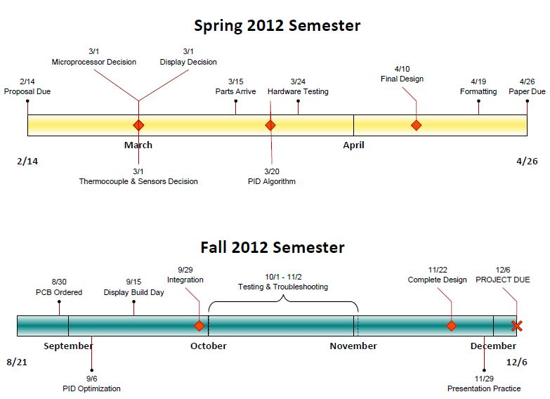
Figure 58: Milestones

The fall semester milestones are still very much realistic. We plan to stick to this schedule in order to maintain a steady development and testing plan for our design. We would like to include our sponsor as much as possible in this development and will therefore need to consider their schedule with ours. These dates may be changed closer to the fall semester, due to unforeseen events but we will still complete the milestones in a reasonable proximity to the scheduled dates. Each group member will be enrolled in at least 3 classes and be working 20 hours a week minimum during the semester; therefore, time management will be critical in order to complete our project in a timely manner.

Final Design Overview

This section covers the final design used in the high precision temperature controller. It contains the overall schematic design, PCB board layout, and physical implementation included chassis layout and design.

Schematic Overview

Shown in Figure 59 is the slave portion of our high precision temperature controller. It will be in charge of controlling the blackbody heat source and contains all the components described in the sections above.
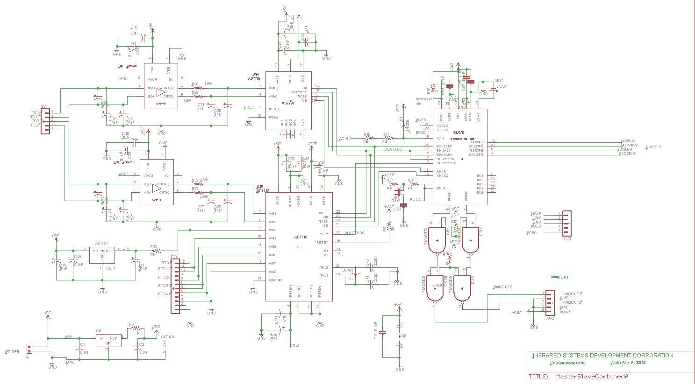
Figure 59-Slave Schematic Design

Shown in Figure 60 is the master portion of our high precision temperature controller. It will be in charge of communicating with the computer communication devices as well as updating the display. It will obtain the temperature from the slave PIC32MX150F128B.

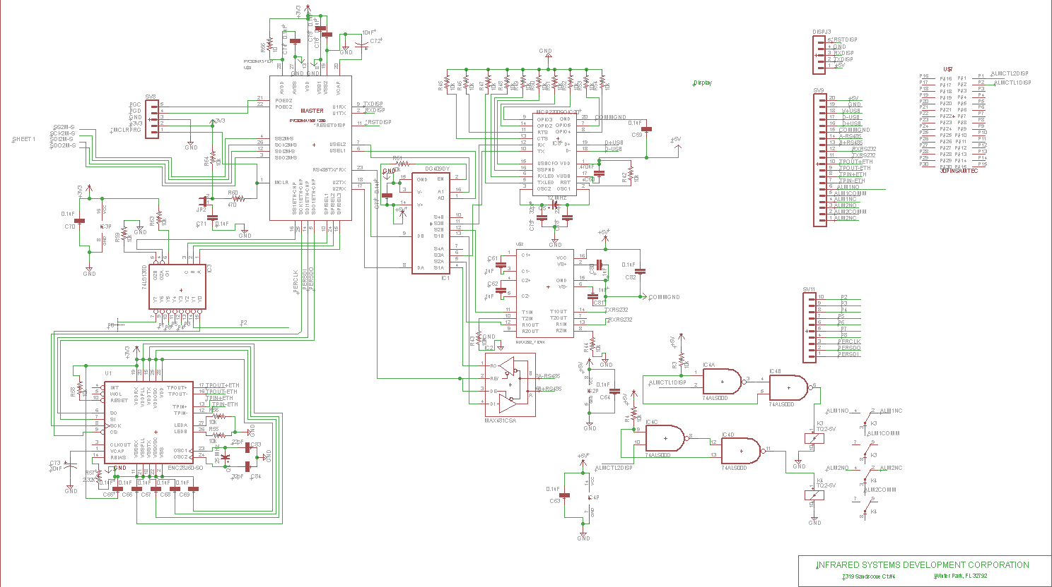
Figure 60-Master Schematic Design

Printed Circuit Board Overview

Show in Figure 61 is our final PCB layout for our high precision temperature controller. We used a four layer board with a dedicated 5V and ground plane.

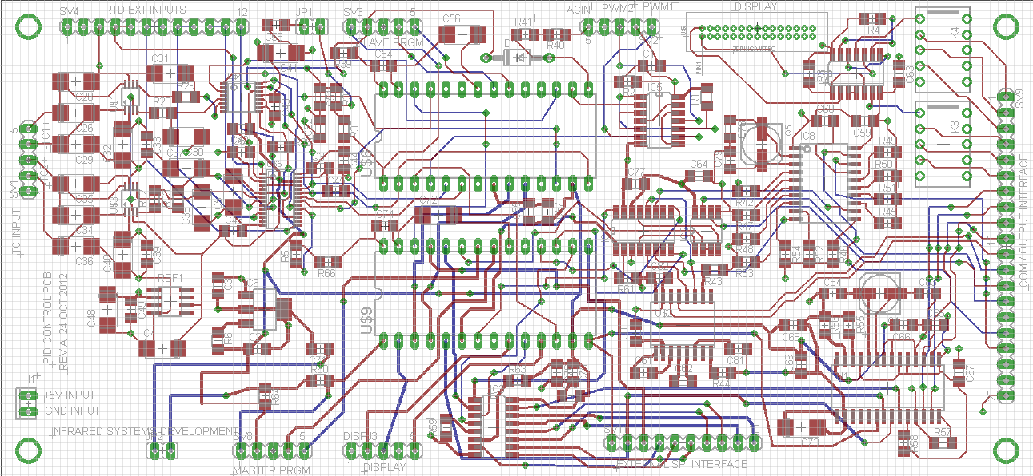
Figure 61-Final PCB Design

Chassis Overview

Shown in Figure 62 is our final chassis layout for the high precision temperature controller. It contains the power supply, solid state relays, alarms, computer interface devices, and the display. Figure 62 proves that we were able to meet the requirement of fitting the temperature controller into an existing chassis.

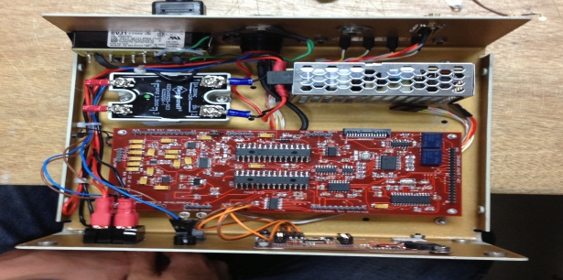
Figure 62-Chassis Design

Appendices

Table of Tables

Table 1: Table Comparing Different Blackbody Models/Types 9
Table 2: Comparing Features of Various Microcontrollers 19
Table 3-Slave Pin Out Table 21
Table 4-Master Pin Out Table 22
Table 5: PWM Period and Duty Cycle 26
Table 6: Setting up the UART Control Lines 30
Table 7: Control Bytes to Interface with the TSC2046 31
Table 8: The gain's impact on the system 41
Table 9: Five sets of Data Sets Available through the User Interface 42
Table 10: Amplifier Candidates 58
Table 11: Temp Sensing Multiplexer Candidates 60
Table 12: Cold Junction Multiplexer Candidates 60
Table 13: Microcontroller Peripheral Decoder Candidates 61
Table 14: ADC Candidates 66
Table 15: Voltage Reference Candidates 68
Table 16: PCB Components 71
Table 17: PCB Fabricator Candidates 72
Table 18: Comparison of Different Display Features 83
Table 19: Pin table for the 5-pin Interface 85
Table 20: Pin out table for expansion port 86
Table 21: Power for Components 90
Table 22: Microchip’s three Analog & Interface Ethernet options 94
Table 23: Packaging types for the Ethernet chip 95
Table 24: RJ45 Mounting Options 97
Table 25: Comparison of TCP/IP and UDP 99
Table 26: Budget 123
Table 28:Final Budget 124

Table of Figures

Figure 1: IR-2106 Extended Area Blackbody 8
Figure 2: IR-563 Cavity Blackbody 9
Figure 3: A basic block diagram of PID Controller 39
Figure 4: The Proportional response from the general transfer function 44
Figure 5: The new signal after influences of the Integral are implemented 45
Figure 6: The final signal after going through all three PID processes 46
Figure 7: Diagram of Control Process 49
Figure 8: Temperature Sensing Block Diagram 51
Figure 9: Temperature vs Voltage Plot of Type S Thermocouple 52
Figure 10: Cold Junction Compensation 53
Figure 11: Thermocouple Amplifier Design 56
Figure 12: RTD Amplifier Design 56
Figure 13: Possible Charge Injection Timing Schematic 63
Figure 14 70
Figure 15 - Example of an External Graphics Controller (Image from Microchip) 74
Figure 16 - Example of an External Graphics Controller not Found in Glass (Image from Microchip) 74
Figure 17: Example of an Integrated Graphics Controller (Image from Microchip) 75
Figure 18: Crystalfontz CFAF320240F-035T-TS - Modified to Appear as the Eye Perceives the Display (showing no FPC connectors) 78
Figure 19: Crystalfontz CFAF320240F-035T-TS - Unmodified, Appears as the Camera Perceives the Display (showing no FPC connectors) 79
Figure 20: Newhaven NHD-4.3-480272MF-ATXI#-T-1 Display (showing FFC connectors) 80
Figure 21: Newhaven NHD-3.5-320240MF-ATXL#-T-1 Display (showing FFC connectors) 81
Figure 22: 4D Systems uLCD-32PT (GFX) 82
Figure 23: Existing drawing of the chassis that will need to be modified 87
Figure 24: Main User Screen 88
Figure 25: Sample Desired Set Point Screen 88
Figure 26: Example Desired Set Point Screen 89
Figure 27: Example Current Set Point Screen 89
Figure 28: Power Diagram 92
Figure 29: Typical ENC28J60-Based Interface 96
Figure 30: Ethernet Termination and External Connections 98
Figure 31: Sample Program Display 101
Figure 32: Final Design 102
Figure 33: Microchip REAL ICE 104
Figure 34: User Menu and Administrator Menu Screen 109
Figure 35: Current Values of Device 110
Figure 36: User Operations 111
Figure 37: Alarm 1 and Alarm 2 111
Figure 38: Alarm 1 Deviations 112
Figure 39: Alarm 2 Deviations 112
Figure 40: Wavelength Ranges 113
Figure 41: Backlight Setting 113
Figure 42: Ramp to Set Point Options 114
Figure 43: Ramp to Set Point Rate 114
Figure 44: Set Point 115
Figure 45: Administrator Passcode 116
Figure 46: Administrator Settings 116
Figure 47: Offset Menu 117
Figure 48: Offset Point and Offset Value 117
Figure 49: Analog Input 1 and Analog Input 2 118
Figure 50: Sensor Type 118
Figure 51: Cold Remote Sensing 119
Figure 52: Heating or Cooling Function 119
Figure 53: Max Power to Heater 120
Figure 54: Number of Samples 120
Figure 55: PID Setting Menu 121
Figure 56: PID Value 121
Figure 57: Subsystem Block Diagram and Assignments 122
Figure 58: Milestones 125
Figure 59-Slave Schematic Design 126
Figure 60-Master Schematic Design 126
Figure 61-Final PCB Design 127
Figure 62-Chassis Design 127

Works Cited

LS200 – Power Supply Datasheet
http://us.tdk-lambda.com/lp/ftp/Specs/ls200.pdf

PTN78000A – Switching Regulator Datasheet
http://www.ti.com/lit/ds/slts246b/slts246b.pdf

PTR08060W – Switching Regulator Datasheet
http://www.ti.com/lit/ds/slts289f/slts289f.pdf

LT1129-3/LT1129-5 – Switching Regulator Datasheet
http://cds.linear.com/docs/Datasheet/112935ff.pdf

Chassis, Heater
http://www.infraredsystems.com/index.html

Display Research
http://www.newhavendisplay.com/

Newhaven 4.3” Display Data Sheet
http://www.newhavendisplay.com/specs/NHD-4.3-480272MF-ATXI-T-1.pdf

Orise OTA5180A Data Sheet
http://www.newhavendisplay.com/app_notes/OTA5180A.pdf

Graphics Controllers
http://www.microchip.com/

Texas Instruments Parts
http://www.ti.com/

Crystalfontz 3.5” Display
http://www.crystalfontz.com/product/CFAF320240F-035T-TS

Thermocouple Introduction and Theory - Omega
http://www.omega.com/temperature/z/pdf/z021-032.pdf

Lookup table for RTD
http://www.omega.com/temperature/Z/pdf/z255.pdf

Calculating Temperature Coefficient (Tempco) and Initial Accuracy for Voltage References
http://www.maxim-ic.com/app-notes/index.mvp/id/3998

64K EEPROM
http://ww1.microchip.com/downloads/en/DeviceDoc/21830E.pdf

PIC24FJ256DA206
http://ww1.microchip.com/downloads/en/DeviceDoc/39969b.pdf

ENC28J60
http://ww1.microchip.com/downloads/en/DeviceDoc/39662c.pdf

IEEE-488
http://www.icselect.com/pdfs/4816_ds.pdf

TSC2046
http://www.ti.com/general/docs/lit/getliterature.tsp?genericPartNumber=tsc2046&fileType=pdf

Looking up Ethernet Parts
http://www.digikey.com/

Networks Research
Notes from Computer Communication Networks EEL 4781

PID Research
http://arri.uta.edu/acs/jyotirmay/EE4343/Labs_Projects/pidcontrollers.pdf

PID Research
http://www.vandelogt.nl/datasheets/pid_controller_calculus_v320.pdf

Cascade and Feed Forward PID Research
http://www.engr.uconn.edu/control/pdf/isa04-1.pdf

4D Systems uLCD-32PT (GFX) Datasheet
http://www.4dsystems.com.au/downloads/4DGL-Display-Modules/uLCD-32-PT(GFX)/Docs/uLCD-32PT-GFX-DS-rev8.pdf

Permission Emails









